Effective Multipath Routing and Anomaly Detection in Wireless Sensor Networks using TM-AD Scheme

Sangeethapriya J ^{1,2 *}, Michael Arock ³ , Srinivasulu Reddy Uyyala ⁴
1.Research Scholar, Department of Computer Applications, National Institute of Technology, Trichirappalli-620015, Tamil Nadu, India
2. Assistant Professor, Department of Information Technology, Saranathan College of Engineering, Trichirappalli-620012, Tamil Nadu, India
3. Professor, Department of Computer Applications, National Institute of Technology, Trichirappalli- 620015, Tamil Nadu, India
4. Associate Professor, Department of Computer Applications, National Institute of Technology, Trichirappalli-620015, Tamil Nadu, India
sangeethapriya.nitt@gmail.com ^{1,2*} , michael@nitt.edu ³ , usreddy@nitt.edu ⁴
*Corresponding author

Abstract

Wireless Sensor Networks (WSNs) in the Internet of Things (IoT) bids play a vital role in collecting real-time data from different challenging contexts, such as healthcare systems, emergencies, smart cities, environmental monitoring, and industrial settings. These networks consist of several small sensor nodes with limited resources, low power consumption, collective data analysis, and transmission to cloud-based platforms and IoT devices for decision-making and analysis. WSNs own several features including extended lifespan and minimal energy consumption, which are essential for utilization in routing purposes. However, WSNs face more probable threats while using unsupervised IP addresses. The sensors can sense, process, and communicate. Unattended sensor networks represent a notable security concern in recent times. The duration of these processes and the vulnerability to numerous outbreaks are significant points of concern, and previous techniques face obstacles when addressing them. Token Manager-based attack detection (TM-AD) systems are designed to detect malicious or misbehaving nodes and to guarantee the overall network’s increased lifespan and efficiency. The proposed system contains a Token Manager (TM-AD), which is essential in monitoring and managing the overall network operations. The proposed TM-AD authentication system which ensures uninterrupted transmission by replacing the malicious nodes with replacement nodes. To assess the efficiency of the proposed TM, a comparative analysis against existing methods is conducted. The evaluation results confirm that the proposed TM-AD system effectively identifies malicious nodes and improves the performance across evaluation metrics.
Keywords: WSN, TM-AD, IoT, malicious, Token, Routing, Anamoly,Authentication,Attack
- Introduction
In recent years, WSN technology has undergone significant development, attracting the interest of both academic and industry communities. A WSN is a self-organized multi-hop network consisting of numerous sensor nodes with distinct attributes, such as flexibility, fault tolerance, high sensing capabilities, and rapid deployment. These characteristics have led to wide range applications of WSN, including environmental monitoring, agriculture, military, Smart Grids, and healthcare. The three main elements of WSN are aggregation nodes (sink nodes), sensor nodes, and management nodes, as depicted in Figure 1. Sensor nodes are strategically placed within the monitored area, either manually or by drone dispersal, forming a WSN through Wireless Self-Organization [1]. In this network, each node acts as a router, establishing and restoring connections as needed. WSNs gather information from sensor nodes, send it to sink nodes in a single-hop or multi-hop fashion. Sink nodes conduct preliminary data processing and information fusion before sending the information to users via satellite or wired networks[2].
WSNs do, however, have security problems because wireless communication channels can be observed, which could result in leaks of information or manipulation. Because sensor nodes in WSNs meanwhile they are placed in harsh, unsupervised, or hazardous areas, malicious actors may be able to physically seize or take control of them. Conventional cybersecurity mechanisms are not entirely appropriate for WSNs due to the increased security threats related to outdated internet networks. Additionally, WSNs operate within restricted communication bandwidth, relying on wireless technologies like Bluetooth and Zigbee, with embedded chips having constrained computing and storage competences [3,4]. Consequently, ensuring communication security while dealing with these restrictions can be interesting. To address WSN security requirements such as data integrity, authentication, and non-repudiation, digital signature technology is a viable remedy. However, digital signature techniques must contend with the risk of man-in-the-middle attacks that include public key replacement. Currently, to tackle this challenge there are three primary solutions are available.
- The Public Key Infrastructure (PKI) cryptosystem presents complicated certificate management issues.
- The second technique is Identity-Based Public Key Cryptography (IBC), which reduces the complexity of certificate management but has a key escrow problem.
- The third system is a Certificateless Public Key Cryptography (CL-PKC) system, wherein the Key Generation Centre (KGC) generates the user's private key (PKK), and the user collaborates to construct a secret value.
Since there is no certificate in the system, the certificate management issues are solved, and meanwhile, the KGC is unable to determine the user’s complete private key, thereby resolving the key escrow problem. Thus, this paper concentrates on the application of Certificateless Signature (CLS) techniques to WSN. The section 2 presents related works to find the problem statement. The section 3 focus on research contributions which includes
- The Token manager concept introduces a method known as Token-Based Server Attack Detection (TM-AD).
- This work reveals a thorough evaluation of the proposed technique combining security analysis and experimental findings, thereby demonstrating its superior effectiveness in comparison to existing techniques.
- To ensure reliable transmission, the routing paths are upgraded by replacing the malicious nodes with the replacement nodes, affirming successful transmission.
- The article emphasizes a comparative analysis of the proposed technique, with a specific focus on assessing various efficiency parameters.
- Promotes secure IoT transmission, by employing encrypted data through a reliable and lightweight pathway to elevate network performance.
The section 4 highlights the experimental results of proposed methodology and compared with existing approaches.

2. Related work
Several researchers have examined and applied various kinds of strategies for protection. Developed blockchain data privacy technique for automated driving [5] by strengthening data transmission security. It is important to remember that this technology has only been used sparingly and is mostly associated with automated driving and related fields.
A big data-based identification method for hacking computer networks' status was presented in [6]. These mechanisms have a detection accuracy of 20%, which is higher than the current intrusion detection system. They primarily rely on deep learning long-term and short-term storage. Consequently, the system's applicability and its potential in wireless sensor networks are limited.
A low-power 3D wireless sensor privacy protection technique is described in [7] to enhance data security. In this paper, the author analyzed how the method uses very little communication energy while improving the accuracy of data fusion to some extent. Hence, the privacy protection ability of the algorithm still holds a lot of space for improvement.
In [8]. introduced research on monitoring methods related to WSN applications. In this work, the Sensors distinguish an attenuated (unknown) deterministic signal when the target is fixed, and the signal depends on the unknown distance between the sensor and the target. Therefore, the simulation results ensure the promising performance of the proposed method.
In [9], the long-range transmission issue that WSNs encounter was examined, leading to the development of an optimized system for WSNs for fuzzy subordinate support systems. There is a discussion on the system's precise level. Homomorphic encryption was proposed by Lakshmi and Deepthi in [10] as a way to allow data aggregation and address the limitations of the data fusion encryption approach in traditional WSNs. It also resists different types of attacks well, which is a significant improvement over existing approaches.
The information security issue about WSNs in the power grid was tackled by [11], and his team members also proposed a blockchain-based data-sharing paradigm. It is crucial to remember that the analysis evaluated how well and safely the data-sharing model shares, stores, and protects sensitive information [11]. An enhanced approach was developed by Jiang et al. [12] to address security flaws and excessive energy consumption in WSN applications, including military surveillance and habitat monitoring. The scheme carefully distributes the sensors. In contrast with traditional deployment plans, this approach may have improved privacy while optimizing energy consumption and information latency [12].
For data compression in WSNs, a data clustering technique that familiarizes features such as adaptive recursion and smooth data compression was developed [13]. Experiments prove that this kind of technique can compress data with as minimal space-time complexity as possible. The system precisely predicts the failure intensity of landslides, according to the optimized WSN presented in [14].
There has been research on a blockchain-based trust management paradigm [15]. Through the use of many assessment criteria, including closeness, honesty, detection rate, average energy consumption, frequency of interaction, and intimacy, these techniques are used to detect malicious nodes and improve the relationships through different metrics. To find and localize malicious nodes in wireless sensor networks (WSNs), the beacon nodes are mainly chosen based on trust values. After that, they transfer the data to the base station, developing a model for evaluating trust.

In [16] proposed a blockchain-based for detecting and localizing the malicious nodes in IoT-based WSNs by using federated random forest and support vector machine techniques. They also discussed secure service provisioning using feature assessment and cascading encryption for detecting and canceling malicious nodes in the network. Security and performance metrics, including accuracy, node honesty, and end-to-end delay of the packet transmission, and measured the performance of the malicious node detection and secure provisioning approaches.
In [17] proposed a blockchain technology of an authenticated group key agreement mechanism for the IoTs. The novel concept called the device manager mediates communications between IoT gadgets and blockchain infrastructures is the proposed protocol and it has been secured after being subjected to various assaults, as indicated by the security analysis. The time expenditures of protocol operations are fair and appropriate for IoT settings shown in the simulation.
In [18] WSNs contribute to the IoT, serving in critical sectors like healthcare, military, and security. Security threats to IoT-WSNs prompt this study's proposal that introduce a robust system for localizing and detecting attacks securely. Also, the technique leverages a hierarchical structure incorporating blockchain-based cascade encryption and trust evaluation. It assesses the reliability of nodes, promotes service provision, and eliminates malicious nodes that affect network integrity. Additionally, the implementation of Federated machine learning bolsters data security and helps in the identification of malicious nodes. Through the amalgamation of these techniques, the approach achieves high detection and classification accuracy in comparative assessments, making it a well-suited solution for large-scale IoT-WSNs characterized by heterogeneous WSNs.
In [19] The WSNs domain holds research in data fusion and privacy protection across major research areas. Operating in challenging environments exposes sensor nodes susceptible to data fusion attacks. To address efficiency and privacy concerns, this work reveals an improved cluster-based privacy data aggregation (I-CPDA) method, implementing techniques such as data slicing and false interference data. Results show a substantial increase in data fusion accuracy, with I-CPDA reaching 90.7%, compared to 68.7% of the traditional CPDA method. Additionally, I-CPDA excels in intercepting data attacks, boasting a success rate of 90.74% as opposed to 76.66% which results in data traffic reduction (56 vs. 200) when 15 nodes are utilized. I-CPDA offers superior fusion, privacy, and overall efficiency compared to traditional methods, rendering it highly suitable for practical implementation.
Problem Statement:
- Privacy issues arise when IoT devices exchange sensitive data over a network channel.
- Existing approaches are easily susceptible to security levels and may not provide sufficient protection.
- No documented evidence that any malicious nodes intruded and disrupted the network transmission
- If any transmission fails there is no established system for implementing alternatives or replacing malicious nodes.
- Previous approaches do not guarantee any reliable communication with a High Packet Delivery Ratio (PDR), throughput, and lifespan.
- Proposed methodology

Sensor nodes deployed
Elect Token manager
Control and maintain the network
Monitor the node’s activity and routing performance
Nodes parameter
Distance, energy, location
Find traffic misbehaving nodes and rectify
Introduced node authentication process
Improve the network security and reduce the traffic
Figure 1 Proposed architecture
Figure 1 illustrates the proposed architecture, emphasizing the central role of the token manager (TM) as a crucial entity. The network's node possessing the highest bandwidth and energy is represented as TM, entrusted with the responsibility of maintaining and monitoring the entire process. Initially, TM prioritizes and distributes tokens to the nearby nodes. After receiving the token, the nodes were acknowledged by TM. During this process, TM collects and updates various characteristics of each acknowledged node, such as position, energy levels, location, and distance. These nodes are categorized as active nodes, while those that do not react are considered either “idle” or “in sleep” mode. TM compiles a list of actively engaged nodes in the network labelling them as cooperative nodes. It’s important to note that even though idle nodes are currently inactive, they have the potential to become active. For packet transmission processing, TM organizes and assembles the cooperative node list. By continuously monitoring the node activity and attributes, TM maintains a record of route information and keeps a routing table. The initial step in packet processing involves a thorough examination of the node activity and the packet size from both source and destination perspectives. Suppose any unusual traffic patterns or instances of nodes are noted, appropriate actions will be taken which include identifying, removing from the network, or temporary holding of the affected nodes. Then, these changes related to data are updated in both TMs. Algorithm 1 explains clearly

- token manager creation randomly deployed ${(N}_{1},N_{2},N_{3}…N_{n})$; // nodes randomly deployed in network region;Nodes properties sch as ${(N}_{d},N_{e},N_{l}…N_{n})$;$he N_{d}=\sqrt{{\left(x_{2}-x_{1}\right)}^{2}+{(y_{2}-y_{1})}^{2} }$;
- $N_{e}=\left(\frac{I_{e}-R_{e}}{T_{e}}\right)$ // $I_{e}→intial energy$; $R_{e}→Residual energy$; $T_{e}→total energy$;
- $N_{l}=\left(x_{1},y_{1}\right)(x_{2},y_{2})$ // f (x, y) coordinates position;
- Check the nodes parameter
- For $(i=0;i<n;i++)$
- If $(N_{d}\left(low\right),N_{e}\left(high\right)threshold level (≥65\%)$
- That node act as ${(T}_{m})$ // token broker;
- Else if
- If $(N_{d}\left(medium\right),N_{e}\left(medium\right)threshold level (≥45\%)$
- That node act as sensor node;
- End if
- Check the nodes activity by ${(T}_{B})$
- For $(i=0;i<n;i++)$
- If
- Sends the request to all neighboring nodes “hello” messages;
- If received the “request” message and send the acknowledgment to ${(T}_{B})$ that node (Active state);
- ${(T}_{B})→cooerative node list$
- Issue the token to all cooperative node list
- ${(T}_{B})→T_{1},T_{2},T_{3}…. T_{n}$
- Els if
- Message received but nodes is not giving response that node is (idle state);
- ${(T}_{B})→idle node list$;
- End if;
- End process

N14
N9
N4
N5
N1
N12
N10
N11
N13
N3
N15
N16
N6
N7
N2
N8
N17
N18
N21
N19
N20
T01

T02

T03

T04

T05

T08

T13

T14

T15

T16

T17

T10

T19

T11

T20

T06

T07

T21

T21

T18

Token manager
Figure 2 Proposed architecture
Figure 2 describes the proposed token base node deployment based on which the nodes are deployed randomly from N1 to N20. According to this deployment, N1 acts as the source and N9 as the destination. The tokens T01 to T21 are issued parallelly. The message broadcasting mechanism determines each node's status, classifying them as either active or inactive, through the token distribution process. Following the broadcast of the "hello" message, the nodes that respond are “active nodes”, whereas those which doesn’t respond are “inactive nodes”. It’s important to note that an idle node has the potential to attain the active status; hence, TM maintains a continuous vigil, by ensuring all node information is monitored and updated accordingly. The execution operation is initiated by TM, which controls both cooperative and non-cooperative node list problems, thereby affirming the issuance of tokens to all active nodes as described in the algorithm.
2. Algorithm for routing maintenance by token broker
- Initialize ${(T}_{B})→cooperative node list$;
- Create the routing process and nodes behaviors monitor by ${(T}_{B})$ list and check nodes activity;
- Check the route availability by ${(T}_{B}→R_{t})$;
- For $(R_{t}=0;R_{t}<N;R_{t}++)$;
- Packet transmission process starts;
- $(R_{t}=R1,R2,R3…R_{n})$;
- If ${(R}_{t}=R1)$ check the route availability
- Case (i)
- If its free packet transmission process starts and monitor the nodes activity
- The node activity is good the packets reach the destination on current route (R1)
- (R1=Nil)
- Case (ii)
- ${(R}_{t}=R2)$ check route 2
- Packets transmission is still processing but some traffic occurs ;
- $R2 \left[\left(N_{d}\right)\left(N_{e}\right)\right]$ the node energy level is low in route 2 so the nodes create unwanted traffic;
- And continuous packet dropping;
- R2 (find the malicious node in route 2);
- If (find the node, temporary hold or remove from the network);
- Nodes authentication process
Check the (node_ id) and (Token_ id); (Routing _ id); // these ids are correct;
Check previous history (packet transmissions);
Check energy _ level is (low) distance _level is (high); // may be this node is a misbehaving node;
- Wait (after some time) // the node’s energy level will come back good
- Once find the misbehaving node;
- Pair of tokens introduced (source id _token, destination id _ token);
- Case (iii)
- If ${(R}_{t}=R3)$ check the route availability
- If its free packet transmission process starts and monitor the nodes activity
- The node activity is good the packets reach the destination on current route (R3)
- (R3=Nil)

  - Routing maintained and monitored by the Token manager
This section delineates the process of packet transmission within the network. As already mentioned in the Algorithm, 1 Token broker server initializes the creation of a Token manager. Then, under the guidance of the Token Manager (TM), multiple routing paths are discovered. Each routing path is identified by a unique Route ID, which comprises a combination of Token ID and Node ID. Above, figure 3 highlights the nodes with low energy levels that potentially generate unwanted traffic. Table 1 illustrates each routing ID is associated with its respective set of Token and Node IDs representing a detailed overview of the network’s routing configurations. Algorithm 2 describes the process of addressing and gathering nodes' activities, facilitating packet transmission, collecting characteristics, and monitoring processes.
N14
N9
N4
N5
N1
N12
N10
N11
N13
N3
N15
N16
N6
N7
N2
N8
N17
N18
N21
N19
N20
T01

T02

T03

T04

T05

T08

T13

T14

T15

T16

T17

T10

T19

T11

T20

T06

T07

T21

T09

T18

Token manager
R1

R2

R3

R4

Figure 3 find the unwanted traffic route
Figure 3 represents the detection of the misbehaving node. The TM is responsible for controlling and monitoring the entire network. The packet processing begins with multipath routing in R1, that contains N01, N02, N03, N04, N05, N06, N07, N08, N09. The R2 includes nodes N01, N02, N06, N07, N21, N12, N09. TM in R2 detects unwanted traffic and checks the node's activity, identifying the misbehaving nodes N21. After finding this node, the node might be temporarily stopped or removed from the network. Moving to R3 comprises of N01, N06, N18, N11, N20, N17, N09. Finally, R4 includes nodes such as N01, N13, N14, N15, N16, N17, and N09 this route saw some normal traffic, prompting a check of node activity and ultimately identifies the node N16 as a misbehaving node and it temporarily holds from the network. Once the misbehaving nodes are identified, the new source IDs and destination IDs are generated for these nodes to intimate a TM. Finally, the security scheme is improved by reinforcing the following algorithm's 3 steps. After finding the misbehaving node there is an enhancement in the new security scheme. Before the network communication the nodes’ parameters such as $(N_{d}\left(medium\right),N_{e}\left(medium\right)threshold level (≥50\%) are assessed$. Only the nodes meeting this threshold are eligible to participate in the network, while others are excluded from the network. In the Second step, the fresh source iDs, destination iDs, and token iDs are registered by TM. After a registration packet transmission process commences and continues after a specified travel time, nodes’ parameters, $N_{d}$and $N_{e}$, are re-evaluated only if they meet the threshold criteria. If this condition doesn’t meet the requirement then, the new nodes which satisfies the threshold criteria are addressed in the network, meanwhile, it temporarily eliminates the older and energy-depleted nodes. The same steps will be repeated and ultimately, calculating the packet delivery ratio, attack detection rate, and end-end delay. Table 1 shows the misbehaving nodes. Table 2 illustrates the structure for creating the source iDs and destination iDs after finding the misbehaving node.
Routing ID | Token-ID | Node ID | Misbehaving nodes
R1 | T01, T02, T03, T04, T05, T06, T07, T08, T09 | N01, N02, N03, N04, N05, N06, N07, N08, N09 | NIL
R2 | T01, T02, T06, T07, T21, T12, T09 | N01, N02, N06, N07, N21, N12, N09 | N21
R3 | T01, T06, T18, T11, T20, T17, T09 | N01, N06, N18, N11, N20, N17, N09 | NIL
R4 | T01, T13, T14, T15, T16, T17, T09 | N01, N13, N14, N15, N16, N17, N09 | N16
Table 1 routing information and find misbehaving nodes
Misbehaving node | Token-ID | Source -ID token | Destination ID token
N21 | T21 | TSID 12 | TDID 21
N16 | T16 | TSID 61 | TDID 16
Table 2 Token manager-based node authentication structure
Algorithm 3Token manager-based node authentication structure
Begin
{
Check the current If $(N_{d}\left(medium\right),N_{e}\left(medium\right)threshold level (≥50\%)$
Nodes energy level (good) and distance (low) // is eligible to participate the network;
Register Node’s id
Register Token _id;
Source _ id;
Destination _ id; // register by TM.
After check the node’s energy and distance level;
Start the packet transmission process ();
Monitor the node ${(N}_{d}$) and ${(N}_{e}$) level is good continue the packet transmission;
Else if
Hold from the network and allocate the next $N_{d}\left(medium\right),N_{e}\left(medium\right)threshold level (≥50\%)$
end if
finally calculate the PDR, End-End delay, system efficiency;
end process
}
- Experimental results

Simulation Parameter | Value
Simulator | NS-2
Simulation time | 315 s
Number of nodes | 100
Simulation area | 2000 × 2500 m
Mac Protocol | IEEE 802.11
Data rate | 24 Mbps
Radio range | 110m
Mobility model | Random waypoint model
Antenna | Omnidirectional antenna
Node speed | 10-35 m/s
Packet size | 512 bytes
Traffic type | Multicast constant bit ratio

The simulation environment emulates a dynamic network, with 120 nodes using the Random Way mobility model. The network occupies a 1700 x 1700 m2 space, allowing the nodes to roam freely within this area. Based on the simulation adheres to the IEEE specifications for the 802.11 Mac protocol, analyzing that the simulation's link-layer protocol is in accordance. To generate network traffic, a constant bit ratio multicast approach is employed. The experiment consists of both IEEE 802.11b and 802.11e WLAN heterogeneous traffic scenarios. Data connections are employed using either a TCP or UDP network topology, with the nodes exhibiting a mobility range between 10-35 m/s. The value of packet size is 2000 bytes, and the data rate is 24 Mbps. The various simulation parameters utilized during the execution are explained elaborately in the provided table.

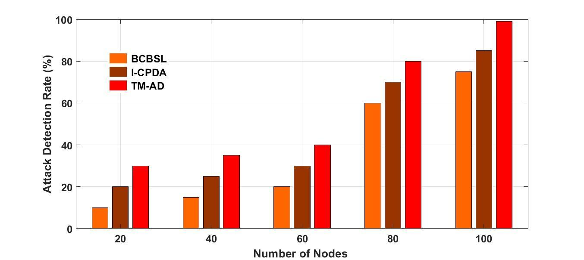
Figure 4 Number of nodes vs. attack detection rate
Figure 4 represents a comparison of the total attacks detected during transmission between the proposed TM-AD and existing methods like BCBSL and I-CPDA. The attack detection rate is measured in (%). The x-axis indicates the number of participating nodes, while the y-axis indicates the detected attack rate observed by each approach. The node count is incremented by 20 and observations are tracked. As illustrated in the graphical representation, the proposed TM-AD exhibits robust performance in detecting attacks. With 20 participating nodes, it achieves 30% with 20 nodes, 36% with 40 nodes, 40% with 60 nodes, 80% with 80 nodes and 100 % with 100 nodes. With 100 nodes, The TM-AD demonstrates an impressive 100% detection rate. These results demonstrate that the proposed TBS-DT consistently outperforms the other existing approaches in terms of attack detection rates across all ranges of nodes.
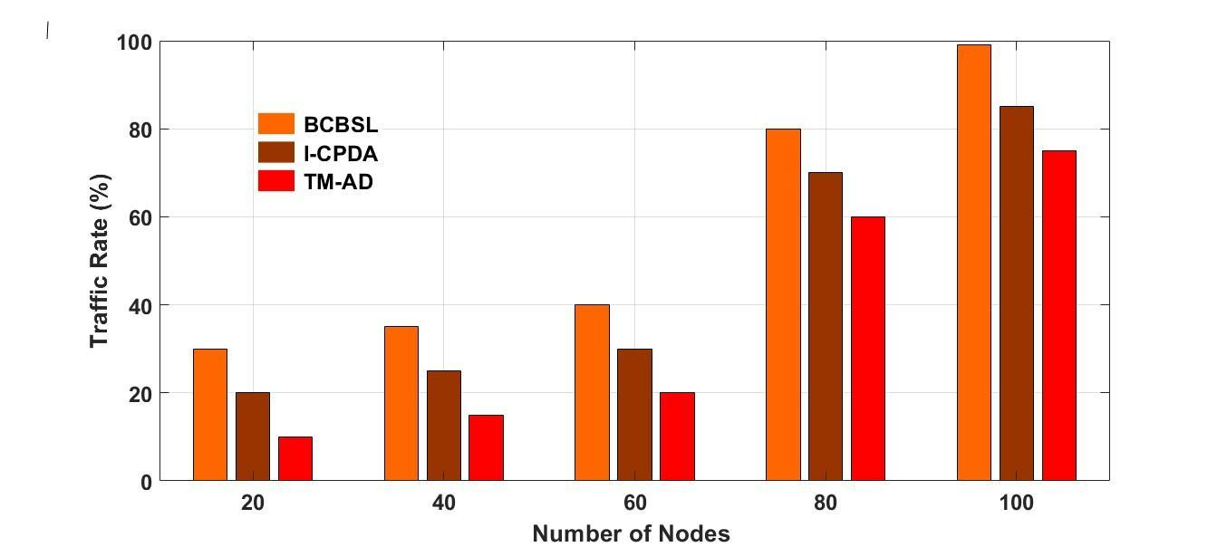
Figure 5 Number of nodes vs. traffic rate
Figure 5 shows the comparison of traffic rates during transmission between the proposed TM-AD and existing methods like BCBSL and I-CPDA. The traffic rate is measured in percentage(%). The x-axis denotes the total number of participating nodes, while the y-axis indicates the traffic rate observed by each approach. The node count increases in increments of 20 and observations are taken. As shown in the graphical representation, the proposed TM-AD exhibits a traffic rate of 10% with 20 nodes, 16% with 40 nodes, 20% with 60 nodes, 60% with 80 nodes, and 76% with 100 nodes. This clearly states that the proposed TM-AD consistently experiences lower traffic rates across all ranges when compared to the other existing approaches.
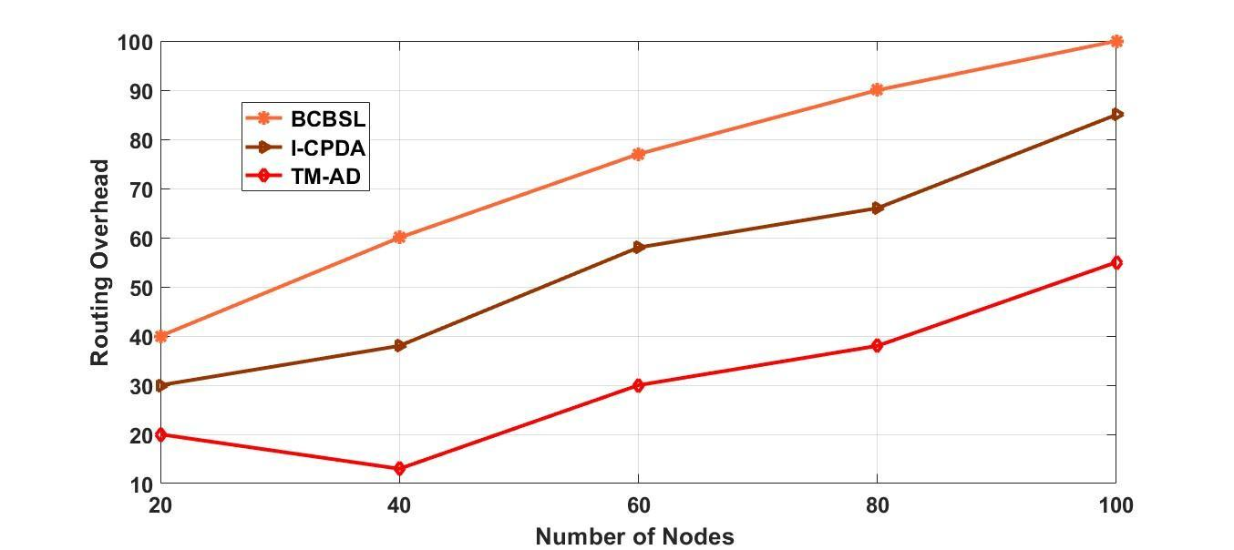
Figure 6 Number of nodes vs. routing overhead
Figure 6 presents the comparison of the routing overhead rate observed during the transmission by the proposed TM-AD with existing methods of BCBSL and I-CPDA. The routing overhead rate is expressed in terms of percentage (%). The x-axis indicates the total number of participating nodes, meanwhile the y-axis denotes the routing overhead rate observed by each approach. The increment of the node counts is increased by 20 and observations are done. The proposed TM-AD shows a routing overhead rate of 20% with 20 nodes, 12% with 40 nodes, 29% with 60 nodes, 39% with 80 nodes, and 55% with 100 nodes in the graphical representation. This establishes that the proposed TM-AD consistently experiences lower routing overhead across all ranges of nodes when compared to other existing approaches.

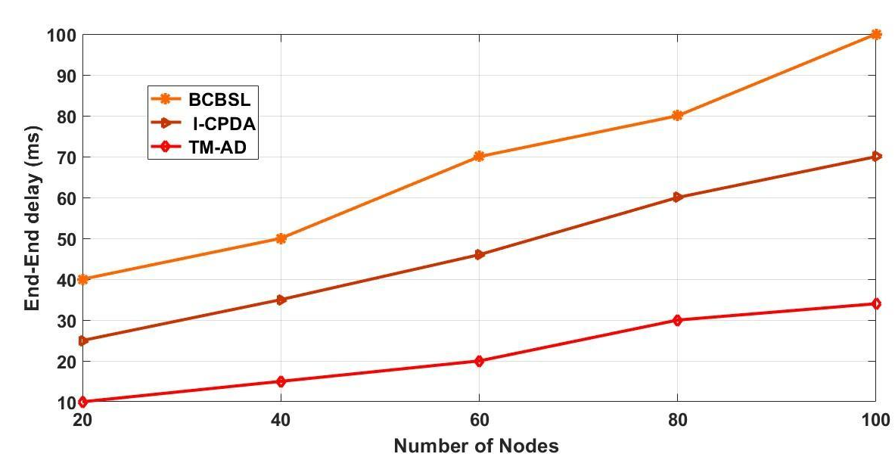
Figure 7 Number of nodes Vs. End-End delay
Figure 7 details the comparison of end-end delay during transmission by the proposed TM-AD with existing methods like BCBSL and I-CPDA. The end-end delay is evaluated in milliseconds(ms). Here, the x-axis represents the total number of participating nodes, meanwhile, the y-axis denotes the total delay experienced by each approach. The node count incremented by 20 and the observations are noted. The graphical representation demonstrates the proposed TM-AD exhibits a delay of 10ms with 20 nodes, 15ms with 40 nodes, 20ms with 60 nodes, 20ms with 80 nodes, and 24ms with 100 nodes. Thus this demonstrates the proposed TM-AD consistently experiences minimal delay across all ranges of nodes when compared with the other existing approaches.
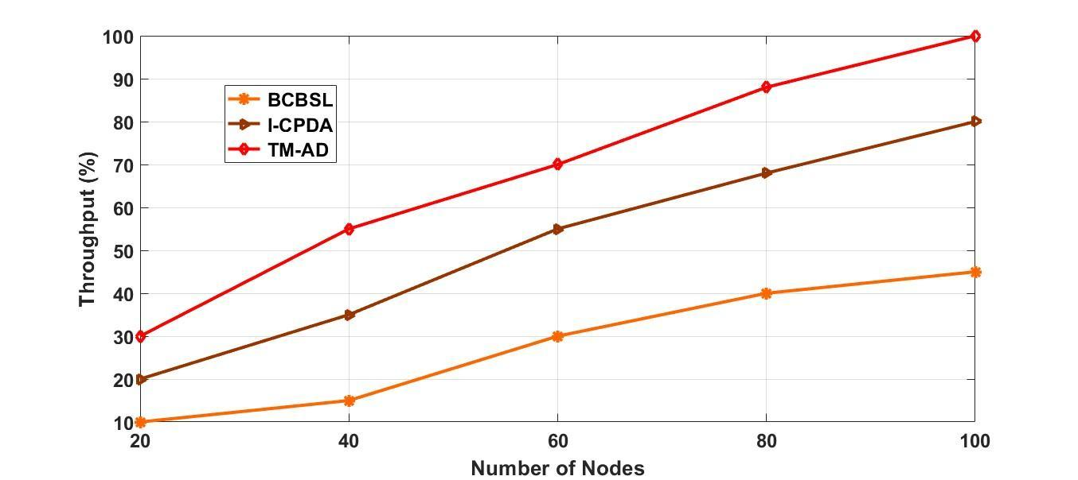
Figure 8 Number of nodes Vs. Network throughput
Figure 8 provides a comparison of network throughput attained during the transmission using the proposed TM-AD against existing methods such as BCBSL and I-CPDA. During execution, the network throughput is measured in terms of percentage (%). The x-axis denotes the total number of nodes, while the y-axis indicates the total network throughput attained by each approach. The node’s count was increased in increments of 20 and the observations were recorded. The graphical representation shows the proposed TM-AD establishes a network throughput of 30% with 20 nodes, 56% with 40 nodes, 60% with 60 nodes, 89% with 80 nodes, and 100% with 100 nodes. Hence, it briefs the proposed TM-AD outperforms the other existing approaches across all ranges of nodes, achieving the highest throughput.
- Conclusion
In various domains, Wireless sensor networks integrated with IoT have attracted considerable attention. While IoT systems offer convenient and faster data transmission channels, they also introduce fresh security risks, particularly in safeguarding sensitive personal data. Preserving data security and privacy remains a major challenge in this context, as previous systems struggle to effectively monitor and detect malicious nodes, resulting in transmission failures and node delays. To overcome these challenges, this paper introduces a Token-manger-based attack detection (TM-AD) system for the effective detection of malicious nodes. TM-AD comprises a component that facilitates the substitution of malicious nodes with substitute nodes. Furthermore, the proposed approach is assessed by comparing it to existing methods using multiple metrics such as Packet Delivery Ratio (PDR), Attack Detection Rate, Traffic Rate, Routing Overhead, Communication Overhead, End-to-End Delay, and Network Throughput. Across all these metrics, TM-AD demonstrates a high level of performance in comparison to existing approaches. Future work in IoT authentication focuses on enhancing security, scalability, and efficiency. The key factors which may focus on light weight optimized authentication algorithms to minimize the power consumption along with robust security. To enhance the security and to reduce the latency, integration of edge or computing with distributed authentication frameworks may designed. An alternative biometric authentication mechanism for IoT devices, exploring the unique challenges to the IoT landscape.
- Reference
- D. He, N. Kumar, and J.-H. Lee, “Privacy-preserving data aggregation scheme against internal attackers in smart grids,” Wireless Networks, vol. 22, no. 2, pp. 491–502, 2016.
- N. Kumar, K. Kaur, S. C. Misra, and R. Iqbal, “An intelligent RFID-enabled authentication scheme for healthcare applications in vehicular mobile cloud,” Peer-to-Peer Networking and Applications, vol. 9, no. 5, pp. 824–840, 2016.
- S. Roy, A. K. Das, S. Chatterjee, N. Kumar, S. Chattopadhyay, and J. J. P. C. Rodrigues, “Provably secure fine-grained data access control over multiple cloud servers in mobile cloud computing-based healthcare applications,” IEEE Transactions on Industrial Informatics, vol. 15, no. 1, pp. 457–468, 2019.
- N. Temene, C. Sergiou, C. Georgiou, and V. Vassiliou, “A survey on mobility in wireless sensor networks,” Ad Hoc Networks, vol. 125, article 102726, 2022.
- R. Kumar, P. Kumar, R. Tripathi, G. P. Gupta, N. Kumar, and M. M. Hassan, “A privacy-preserving-based secure framework using blockchain-enabled deep-learning in cooperative intelligent transport system,” IEEE Transactions on Intelligent Transportation Systems, vol. 23, no. 9, pp. 16492–16503, 2022.
- M. Mahdavisharif, S. Jamali, and R. Fotohi, “Big data-aware intrusion detection system in communication networks: a deep learning approach,” Journal of Grid Computing, vol. 19, no. 4, pp. 1–28, 2021.
- L. Feng and B. Liu, “Low-energy data fusion privacy protection algorithm for three-dimensional wireless sensor network,” Mobile Information Systems, vol. 2022, Article ID 3580607, 10 pages, 2022.
- K. Pramod, S. Pierluigi, and C. Domenico, “Distributed detection in wireless sensor networks under multiplicative fading via generalized score tests,” IEEE Internet of Things Journal, vol. 8, no. 11, pp. 9059–9071, 2021.
- I. Nasurulla and R. Kaniezhil, “Integration of fault-tolerant feature to OMIEEPB routing protocol in wireless sensor network,” International Journal of Intelligent Computing and Cybernetics, vol. 15, no. 3, pp. 414–424, 2022.
- V. S. Lakshmi and P. P. Deepthi, “A secure channel code-based scheme for privacy preserving data aggregation in wireless sensor networks,” International Journal of Communication Systems, vol. 32, no. 1, article e3832, 2019.
- X. Zhang, L. Zhao, X. Gao, and X. Zhang, “A data-sharing model based on blockchain for power grid big data,” Journal of Physics: Conference Series, vol. 1792, no. 1, article 012051, 2021.
- S. Jiang, M. Li, and Z. Tang, “A new scheme for sourcelocation privacy in wireless sensor networks,” International Journal of Network Security, vol. 20, no. 5, pp. 879–888, 2018.
- M. K. Alam, A. A. Aziz, S. A. Latif, and A. A. Aziz, “Error-control truncated SVD technique for in-network data compression in wireless sensor networks,” IEEE Access, vol. 9, pp. 13829–13844, 2021.
- P. Giri, K. Ng, and W. Phillips, “Wireless sensor network system for landslide monitoring and warning,” IEEE Transactions on Instrumentation and Measurement, vol. 68, no. 4, pp. 1210– 1220, 2019.
- T. H. Kim, R. Goyat, M. K. Rai et al., “A novel trust evaluation process for secure localization using a decentralized blockchain in wireless sensor networks,” IEEE Access, vol. 7, pp. 184133–184144, 2019.
- Z. Abubaker, N. Javaid, A. Almogren, M. Akbar, M. Zuair, and J. Ben-Othman, “Blockchained service provisioning and malicious node detection via federated learning in scalable Internet of Sensor Things networks,” Computer Networks, vol. 204, article 108691, 2022.
- C. Ming, C. Xiaoting, D. Wensheng, and G. Jiahui, “A secure blockchain-based group key agreement protocol for IoT,” The Journal of Supercomputing, vol. 77, no. 8, pp. 9046–9068, 2021.
- Gebrekiros Gebreyesus Gebremariam, J. Panda, S. Indu, "Blockchain-Based Secure Localization against Malicious Nodes in IoT-Based Wireless Sensor Networks Using Federated Learning", Wireless Communications and Mobile Computing, vol. 2023, Article ID 8068038, 27 pages, 2023.
- Lusheng Shi, Kai Li, Huibo Zhu, "Data Fusion and Processing Technology of Wireless Sensor Network for Privacy Protection", Journal of Applied Mathematics, vol. 2023, Article ID 1046050, 10 pages, 2023.

