https://doi.org/10.31449/inf.v45i1.1234 informatica 45 (2021) 501–505 501

Gujarati Optical Character Recognition Using Efficient Text Feature Extraction Approaches
Avani Samir Bhuva¹, Dr.Dhirendra Mishra ²
avani.bhuva@nmims.edu, dhirendra.mishra@nmims.edu

¹Computer, MPSTME (NMIMS) Bhakti Vedant Marg, opp. Cooper Hospital, Navpada, Suvarna Nagar, Vile Parle West, Mumbai, India
²Computer, MPSTME (NMIMS) Bhakti Vedant Marg, opp. Cooper Hospital, Navpada, Suvarna Nagar, Vile Parle West, Mumbai, India

Keywords: Image Processing, Optical Character Recognition, Gujarati Text Feature Vector Dictionary, Integrated Shape Numeric Encoding Approach (ISNEA), One-Bit Frequency Count Approach (OBFCA), Fusion of Region Geometric Features (FRGF)

Received: February 27, 2025

India ranks as the second most populous nation globally, representing 17.74% of the world's total population. The country is characterized by its linguistic diversity, boasting 22 official languages. The proliferation of digitized documents following the COVID-19 pandemic has complicated the task of information retrieval. Consequently, there has been a growing interest among researchers in the recognition of Gujarati characters and numerals, likely driven by an increase in user demand. The intricate nature of the Gujarati language has resulted in a scarcity of available datasets. Most research endeavors have traditionally relied on written documents to compile the Gujarati dataset. In this study, we analyzed 23,100 distinct augmented Gujarati texts. To extract features from these texts, we introduced three methodologies: The Integrated Shape Numeric Encoding Approach (ISNEA), the One-Bit Frequency Count Approach (OBFCA), and the Fusion of Region Geometric Features (FRGF). The FRGF method is particularly adept at processing multiple regions, thereby enhancing the accuracy of text feature classification. The extracted features were cataloged in a Gujarati Text Feature Vector Dictionary. Rigorous experiments were conducted, and comparisons with existing methodologies revealed that our proposed approaches yield superior results. Notably, the FRGF method excelled in both single and fused feature scenarios. The use of eccentricity as a standalone feature achieved peak classification accuracies of 93.50%

1. Introduction

The utilization of the internet has significantly evolved over the past decade. Users typically formulate queries to seek information online, subsequently receiving relevant explanations. With the advancement of digital technology, information can be effortlessly accessed from various formats, including documents, images, and videos that are uploaded daily. According to recent surveys, over 150,000 new videos are added to YouTube every minute. In the aftermath of the COVID-19 pandemic, approximately 3.7 million videos are uploaded each day, amounting to around 271,330 hours of video content. This digitized information is available in multiple formats and varies in size across diverse domains such as education, cooking, sports, and entertainment, as well as in numerous languages, including English, Hindi, Gujarati, Tamil, and others. However, extracting information from these digitized resources presents a considerable challenge.
The process of converting documents or images into machine-readable text is referred to as optical character recognition (OCR). An OCR system interprets images containing printed or handwritten characters and converts them into editable text formats. This involves segmenting the text image into lines and subsequently into individual characters, creating distinct areas for analysis. During character extraction, various attributes of the text image are evaluated, including corner points, features of different regions, the ratio of character areas, and the convex area encompassing all characters. The accompanying diagram illustrates the workflow of the OCR system, which begins with dataset collection, followed by the application of various image processing algorithms for pre-processing and feature extraction from the images.
Digital image processing employs computer algorithms to manage large volumes of images, videos, and documents. By utilizing image processing techniques, meaningful information can be retrieved from these digitized datasets. Given that the information exists in various forms, specific techniques are necessary for effective extraction. This research paper examines several techniques within the domain of image processing aimed at extracting information from textual content.
Gujarati is an Indo-Aryan language with historical origins tracing back to the tenth and eleventh centuries. It emerged from the region of Gujarat in India and has developed into a dynamic language shaped by influences from Sanskrit, Prakrit, Apbhransh, Arabic, Persian, Portuguese, and English. Among the 7,139 languages recognized globally, English, Chinese, and Hindi are the most widely spoken. India ranks second in linguistic diversity, following Papua New Guinea. Gujarati is the sixth most spoken language in India, following Hindi. Notably, in Gujarati, the same words can convey different meanings depending on gender, highlighting the language's subtlety in this regard. Gujarati nouns are categorized into two numbers (singular and plural) and are classified as Feminine, Masculine, or Neuter. For instance, "bahen" (બહેન) refers to "sister" in the feminine form, while "bhāī" (ભાઈ) denotes "brother" in the masculine form. Additionally, nouns such as countries and oceans are typically masculine, rivers are feminine, and cities and lakes are neuteral. The language comprises 36 consonants, 26 vowels, and numerical symbols as illustrated in the accompanying figure.
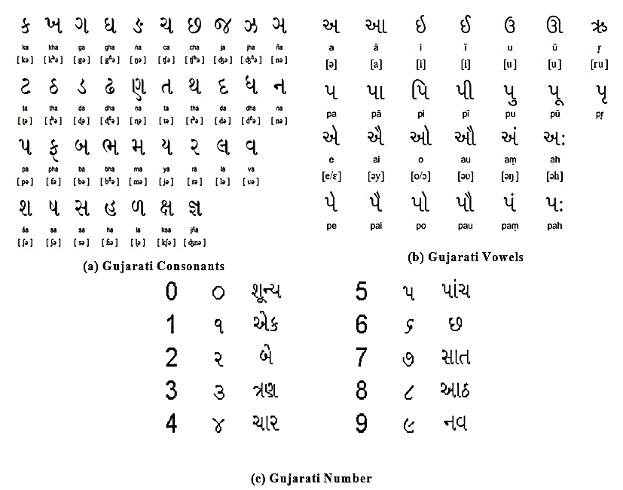

Figure1: (a)-(b) represents Gujarati Text (c) represent Gujarati number
In the realm of image processing, features refer to the unique characteristics or patterns present within an image that convey significant information regarding its structure, visual appearance, and content. The process of feature extraction is essential for the effective analysis and interpretation of images, facilitating various tasks such as object detection, recognition, and classification. Features can be categorized as low-level, which capture fundamental attributes like edges and textures, or high-level, which embody more abstract notions such as shapes or areas of interest. Mathematically, an image can be represented as a two-dimensional function I(x,y), where x and y signify the spatial coordinates (horizontal and vertical positions) of each pixel. The function I(x,y) provides the intensity or color value at each pixel, whether in grayscale or RGB format. The extraction of these features is a critical step in image processing and pattern recognition, aimed at converting raw data into a collection of meaningful attributes or "features." These features encapsulate vital information from the data, including shapes, textures, colors, or patterns, which can be utilized for classification, clustering, and detection tasks. By diminishing the dimensionality of the data, feature extraction streamlines analysis while maintaining the essential characteristics of the data. Mathematically, this process can be represented as a transformation that maps the input data, X, into a feature space, ϕ(X), where each dimension corresponds to a specific feature:
ϕ(X) = {f1(X), f2(X), …, fn(X)} (1)
In this equation, X denotes the original image, ϕ(X) represents the transformed data within the feature space, and fi(X) indicates the i^{th} feature extracted from X.
After feature extraction, when multiple features are combined to represent a data point, we often sum or aggregate individual feature values to form a final feature score or composite feature vector. The approach depends on the specific use case and features involved. Here is a general formula for the final sum of features, where each feature contributes to a cumulative score:
Let: f_{i}(x) represents the i^{th} feature extracted from the data X and $ω_{i }$be the weight assigned to the f_{i}(x), which represents the importance of each feature in the final score.
Then, the final feature score F(X) is given by the weighted sum of all features:

$$F\left(X\right)=\sum_{i=1}^{n}{ωi}f_{i}(x)$$ | (2)
Where n is the total number of features, $ω_{i }f_{i}\left(x\right)$is the weighted contribution of the i^{th} feature of the final score.
F(X) represents the aggregate or cumulative feature score for X. This section provides a comprehensive overview of the proposed framework.
Text feature extraction in image processing is a specialized method focused on identifying, localizing, and extracting textual information from images. This technique is vital for applications such as document digitization, scene text recognition, and image-based language processing. The process of extracting textual features allows computers to comprehend and analyze the content of text embedded within images. This capability is essential for applications such as Optical Character Recognition (OCR), Natural Language Processing(NLP), and automated document analysis. During text feature extraction, images are scrutinized to detect patterns that correspond to individual characters or words, which are subsequently converted into organized text data. In contrast to conventional object recognition, text feature extraction presents distinct challenges, including diverse fonts, backgrounds, orientations, and noise that may obscure the characters. Various methodologies for text feature extraction are outlined below.
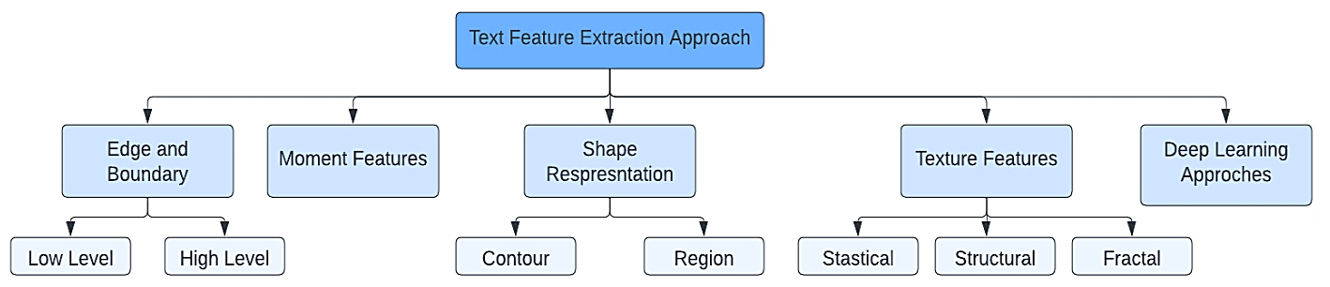

Figure 2: Classification of Text Feature Extraction Approaches

The organization of the paper is as follows: Section 2 provides a review of related work concerning Gujarati text feature extraction techniques. Section 3 details the proposed methodologies. Section 4 showcases experimental results along with a comparative analysis. Finally, Section 5 concludes with a summary of the proposed method and discusses avenues for future research. The necessity for feature extraction methodologies specific to Gujarati text arises from the need to assess the efficacy of the Gujarati OCR Dataset in relation to both documented and handwritten texts sourced from various users.

2. Literature Review
As the volume of digital documents has been increased after COVID, due to which accurate retrieval of meaningful information from those documents is a challenging task. These features capture information about key aspects of the image, making it possible to analyze, interpret, and extract relevant information. Features are essential for tasks such as image recognition, object detection, segmentation, and other forms of image analysis. The Text features in image processing refer to characteristics or attributes related to the textual content present within images. In this research we are focusing on text features, which are essential for optical character recognition (OCR), document analysis, scene text recognition and many more. Below diagram shows the different category of feature extraction techniques.
There are numerous types of text features like OCR Features, Text Region Features, Text Texture Features, Text Layout Features, Text Color features which are designed to handle various challenges associated with recognizing text from scanned documents, images, or other sources. There are many text feature extraction approaches available in Image Processing such as Text Localization, Connected Components, Skeletonization, Bounding Box Coordinates etc. Hong Liang et al [3] has presented exhaustive research work

Extraction Approaches
on different text feature extraction approach using Deep Learning methodologies. S.A. Rajesh et al. [4],[5] & A. O. Salau et al. [33] has discussed various Image processing based features extraction approaches. To process the Gujarati text is a challenging process due to its rich morphology. The researcher Nikita P. Desai et al. [6] considering Gujarati's rich morphology, which causes a single word to have multiple versions making it challenging for Gujarati language. Anardan Bharvad et al [7] has compared various methods Stroke Orientation Estimation Technique, Neural Network, Naive Bayes, Sparse Representation Classifier, Low-level Strokes, Support Vector Machine, Wavelet Features Extraction for recognition of Gujarati handwritten digits. Although the gradient's direction was taken into account as a function vector, the researcher obtained significantly lower accuracy. S. Gautam et al. [8] discussed various approaches for retrieval of documents in Gujarati text. This research paper has also provided an exhaustive literature survey by comparing different text recognition methods, feature extraction approach, feature matching techniques which can be further used for retrieval approaches. K. B. Khushali et al. [9] described different Gujarati text recognition methods, properties for Gujarati script, recognition of printed and handwritten documents. The researchers Jyoti Pareek et al. [10] have proposed a unique method for extracting features from raw character images using the skeletonization concept. The researcher [11] proposed OCR approach for Gujarati handwritten digits and observed that verification of numbers like zero, four and seven, is very high- 98% and for digit six 72% and also stated Gujarati handwritten digit recognition rate is also low as compared to Kannada, Telugu, Tamil and Malayalam. Table 1 presents a summary of the literature pertaining to the research paper, detailing the datasets utilized, the feature extraction methodologies employed and the accuracy achieved.

Table 1: Literature Survey on Gujarati Text Feature
Paper | Dataset | Sample size | Text Feature Extraction Approach | Classification Accuracy
[7] | Gujarati Handwritten Digits | 600 | Matrix Pattern Method | without Skeleton 89.83%, with Skeleton 91.76%
[8] | Handwritten Data | 9318 | HoG and SD | Convolutional Autoencoder  67.95%
[9] | Gujarati Handwritten Text | 22 | Histogram of Oriented Gradient , Chain Code Histogram | SVM -88.4%
[10] | Gujarati Handwritten Text | 10000 | -- | CNN- 97.21%  64.28%
[11] | Gujarati Handwritten Digits | 300 | Pattern Matrix | Feed Forward Back Propagation Neural Network- 81.66%
[12] | Gujarati Handwritten Digits | 5000 | Invariant Moments | Neural Network 80.5%
[13] | Gujarati Handwritten Digits | 600 | Block wise division character | Naive Bayesian model 80.5%
[14] | Gujarati Handwritten Digits | 2500 | Pre trained CNN networks | EfficientNet 96.5%
[15] | Gujarati Handwritten Digits | 14000 | -- | CNN- 99.81%
[16] | Newspaper, articles etc. | 500 | Darknet-53 | FCN
[17] | Gujarati Characters | 6000 | Deep Learning | LSTM-97.00%
[18] | Gujarati Handwritten Text | -- | DNN | Neural Network
[19] | Gujarati Handwritten Text | 30 | Morphological Transformation | K-NN 82.03%
[20] | Gujarati Handwritten Text | 200 | -- | Efficient Det-60%  YOLO-42.64%  FASTER RCNN - 55%
[21] | Gujarati Newspapers Articles | 6558 | -- | 68.17%  EfficientNetB3-99.70%
[22] | Gujarati Handwritten Text | 5980 | -- | CNN- 94.8%
[23] | Online image from internet | -- | -- | k-Nearest Neighbor  67.00%  The Minimum Hamming Distance 39%

Along with this exhaustive literature survey in this section we have discussed about different languages. Ismail Shah et al. [24] represented an approach for word spotting in Gray-scale Pashto Documents which was written in modified Arabic scripts. Features are extracted from gray scale images and then converted to binary feature vectors. The size of the data set is 4200 words. The average precision rate achieved is 94.75 % for an average recall of 60.25%. Kolcz et al.[25] proposed a method to extract Spanish language text from a 13 page long document using Line Oriented Approach. Enver Akbacak et al.[26] has collected 15 images having 2381 English words and obtained single feature using dynamic time warping. Also Yogya Tewari et al. [27] has developed a model that uses CNN to split signs into the appropriate English alphabets in order to translate signs from American Sign Language (ASL) into English letters. Up to 99.78% accuracy was achieved by the model in identifying 26 alphabets and 3 extra characters. Hassan Althobaitim et al. [30] have applied Chain code method on OCR in handwritten Arabic language. The accuracy was 92% to 97% based on character input. On Document Analysis and Recognition (CEDAR) dataset Muhammad Arif Mohamad et al. [31] has applied the Chain Code approach to extract the features and stated this approach takes 1.10 seconds to solve the entire set of character images.
Researcher Mohamed fakir et al. [28] has mentioned that exhaustive work has been done for various Indian languages like Hindi, Kannada, Tamil, Bangala, Malayalam, Gurumukhi. In total out of 7000 languages recognized around the world, English 38%, Chinese 33%, other regional language constitute only 2%. Regional language like ‘Gujarati’ which is spoken by more than 66 million people is the 26th most widely spoken language in the world and only 2% research has been accomplished as per literature.
2.1 Motivation and Problem Definition:
The development of Gujarati-specific text feature extraction approach would address the below mentioned challenges by leveraging modern techniques, such as deep learning and Image processing algorithms, to handle script-specific complexities, noisy data, and diverse text styles. Such an approach would not only enhance the accuracy of text recognition systems for Gujarati but also contribute to the broader goal of making regional language data accessible and usable in the digital age. Numerous research gaps have been identified from the literature [7]-[23] regarding text feature extraction methodologies over Deep Learning and Image processing concepts. The literature has revealed certain research gaps, and the proposed solutions are outlined in the table below.

Table 2: Detailed analysis of research gaps with respect to proposed work

Research Gap | Underlying Issues | Proposed Solution
Dataset utilization [7]-[23] | Existing major research work as mentioned in [7]-[23] done under the Gujarati digits and limited to Guajarati text. | Worked over Guajarati OCR text dataset with 23100 samples of text variations
Lack of Explainability [14]-[22] | in Deep learning models often operate as black boxes, making it difficult to understand how features are extracted and why certain errors occur. | Incorporating explainability techniques we have provided our proposed solution with details text feature values and presented in the table and the graphical manner.
Computational Efficiency [14]-[22] | Deep learning models for text feature extraction are often resource-intensive, making them impractical for deployment on edge devices. | Image processing models doesn’t required high computational devices for the feature extraction process
Generalization Across Languages [24]-[28],[30]-[31] | Existing Deep models are often trained on datasets from high-resource languages (like English) and may not generalize well to low-resource or complex scripts (e.g., Gujarati, Devanagari, Arabic, etc.). | Creating Gujarati language-agnostic text feature extraction frameworks that adapt to a wide variety of scripts and styles.
Complex Fonts and Handwritten Text [7]-[23] | Extracting features from Gujarati handwritten or stylized text remains a challenge due to the variability in character shapes, spacing, and strokes. | Developed image processing approaches those able to identify the 60 augmented variations of single alphabet from 385 classes.
Text Feature Extraction for Non-Latin Scripts [24]-[28],[30]-[31] | A lack of publicly available datasets and models optimized for non-Latin scripts (e.g., Gujarati, Tamil, Chinese) limits research in this area. | Curating diverse, open-source datasets for Gujarati languages and designing script-specific feature extraction pipelines.
Multi-modal Feature Integration [7]-[28],[30]-[31] | Current text feature extraction methods focus only on single feature values not on composite feature values. | We have proposed the fusion approach which successfully able to extract the fusion features.

Unique contribution for underlying issues and challenges:
1. We introduce an innovative Shape Numeric Encoding Approach (ISNEA) that creates a pixel-level representation of the shape of text images, with a particular emphasis on their boundaries. These numerical representations are compiled as features which will be unique length of each feature, resulting in a detailed feature vector that is integrated into the Gujarati text feature vector dictionary. This technique effectively captures the shape characteristics of the text in a numerical format.
2. In addition, we propose the One-Bit Frequency Count Approach (OBFCA), which aims to extract the central axis of the text by employing morphological operations, thereby producing a thin boundary representation. Once this thin boundary image is generated, it is converted into a character array to obtain the numerical values of the grayscale image. This grayscale character array is then transformed into a binary character array through pixel value substitution. In the concluding phase, we calculate the frequencies of 1’s in a row-wise manner for a 32x32 image, with the cumulative frequency recorded as a feature vector in the Gujarati text feature vector dictionary.
3. We also proposed the third approach, in which we advance the framework for regional analysis by incorporating connected components to determine the number of regions within the text. We extract geometric features from these text regions, which are subsequently categorized into distinct features and combined features.
4. We perform comparative experiments to evaluate the efficacy of the proposed framework utilizing the Gujarati OCR dataset, comparing it against both existing and cutting-edge methodologies.
3 Proposed Approaches for Text Feature Extraction:
This research was undertaken to develop a feature vector dictionary. Our subsequent objective is to expand this investigation by integrating it with content obtained from video frames. Following the extraction of Gujarati text features, these will be evaluated against our proposed Gujarati text feature vector dictionary. Additionally, training convolutional neural networks (CNNs) requires both hardware support and considerable time investment to effectively process the text features. Currently, we have not employed state-of-the-art techniques in this research endeavor. However, we have conducted comparisons between the proposed methods and those based on CNN and long short-term memory (LSTM) architectures in the experimental section. The basic architecture of the proposed system is shown in the below given image.
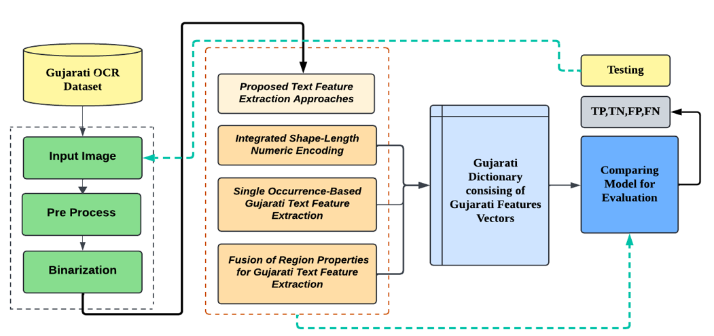
Figure 3: Proposed Workflow for Text Feature Extraction Approach

The system's architecture is organized into three distinct stages: (i) Preprocessing and Binarization, (ii) Extraction of text features utilizing the proposed methodologies, and (iii) Storage of the extracted features in a Gujarati feature vector dictionary. In the first stage, input text images undergo a Binarization process. The outcomes of this initial stage are visually represented in Fig. 4. The second stage focuses on the extraction of shape, boundary, and geometric features specific to Gujarati text, with the results depicted in Figs. 5, 6, and 9. The feature vector dictionary will be formatted numerically, and the visual representation of the third stage is presented in Fig. 9.
3.1 Integrated Shape Numeric Encoding Approach (ISNEA):
The morphological richness of the Gujarati language contributes to a high complexity in its textual structure. As a result, the tasks of processing and feature extraction are notably challenging. This section will address the first proposed approach, which aims to extract shape features from Gujarati text through a numerical encoding method. A detailed block diagram outlining the proposed methodology is displayed below.
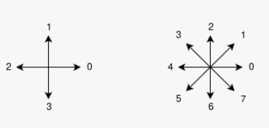
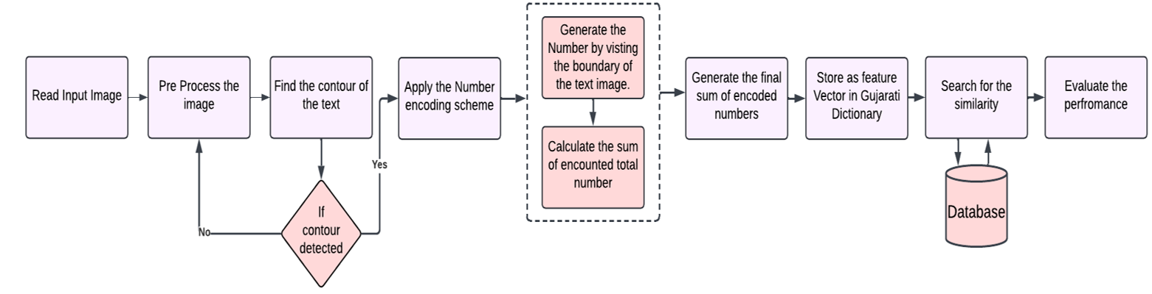
Figure 4: Proposed Detailed Diagram on Integrated Shape Numeric Encoding Approach (ISNEA)

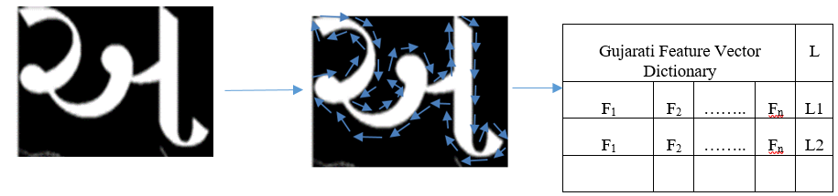
Figure 5: Numeric Encoding Feature for Gujarati Alphabet ‘Aa’

As we can see in the above figure by using the Number coding scheme we have labeled the boundary of the text ‘Aa’ based on the arrow direction. The overall sum will be calculated as feature vector and will be stored in the Gujarati Feature vector dictionary. This entire process has been discussed in the below algorithm.
Algorithm 1 Integrated Shape Numeric Encoding Approach (ISNEA) to Extract Gujarati Text Features
Input: Different Gujarati text images
Output: Extract the Gujarati text features and generate the feature vector file.
Procedure:
1: Preprocess the input image
2: Find the contour of the image:
If no contour present, then Go Step:1
Otherwise
Generate the Number Encoding by using following process:
- Select first contour
C={(x_{0,}y₀),(x_{1,}y₁),……(x_{n,}y_{n})} (3)
be the ordered set of boundary pixels along the contour of a region.
The Numeric Encoding NC for this contour can be represented as:
NC_{i}={nc_{0,}nc_{1,}nc_{2….}nc_{n-1}} (4)
Where each nc_{i} is determined by:
d_{i=}direction(x_{i,}y_{i})→(x_{i+1,}y_{i+1}))
3: For a pair of consecutive contour points (x_{i,} y_{i}) and (x_{i+1,} y_{i+1})
- Compute the relative position:
- $∆_{X}=x_{i+1}-x_{i}$ (5)
- $∆_{y}=y_{i+1}-y_{i}$ (6)
Use the relative position to assign the direction code d_{i} based on the direction table above.
- For example, if Δx=1 and Δy=0, the movement is to the right (numeric encoding 0), if Δx=-1 and Δy=-1, the movement is down-left (numeric encoding 5)
- Traverse along with the boundary of the text over the entire image
4: Generate the final feature score or composite feature vector as mentioned in equ.(2)
5: Store the feature vector in the Gujarati Dictionary files.
6: Search for similar Feature Vector.
7: Calculate the performance of the proposed system.

The numeric Encoding is presented in the below table where NC3 is numeric value for image 3, NC14 for the image 14 and so on. Alongside L is the overall length of the features together and stored in Gujarati dictionary for the matching criteria

Table 3: Feature set of Numeric Encoding Approach

NC | F1 | F2 | F3 | F4 | F5 | F6 | F7 | F8 | F9 | F10 | F11 | F12 | F13 | F14 | F15 | F16 | F17 | F18 | F19 | F20 | F21 | F22 | L
NC3 | 7 | 7 | 0 | 6 | 7 | 7 | 5 | 5 | 6 | 5 | 6 | 4 | 4 | 5 | 1 | 1 | 1 | 0 | 3 | 3 | 2 |  | 85
NC14 | 7 | 0 | 7 | 0 | 0 | 6 | 7 | 5 | 5 | 6 | 4 | 1 | 3 | 4 | 3 |  |  |  |  |  |  |  | 58
NC29 | 7 | 7 | 7 | 0 | 7 | 0 | 6 | 7 | 7 | 5 | 5 | 6 | 5 | 6 | 4 | 5 | 2 | 1 | 1 | 0 | 4 | 3 | 95
NC58 | 1 | 2 | 0 | 1 | 7 | 0 | 7 | 5 | 5 | 6 | 4 | 4 | 5 | 3 | 4 | 3 | 4 | 3 | 2 | 3 | 2 | 3 | 74
NC60 | 7 | 0 | 7 | 0 | 7 | 0 | 6 | 7 | 7 | 5 | 5 | 6 | 5 | 6 | 4 | 2 | 1 | 1 | 0 | 3 | 3 |  | 82
NC70 | 7 | 7 | 7 | 1 | 7 | 0 | 6 | 7 | 7 | 5 | 5 | 6 | 5 | 7 | 4 | 2 | 1 | 1 | 1 | 3 | 3 |  | 92

This method encounters difficulties when the text encompasses multiple regions, as illustrated in Figure 8. In these instances, the approach is unable to produce a comprehensive numerical encoding for the input text image. To address these challenges, we have proposed new methodology, which will be detailed in the subsequent sections.
3.2 One-Bit Frequency Count Approach (OBFCA):
This method is dividing into three stages. Stage-I generating the thin boundary of the input image, stage-II generating the char array of the thin boundary image and stage-III store char array as feature vector in Guajarati Text dictionary. The proposed detailed diagram is shown in Fig. 6.
Stage-II
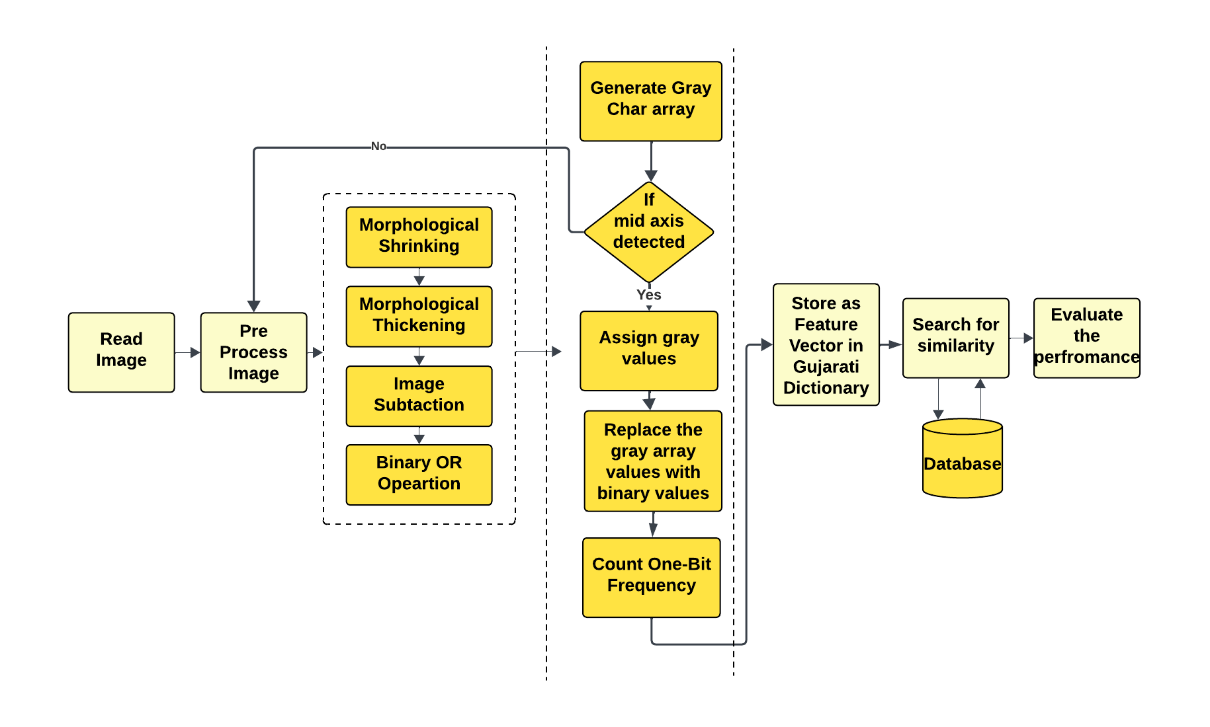
Stage-III
Stage-I

Figure 6: Proposed Detailed Diagram for One-Bit Frequency Count Approach (OBFCA)
The detailed explanation of the proposed approach is mentioned below.

Algorithm 2 One-Bit Frequency Count Approach (OBFCA)
Input: Different Gujarati text images
Output: Extract the Gujarati text features and generate the feature vector file.
Procedure:
1: Preprocess the input image
2: Declare the structuring element by using the following process:
- Structuring element S is defined as binary matrix with a specified origin that act as a reference point. Let:
- S⸦Z² represent the set of coordinates of the structuring element in a 2D space.
- (x_{s,}y_{s})ϵ S denote the coordinates of a point within the structuring element.
- O=(x_{0,}y₀) denote the origin point within S.
The structuring element can then be defined as:
S={(x_{s,}y_{s})|(x_{s,}y_{s})ϵZ²,S(x_{s,}y_{s})=1} (8)
Where:
S(x_{s,}y_{s})=1 indicates that the point (x_{s,}y_{s}) is part of the structuring element. S(x_{s,}y_{s})=0 means it is not part of the structuring element and thus ignored during the morphological operation. For this research work we have used the eclipse based structuring element E with centered at the origin (0,0) and set of points (x,y) can be presented using following equation:
E={(x,y)|$\frac{ x^{2}}{a^{2}}$+$\frac{ y^{2}}{a^{2}}≤1$} (9)
where each point (x,y) within the structuring element matrix E contributes to the morphological operation.
3: To get the mid axis of the Gujarati text by using following process:
- I represent the binary input image, where foreground pixels have a value of 1, and background pixels have a value of 0.
- S be the eclipse structuring element used for shrinking mentioned in equ.(9) typically has a centre as origin.
- Apply Morphological shrinking by using following formula:
$I_{k+1}$=($I_{k}⊖S)∪(I∩δ)$ (10)
Where $I_{k}$ represents the image at the K^{th} iteration of shrinking and $δ$ is a set of anchor points (or key points) that ensure that certain critical pixels remain unaffected, preserving the structure. The operation I_{k+1} performs shrinking and then restores some specific pixels (defined by δ) to prevent complete removal of objects.
- Apply Morphological Thickening on the Eroded image using following:
$(I⊕S)(x,y)=\max_{(u,v)∈S}I(x-u,y-v)$
(11)
- Perform subtraction between two resultant images.
$I_{diff}$(x,y)=|I_{1(x,y)}-I_{1(x,y)}| (12)
- $I_{diff}$(x,y) is the absolute difference between corresponding pixels in I₁ ​ and I₂​, ensuring all values are non-negative.
- Apply Binary_OR operation on the subtracted image.
3: Input the subtracted image and convert to gray image.
4: Find the contour of the image using equ. (6) & (7)
- Iterate over contours and draw bounding boxes.
5: Generate the gray char array by following:
- If the text boundary (mid axis) is present, then assigned gray value.
- If not text boundary (mid axis) is not present, then assigned 0 value.
6: In the data frame replace all the 255 with value 1.
7: Iterate over columns and replace zeros with NaN.
8: Count the number of occurrences of '1' in each row.
9: Store as composite feature in Gujarati text feature dictionary.
10: Search for similar Feature Vector.
11: Calculate the performance of the proposed system
In the proposed study, the generated character array will have all pixel values ranging from 0 to 255 replaced with 1, while the remaining values will be set to 0. This results in a binary character array. Upon zooming out of the character array, it becomes evident that figure b illustrates the shape of the Gujarati text 'Aa'. This process has been applied to all 23,100 images, converting them from grayscale values to binary values to obtain the final count. Therefore, our proposed method effectively extracts the slender shape of the Gujarati text, as demonstrated in the image below.

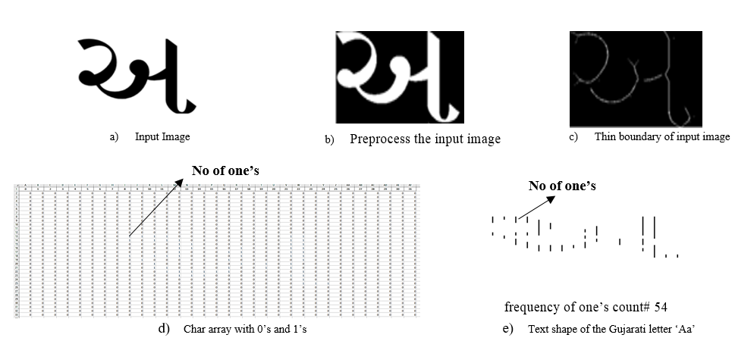
Figure 7: Resultant image of Fusion of Region Geometric Features (See the results from left to right)

The experiment was conducted on 23100 images and extracted features labelled as 1(1),1(2) and 1(60) as discussed single alphabet is having 60 variations. Wherever the boundary or the mid axis is present it will assign values from 1-255 and rest will be assigned as 0. In the below table six samples of the images shown where row-1 belongs to 1(1), row-2 belongs to 1(2) and so on. This table represents the features of the 1st six images 1(1)-1(6) of alphabet ‘Aa’.

Table 4: Feature set of One-Bit Frequency Count Approach

F1 | F2 | F3 | F4 | F5 | F6 | F7 | F8 | F9 | F10 | F11 | F12 | F13 | F14 | F15 | F16 | F17 | F18 | F19 | F20 | F21 | F22 | F23 | F24 | F25 | F26 | F27 | F28 | F29 | F30 | F31 | F32
0 | 0 | 0 | 0 | 0 | 0 | 0 | 0 | 0 | 0 | 0 | 6 | 6 | 4 | 5 | 5 | 7 | 3 | 4 | 5 | 7 | 5 | 1 | 3 | 0 | 0 | 0 | 0 | 0 | 0 | 0 | 0
0 | 0 | 0 | 0 | 0 | 0 | 0 | 0 | 0 | 0 | 0 | 0 | 0 | 4 | 2 | 3 | 3 | 6 | 6 | 4 | 4 | 1 | 2 | 0 | 0 | 0 | 0 | 0 | 0 | 0 | 0 | 0
0 | 0 | 0 | 0 | 0 | 0 | 0 | 0 | 0 | 0 | 0 | 0 | 0 | 3 | 4 | 4 | 6 | 7 | 5 | 5 | 6 | 2 | 3 | 0 | 0 | 0 | 0 | 0 | 0 | 0 | 0 | 0
0 | 0 | 0 | 0 | 0 | 0 | 0 | 0 | 0 | 0 | 0 | 4 | 4 | 4 | 5 | 6 | 6 | 6 | 9 | 1 | 3 | 0 | 0 | 0 | 0 | 0 | 0 | 0 | 0 | 0 | 0 | 0
0 | 0 | 0 | 0 | 0 | 0 | 0 | 0 | 0 | 0 | 0 | 6 | 5 | 4 | 5 | 4 | 7 | 2 | 4 | 5 | 7 | 5 | 1 | 3 | 0 | 0 | 0 | 0 | 0 | 0 | 0 | 0
0 | 0 | 0 | 0 | 0 | 0 | 0 | 0 | 0 | 0 | 0 | 3 | 4 | 2 | 5 | 5 | 6 | 5 | 6 | 5 | 4 | 5 | 2 | 2 | 2 | 0 | 0 | 0 | 0 | 0 | 0 | 0

The experimental results will be discussing in the result analysis section.
3.3 Fusion of Region Geometric Features (FRGF):
In the context of image processing, the term "region" typically denotes a connected and coherent segment within an image that exhibits similar characteristics, such as intensity or color. When referring to text within images, a text region specifically indicates an area where text is located. These text regions play a crucial role in tasks such as text detection and recognition in the field of computer vision. Text detection represents the preliminary phase in which text is identified within the image; once these text regions are recognized, they are frequently classified as Regions of Interest (ROIs). Optical Character Recognition (OCR) algorithms can then be utilized to identify and extract the actual textual content from these designated areas. In this study, we have examined 23,100 samples of Gujarati text and identified the corresponding text regions. Additionally, we have further categorized the images into various regions. The accompanying image illustrates the different regions associated with the alphabet 'Aa'.

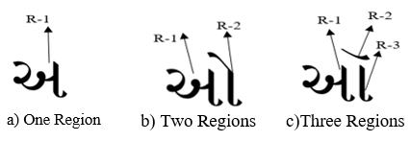
Figure 8: Region Representation of Gujarati Text

We have similarly identified all regions within the Gujarati text images. Various geometric characteristics will be analyzed, including area, centroid, eccentricity, perimeter, and length. For the purposes of this experiment, we have excluded the Bounding Box, as the text size is consistently 32x32, resulting in no distinctiveness across all 23,100 samples. In contrast, the remaining five geometric features exhibited unique values, and a composite feature has also been generated and recorded in the Gujarati text feature vector dictionary shown below.
A detailed illustration of this process is provided in the diagram below.

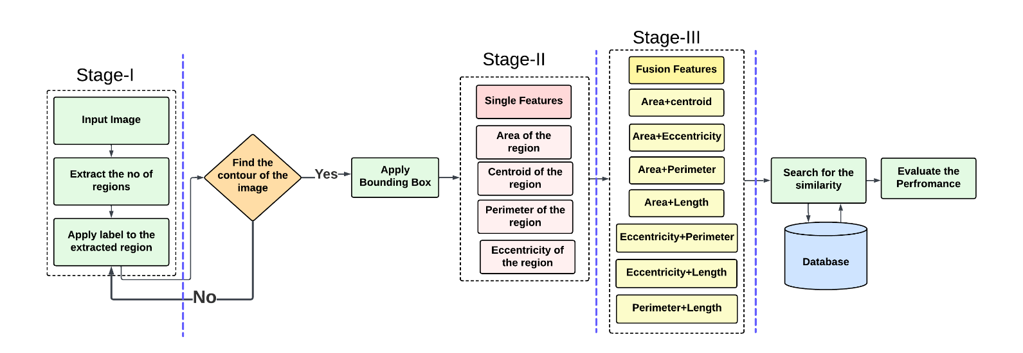

Figure 9: Detailed Proposed Diagram for Fusion of Region Geometric Features (FRGF)

Algorithm 3 Fusion of Region Geometric Features (FRGF)
Input: Different Gujarati text images
Output: Extract the Gujarati text features and generate the feature vector file.
Procedure:
1: Convert input image to binary image
2: Extract the number of regions from the text by using the following process:
I(x,y)be a binary image of size where:
- I(x,y)= 1 indicates foreground pixels (text).
- I(x,y)= 0 represents background pixels.
2.1: Apply the label to the extracted regions:
- Traverse each pixel I(x,y) in the binary image.
- For each unvisited foreground pixel I(x,y)= 1, initiate a new region.
- Recursively or iteratively label all connected pixels with the same label until the entire connected region is covered.
2.2: Counting Regions: Let 𝐿 be the labelled image where each connected region has a unique label.
- The total number of distinct labels 𝑛 in 𝐿, excluding the background label, represents the number of regions in the text mentioned in Fig.8.
So mathematically entire process will be described as: Let R_{K} be the k^{th} connected region in L, where k=1,2,3…..n. Then, the number of regions N can be represented as:
$$N=\sum_{k=1}^{n}{δ(R_{k}} )$$
(13)
Where $δ(R_{K}$) =1 for each unique connected region $R_{K}$​, and n is the number of distinct labels in L.
3: Find the contour of the image equ. (6) & (7):
- If text is present:
Iterate over contours and draw bounding boxes
else
return to the step 3
4: Generate the region properties:
- Calculate the area of the region: The area of a region is its total number of pixels. Where N and M are the dimensions of the image, and R(i,j) is the binary value (1 for the region, 0 for the background) at pixel (i,j).
- Centroid: It is the average location of all its pixels, is its center of mass. The coordinates of the pixels in a binary image, where a region is represented by a group of connected pixels, can be used to determine the centroid. In terms of math, the centroid is calculated as:
$Cx=\frac{1}{A}∑i∑j .x_{ij}$ (14)
- A region's eccentricity can be used to gauge its length. A perfect circle is delimited by a value of 0, but longer forms are represented by larger values. For a binary image, where a region is represented by a set of connected pixels, the eccentricity can be computed using the second central moments of the region. The eccentricity (e) is defined as:
$e=\sqrt{1-\frac{b^{2}}{a^{2}}}$ (15)
Where (a) is the length of the major axis and (b) is the length of the minor axis.
- Perimeter: It is the length of a region's border. It offers details on the object's intricacy and form.
$$p=\sum_{i=1}^{N}{X}\sqrt{{\left(x_{i}-x_{i-1}\right)}^{2}+{\left(y_{i}-y_{i}-1\right)}^{2}}$$
(16)
Length of the region
5: Store the extracted single features in the Gujarati text feature vector dictionary.
6: Combined the single features and generate the fusion features and stores in Gujarati text feature vector dictionary
7: Search for similar Feature Vector.
8: Calculate the performance of the proposed system

The experiment was conducted over 23100 images. The generated single features sets and fusion feature set of Image ‘Aa’ is generated successfully. Few feature set’s values can be seen in the below table
Table 5: Single Feature set representation (A=Area, C1and C2= Centroid, ECC=Eccentricity, PERI=Perimeter, LEN=length)

Image | A | C1 | C2 | ECC | PERI | LEN
1 (1).jpg | 949 | 15.4056902 | 15.45626976 | 0.117048599 | 218.4264069 | 38.18307376
1 (2).jpg | 989 | 15.43781598 | 15.4479272 | 0.053172565 | 184.6984848 | 37.52549141
1 (3).jpg | 965 | 15.38756477 | 15.37202073 | 0.103694798 | 190.5269119 | 37.94583387
1 (4).jpg | 946 | 15.51162791 | 15.52854123 | 0.155878798 | 207.491378 | 38.32901689
1 (5).jpg | 952 | 15.40336134 | 15.82983193 | 0.166707461 | 219.0121933 | 38.10294285

Also we have extracted fusion features which has been presented in the below table.

Table 6: Fusion feature set representation (ARCE= Area +Centroid, AREC= Area+ Eccentricity, ARPE=Area + Perimeter, ARLE=Area + Length, ECPE=Eccentricity + Perimeter, ECLE=Eccentricity + Length, PELN=Perimeter + Length)

Image | ARCE | AREC | ARPE | ARLE | ECPE | ECLE | PELN
1 (1).jpg | 979.86196 | 949.1170486 | 1167.426407 | 987.1830738 | 218.5434555 | 38.30012236 | 256.6094806
1 (2).jpg | 1019.885743 | 989.0531726 | 1173.698485 | 1026.525491 | 184.7516574 | 37.57866398 | 222.2239762
1 (3).jpg | 995.7595855 | 965.1036948 | 1155.526912 | 1002.945834 | 190.6306067 | 38.04952867 | 228.4727458
1 (4).jpg | 977.0401691 | 946.1558788 | 1153.491378 | 984.3290169 | 207.6472568 | 38.48489569 | 245.8203949
1 (5).jpg | 983.2331933 | 952.1667075 | 1171.012193 | 990.1029429 | 219.1789008 | 38.26965031 | 257.1151362

4. Experiments and result discussion
The literature indicates that the complexity and lack of available datasets for the Gujarati language necessitated the creation of a major dataset through the collection of handwritten documents from users, which encompass both numbers and letters. In this study, we utilized the Gujarati OCR dataset and introduced three distinct techniques for text feature extraction. The Gujarati language dataset has been previously addressed in the literature review, as shown in Table-1 [7] - [23]. Consequently, it is essential to employ statistical evaluation to accurately assess the performance of the proposed methods. The effectiveness of the proposed approach is tested on the Gujarati OCR dataset, and its performance is compared with that of leading methods using established performance metrics.
4.1 Datasets description
The proposed study is assessed using two distinct datasets. Dataset-1 comprises images of 77 Gujarati alphabets that were randomly sourced from the internet. Dataset-2 refers to the Gujarati OCR dataset introduced by Anand R et al. [34]. This dataset includes images rendered in the "Shruti" font style, featuring a font size of 12 and various stylistic variations, specifically tailored for the Gujarati language. The images are presented in RGB format. The collection encompasses 34 characters of the Gujarati language along with 11 variants of modifiers (Maatra), resulting in a total of 374 unique characters and 11 distinct vowels, culminating in 385 characters overall. To ensure consistency, all images are standardized to a size of 32x32 pixels. Additionally, the dataset undergoes image augmentation techniques, including horizontal and vertical shifts, zooming, rotation, and brightness adjustments, to create further variations for each character. Each class contains a total of 60 samples. The following table provides a detailed analysis of the dataset utilized for the three proposed approaches: ISNEA, OBFCA, and FRGF, both as individual features and in fusion.
Table 7: Description of the Gujarat Text Dataset

 | Dataset-1 | Datset-2
Dataset | Randomly collected from the internet | Gujarati OCR Dataset
Size of the Text Image | 200x200 | 32x32
Augmented Text | 0 | 60
Total no of alphabets collection | Consonant-33, Vowel-14, Matra’s-20, Numbers-10 | 385 (Consonant + Vowels + Marta's with all the combinations)
Total no of final samples | 77 samples | 23100 samples

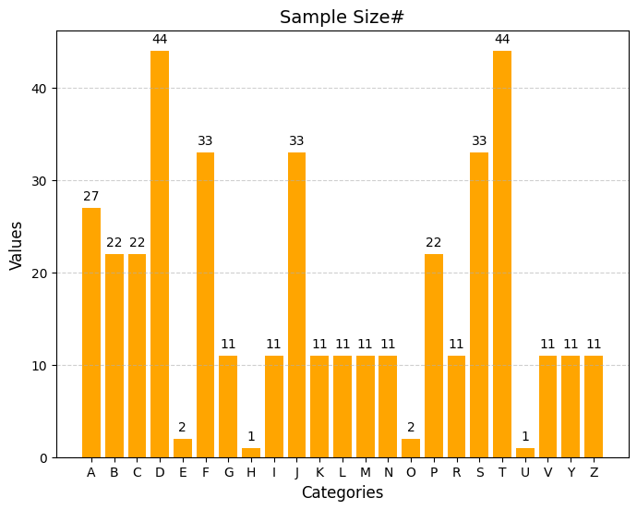
Figure 11: Graphical Presentation of total no of samples in each alphabets

4.2 Effectiveness of the proposed model
This study is based on the principle of extracting Gujarati text features whenever they are present in an image or video frame. This section presents the experimental results, which are quantitatively assessed based on the available Gujarati text, to demonstrate the efficacy of the proposed method. A quantitative analysis of the proposed work is discussed in this section.
4.2.1 Quantitative Results
This section presents a quantitative analysis of the proposed methodology. The experiments are carried out using Gujarati OCR datasets, as outlined in Section 4.1, to evaluate the effectiveness of the proposed approach. The accuracy of the text feature extraction model is assessed through six statistical measures. Positive Predictive Value evaluates the correctly identified text features, while Recall assesses the model's capability to accurately identify all relevant features or terms within a text. Specifically, the false negative rate (FNR) refers to the incorrect identification or extraction of features that are not present in the text. The false positive rate (FPR) is utilized for keyword extraction, occurring when the model mistakenly identifies a feature that does not exist in the text or misclassifies a non-target as a target. True negatives represent instances where the model accurately recognizes the absence of a specific feature. The F1 Score, which is the harmonic mean of precision and recall, ranges from 0 to 1, with 1 indicating perfect precision and recall, and 0 reflecting poor performance in one or both metrics. Lastly, the percentage of correct classification (PCC) serves as a crucial evaluation metric, measuring the overall effectiveness of the model in accurately identifying text features. In the context of text feature extraction, PCC quantifies the proportion of instances (such as words, phrases, or documents) that the model correctly classifies as belonging to a specific category or possessing a particular feature, such as a keyword.

$$Recall=\frac{tp}{tp+fn}$$ | (17)
$$Positive Predictive Value (PPV)=\frac{tp}{tp+fn}$$ | (18)
$$FPR=\frac{fp}{fp+tn}$$ | (19)
$$FNR=\frac{fn}{tp+fn}$$ | (20)
$$F-1 Score=2 ×\frac{Precision × Recall}{Precision × Recall}$$ | (21)
$$PCC=\frac{tp+tn}{tp+fp+tn+fn}$$ | (22)

The objective of the proposal is to identify and recognize OCR Gujarati text through various image processing techniques. The features extracted were compiled into a Gujarati Text Feature Vector Dictionary, which served as the basis for conducting search and matching operations. For the purposes of this experiment, a random selection of 1,000 samples was utilized.

4.2.2 Discussion on Proposed Work Quantitative Results and text feature set values
The proposed technique, ISNEA, has been developed utilizing the Numeric Encoding Scheme, resulting in the generation of text features. When evaluating randomly selected alphabets from the internet, the accuracy achieved was relatively low at 57.18%. This diminished accuracy can be attributed to variations in color, texture, and the overall quality of the text images. In contrast, the OCR Gujarati dataset, which included various modifications, yielded a significantly higher accuracy of 87.50% PPC. The feature set values for 60 images are illustrated below, with the horizontal axis representing the number of images and the vertical axis displaying the feature vector score. The maximum value recorded is 279, indicating that a single text can exhibit numerous variations in terms of direction. The length features derived from the ISNEA approach have been successfully generated for 23,100 samples and are plotted for 60 samples of individual Gujarati text images in the graph provided below.
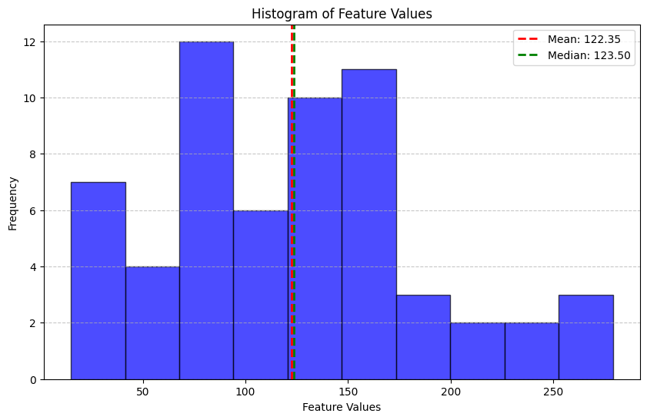
Figure 12: Single ISNEA feature set values (n=60)

The analysis of the graph indicates that the feature values exhibit significant divergence within the range of 10 to 279. The second method, OBFCA, involves extracting the central axis of the image through the application of various morphological operations. Subsequently, the proposed solution is implemented on the resulting image by creating a gray character array, which is then converted into a binary character array, as outlined in the proposed algorithm. Finally, the frequency of 1's is counted on a row-wise basis and stored as features in a dictionary. The calculated PCC yielded a matching accuracy of 90.00%. Consequently, the performance of the proposed method improved by 0.3% in comparison to the initial approach. The composite features derived from OBFCA were successfully calculated and are illustrated in the graph presented in Figure 12 below.
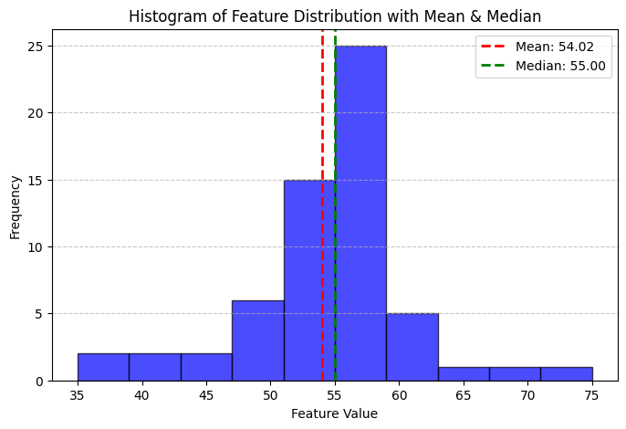
Figure 13: Single OBFCA feature set values (n=60)
From the above graph we can identify the feature are classifying between the range of 40 – 70.

The third approach is Fusion of Region Geometric Features (FRGF) in which geometric features like area, perimeter, length and eccentricity are generated for 23100 samples. In the FRGF concept initially we have stored all the single features in the same Gujarati Dictionary file due to which the overall accuracy was 69.24%. The reason for the low accuracy is many single features comprising of the equivalent values. For the proposed work the single features are combine together to generate fusion features. All the single as well as fusion feature set values will be stored in different Gujarati text feature vector dictionary. The feature set values of all the features are represented in the below graphs.

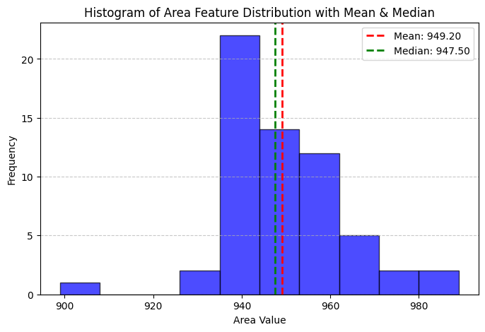 | 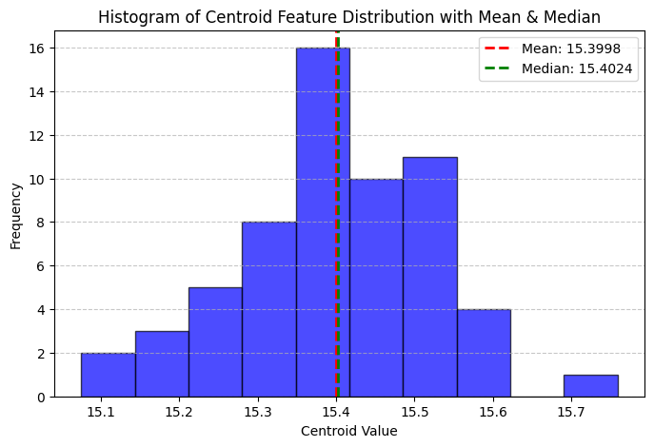
Figure 14: Area feature set values (n=60) | Figure 15: Centroid feature set values (n=60)
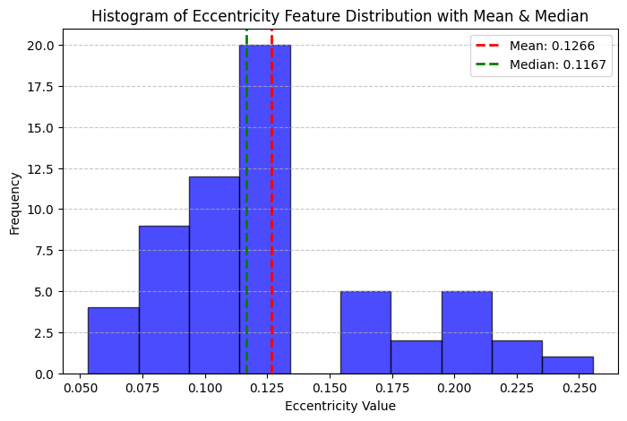 | 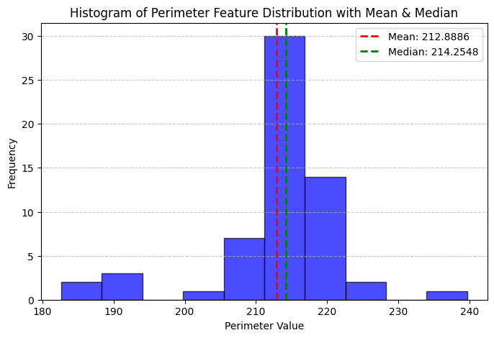
Figure 16: Eccentricity feature set values (n=60) | Figure 17: Perimeter feature set values (n=60)
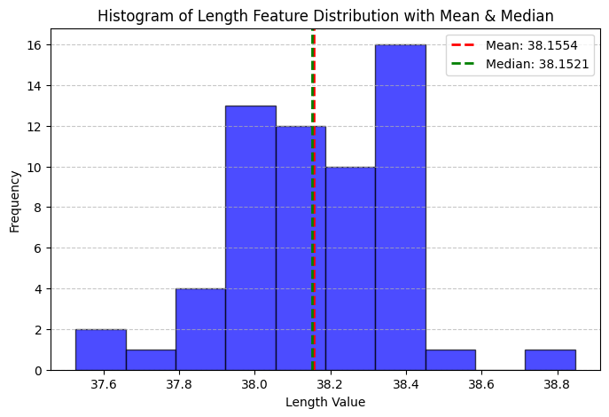
Figure 18: length feature set values (n=60)

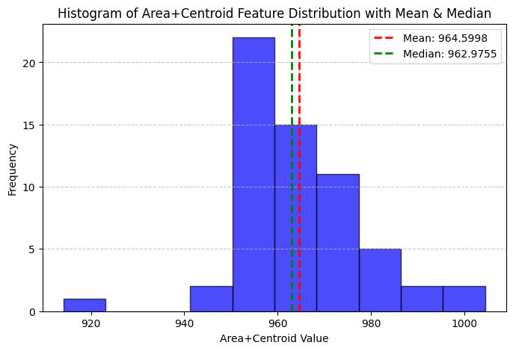 | 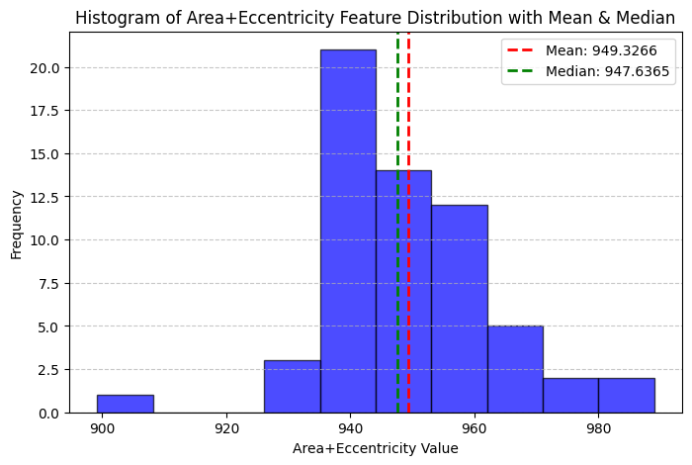
Figure 19: ARCE fusion feature set values (n=60) | Figure 20: AREC fusion feature set values (n=60)
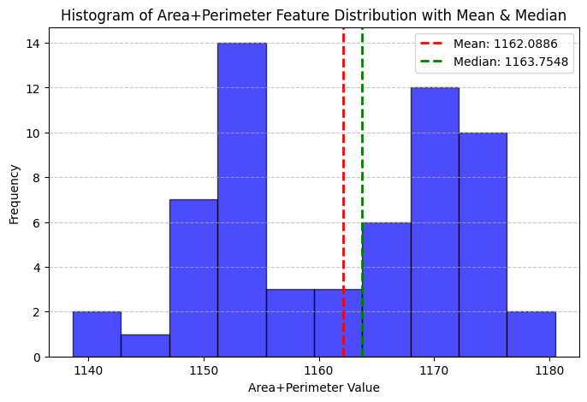 | 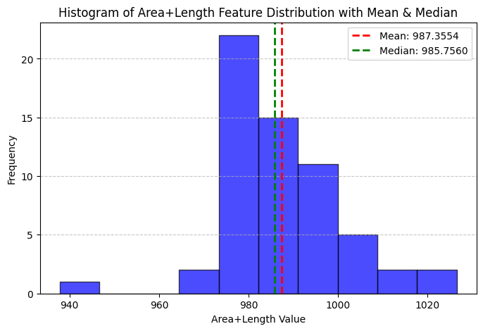
Figure 21: ARPE fusion feature set values (n=60) | Figure 22: ARLE fusion feature set values (n=60)
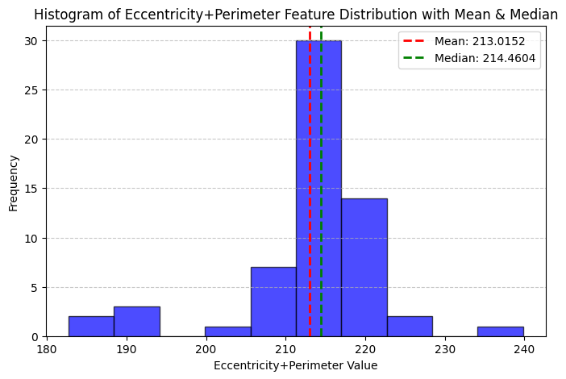 | 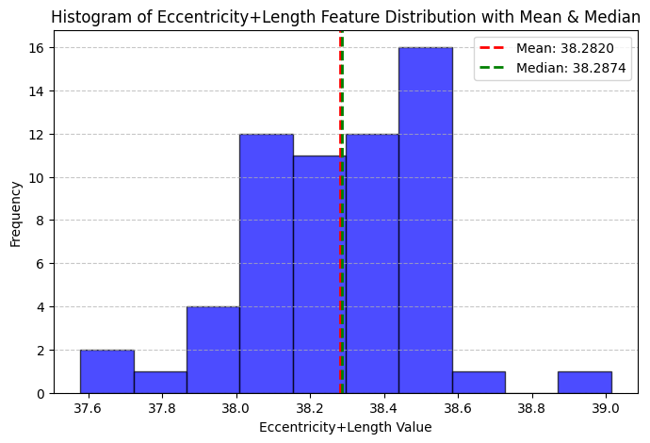
Figure 23: ECPE fusion feature set values (n=60) | Figure 24: ECLE fusion feature set values (n=60)
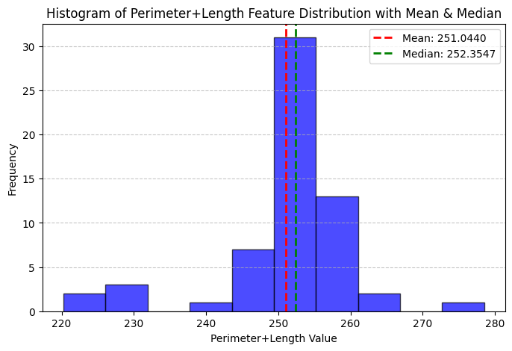
Figure 25: PELE fusion feature set values (n=60)

The above 12 graphs showing the feature set values of 60 samples from 23100 samples. In the single feature Eccentricity with 93.50% and in fusion Eccentricity with perimeter ECPE with 92.75% gives the best performance. From the analysis we can say that the third approach is performing well as compare to first two approaches. The proposed method successfully able to generate the Gujarati text features, also able to identify correct the text feature and classify the text feature based on the shape, region of the Gujarati text.
Table 8: Statistical feature mean and median values of text feature extraction approaches
Approaches | Mean | Median
ISNEA | 122.35 | 123.5
OBFCA | 54.02 | 55
Area | 949.2 | 947.5
Centroid | 15.3998 | 15.4024
Eccentricity | 0.1266 | 0.1167
Perimeter | 212.8886 | 214.2548
Length | 38.1554 | 38.1521
ARCE | 964.5998 | 962.9755
AREC | 949.3266 | 947.6365
ARPE | 1162.0886 | 1163.7548
ARLE | 987.3554 | 985.756
ECLE | 38.282 | 38.2874
ECPE | 213.0152 | 214.4604
PELE | 251.044 | 252.3547

The table provides a comparative examination of the Mean and Median values associated with various feature extraction techniques utilized in the study. The ISNEA and OBFCA methods exhibit mean values of 122.35 and 54.02, respectively, with slightly elevated median values of 123.5 and 55, which indicates a minor variation in their distributions. In the context of geometric features, the Area demonstrates a mean of 949.2, which is closely matched by its median of 947.5, implying a well-balanced distribution. The Centroid values reveal minimal variation, with a mean of 15.3998 and a median of 15.4024. Likewise, Eccentricity, which quantifies shape elongation, presents a low mean of 0.1266 and a median of 0.1167, indicating slight variability. For Perimeter and Length, the mean values (212.8886 and 38.1554) are in close proximity to their respective medians (214.2548 and 38.1521), suggesting that the distributions are nearly symmetrical. The ARCE and AREC methods yield similar mean values (964.5998 and 949.3266) alongside corresponding medians (962.9755 and 947.6365). The ARPE and ARLE methods report the highest mean values (1162.0886 and 987.3554), with medians showing slight deviations at 1163.7548 and 985.756, respectively. The ECLE and ECPE methods display minimal discrepancies between their mean and median values, indicating stable distributions. Finally, PELE reveals a mean of 251.044 and a median of 252.3547, suggesting consistency in the extracted values. In summary, the minor differences observed between the mean and median values across most features imply a relatively normal distribution with minimal skewness, thereby ensuring reliable and consistent outcomes in feature extraction. The Quantitative result analysis for feature classification of all the proposed work mentioned in Table.9
Table 9: Quantitative analysis of Proposed Work (Bold decapitates best results)
Proposed Approaches | %Recall | %PPR | %PPC | %F-1
ISNEA | 0.5415 | 0.5112 | 0.5718 | 0.561
ISNEA | 0.86 | 0.8947 | 0.875 | 0.8718
OBFCA | 0.89 | 0.9167 | 0.9 | 0.898
A | 0.93 | 0.9192 | 0.9242 | 0.9239
C | 0.91 | 0.8948 | 0.8979 | 0.8953
ECC | 0.95 | 0.9394 | 0.935 | 0.9347
PERI | 0.94 | 0.9247 | 0.9275 | 0.9247
LEN | 0.91 | 0.8901 | 0.9 | 0.895
ARCE | 0.92 | 0.901 | 0.905 | 0.9055
ARPE | 0.94 | 0.9208 | 0.925 | 0.9254
AREC | 0.93 | 0.92 | 0.92 | 0.92
ARLE | 0.91 | 0.9 | 0.9 | 0.9
ECPE | 0.87 | 0.9247 | 0.9275 | 0.9247
ECLE | 0.92 | 0.91 | 0.91 | 0.91
PELN | 0.92 | 0.92 | 0.92 | 0.92

The analysis of the table indicates that ISNEA does not yield superior results for online downloaded images. In contrast, the Guajarati OCR dataset demonstrates commendable performance, despite the challenges posed by regional disconnectivity, which results in incomplete numeric encoding. The proposed OBFCA approach shows improved performance relative to ISNEA. However, as highlighted in the research gap, there has been insufficient exploration of feature fusion, leading to the third approach excelling in feature extraction and gives the best results among three proposed approaches.

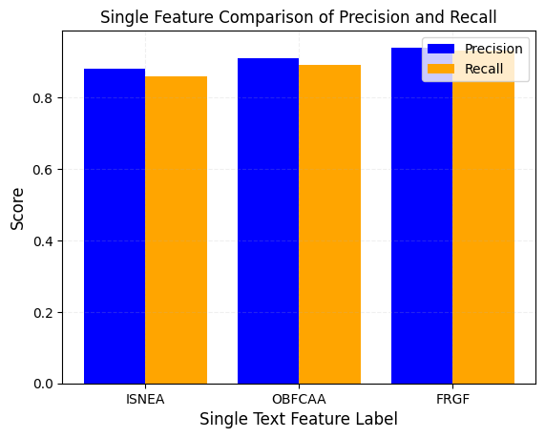 | 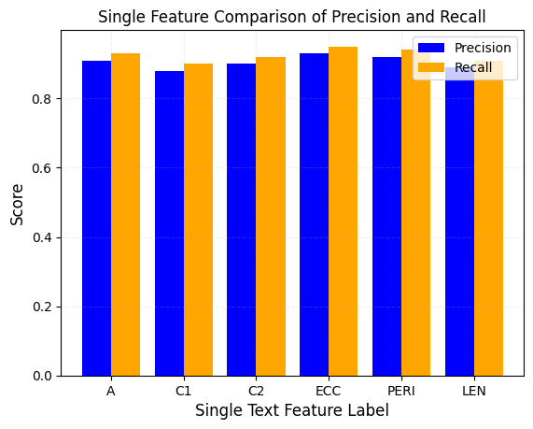
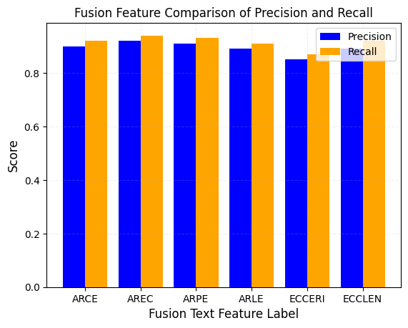
Figure 26. (a) Analysis of ISNEA, OBFCAA and FRGF (b) Single feature analysis of FRGF (c) Fusion feature analysis of FRGF

The analysis evaluates multiple features and their combinations across key metrics: True Positive Rate (TP Rate), True Negative Rate (TN Rate), False Positive Rate (FP Rate), and False Negative Rate (FN Rate). Among individual features, Eccentricity achieves the highest TP (93%) and TN (94%) rates with the lowest FP (6%) and FN (7%) rates, indicating superior reliability in detection. Area also performs well with a TP rate of 91% and FN rate of 7%, while Image demonstrates lower performance, with a TP rate of 77.4% and relatively high FP (12%) and FN (12.6%) rates. For feature combinations, Area + Eccentricity and Perimeter + Length perform similarly well, with TP and TN rates above 90% and FN and FP rates around 7–8%, suggesting that combining features enhances performance in some cases. Among the classes, OBFCA outperforms others with a TP rate of 88% and a TN rate of 92%, while FRGF overall struggles with the lowest TP rate (82%) and the highest FN rate (18%), highlighting its weaker detection capabilities. Overall, the analysis reveals that Eccentricity and its combinations provide the most reliable results, while certain classes and individual features need improvement.

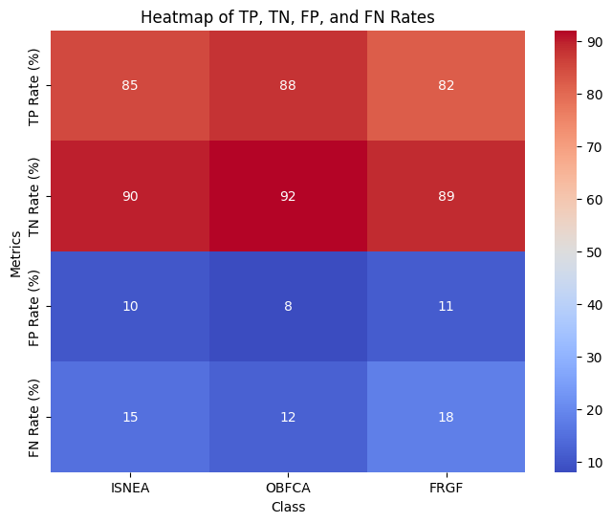 | 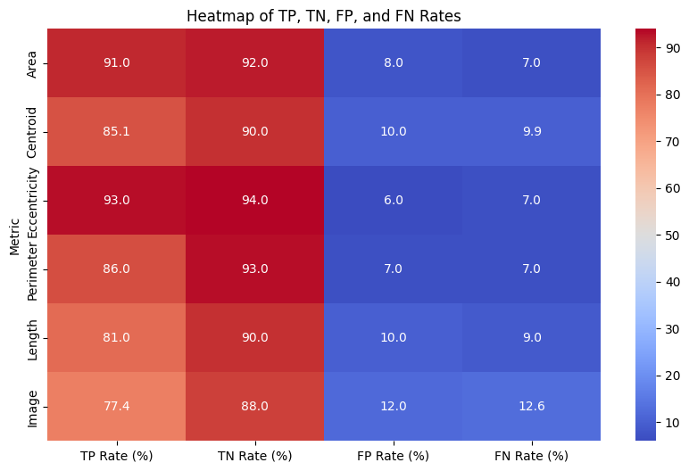
TN,TP,FN,FP rates ISNEA, OBFCA and Overall FRGF classification | TN,TP,FN,FP rates FRGF single features classification
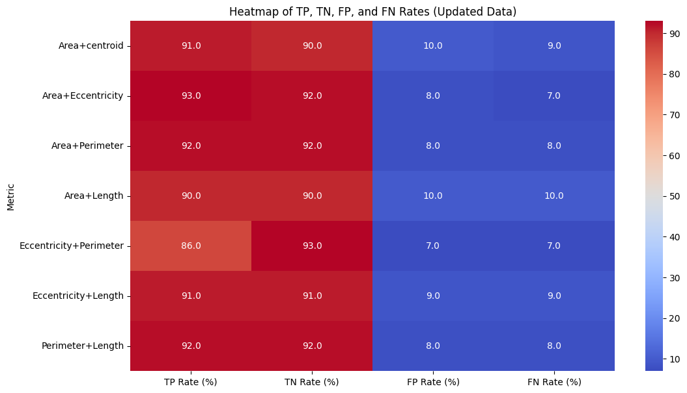
TN,TP,FN,FP rates FRGF classification of Fusion features
Figure 27. TN,TP,FN,FP Classification

Also the assessment analysis has been prepared by comparing existing approach with proposed work as mentioned in Table.8. As researchers have always generated their own dataset to work over Gujarati dataset so no standard research paper was found to compared our results. Hence in this section we have compared different existing approaches with our proposed work. Our proposed method FRGF ECC performs superlative as compared to other existing approaches.

Table 10: Average quantitative analysis of proposed method FRGF with existing method with different Gujarati Dataset

Approaches | Dataset | %PCC
HDWT [35] | Book , magazines etc. | 0.92
CCH [36] | Thesis Document | 0.55
CCH [36] | Gujarati – saral | 0.89
LSTM [38] | Collected from human | 0.9838
CNN [38] | Collected from human | 0.9853
Proposed FRGF ECC | Gujarati OCR Dataset | 0.935
Proposed FRGF ECPE | Gujarati OCR Dataset | 0.9275

This table provides a performance comparison of various text recognition and feature extraction approaches on datasets involving Gujarati text. Traditional methods like HDWT and CCH show varying success, with HDWT achieving moderate accuracy and CCH struggling on structured datasets but performing better on simpler datasets. Deep learning approaches such as LSTM and CNN outperform traditional methods, achieving PCC scores above 98%. The proposed methods (FRGF ECC and FRGF ECPE) demonstrate strong performance, with PCC values above 92%. These results indicate the effectiveness of the proposed methods for Gujarati OCR task as compared to other dataset. The different text feature extraction approaches has been compared with the existing one and detailed analysis has been presented in the below graphs.

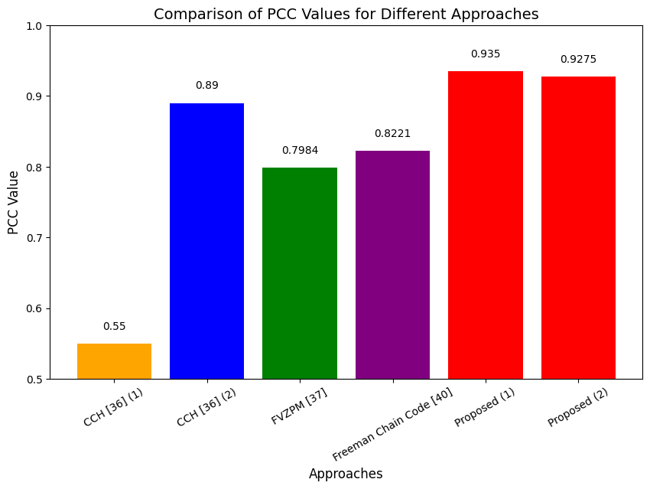 | 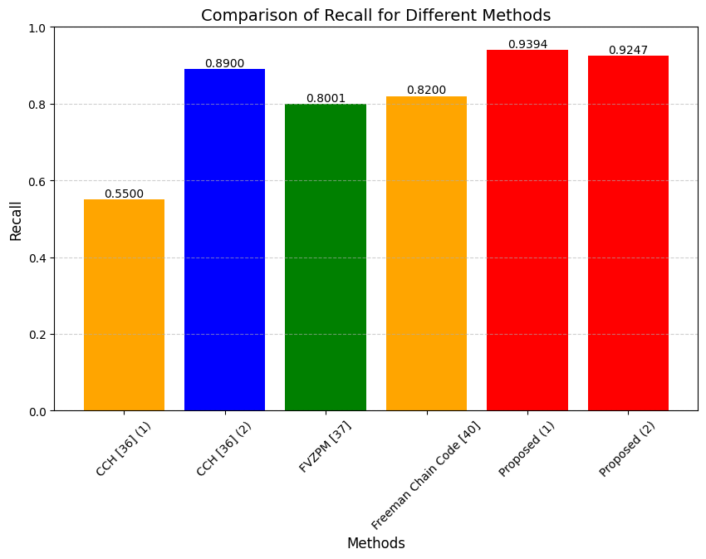
- PCC analysis of proposed with existing | - Recall analysis of proposed with existing
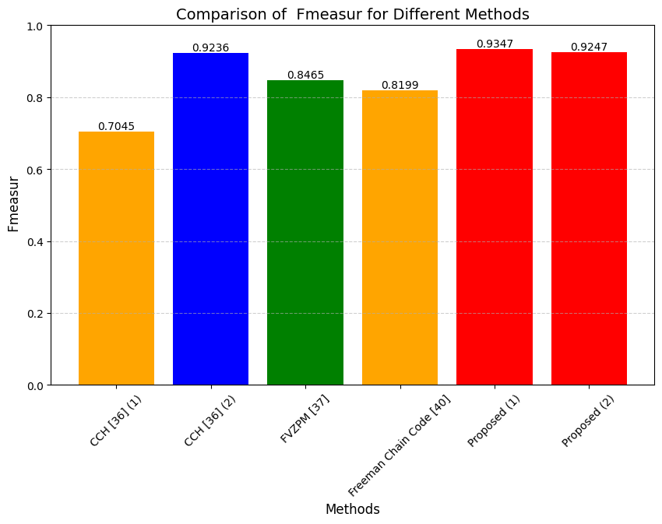
(c) F-Measures analysis of proposed with existing
Figure.16 (a)-(c) Average quantitative analysis of proposed method with existing method with different Gujarati Dataset (Proposed-1=FRGF ECC, Proposed -2= FRGF ECPE)

5. Conclusion and Future Scope
This study introduced effective methods for feature extraction of Gujarati text, leveraging fundamental concepts of image processing. Given the inherent complexity of the Gujarati language, the research concentrated on the diverse variations of Gujarati text, encompassing 385 distinct characters, including matra’s and alphabets. Three specific methodologies were proposed: The Numeric Encoding Approach (ISNEA), the One-Bit Frequency Count Approach (OBFCA), and the Fusion of Region Geometric Features (FRGF). These techniques successfully generated features for Gujarati text, which were subsequently catalogued in a Gujarati Text Feature vector dictionary. A quantitative performance analysis of the proposed methods was conducted, with feature set values illustrated in graphical form for 60 samples selected from a total of 23,100. The experimental results were assessed using the Gujarati OCR dataset and compared against existing methodologies. As part of ongoing research, efforts continue to refine state-of-the-art techniques to achieve optimal results in extracting Gujarati text features. Notably, the FRGF method demonstrated exceptional performance, achieving accuracies of 93.50% and 92.75% for geometric features such as eccentricity and the combined features of perimeter and eccentricity, respectively. However, a limitation identified in the Numeric Encoding Approach is its inability to generate numeric encodings for text containing two or more regions, resulting in only a partial numeric code for the first connected region. To address this limitation, two additional approaches have been proposed and successfully implemented on the Gujarati OCR dataset. Future research may extend to the detection of Gujarati numerals, exploration of additional geometric features using Image processing. The state of art approaches can also on the Gujarati OCR dataset to enhance text feature extraction performance.
Acknowledgements Not applicable.
Authors’ contributions The manuscript has been written by author 1 and reviewed by author 2.
Funding Not applicable.
Availability of data and materials Data are easily available online.
Declarations
Conflict of interests The authors declare that they have no competing interests.
Consent for publication Not applicable.
Ethics approval Not applicable.
Consent to participate Not applicable.
6. References

[1] “invideo.in”, Accessed on 4th Aug 2022 [Online] Available:https://invideo.io/blog/video-marketing-statistics/.
[2] Dr. A. Anushya 2020 Video Tagging Using Deep Learning:A Survey International Journal of Computer Science and Mobile Computing Vol.9 Issue.2.
[3] Hong Liang Xiao Sun, Yunlei Sun and Yuan Gao 2017 Text feature extraction based on deep learning: a review Liang et al. EURASIP Journal on Wireless Communications and Networking Article Number:211
[4] S. A. Rajesh V. A. Bharadi and P. Jangid 2015 Performance improvement of complex plane based feature vector for online signature recognition using soft biometric features International Conference on Communication, Information & Computing Technology , pp. 1-7
[5] Shah A. Mishra D. 2018 A Review of Biometrics Modalities and Data Mining Algorithm Ambient Communications and Computer Systems. Advances in Intelligent Systems and Computing vol 696. Springer
[6] Desai N.P. and Dabhi V.K. 2022 Resources and components for gujarati NLP systems: a survey Artificial Intelligence Review 55(11):1-19
[7] J. Bharvad D. Garg and S. Ribadiya 2021 A Roadmap on Handwritten Gujarati Digit Recognition using Machine Learning International Conference for Convergence in Technology pp. 1-4
[8] K. S. Gautam and M. M. Goswami 2020 Survey on Handwritten Gujarati Word Image Matching International Conference on Advanced Computing and Communication Systems India pp. 534-538
[9] K. B. Khushali M. M. Goswami and S. K. Mitra 2020 Handwritten Gujarati Word Image Matching using Autoencod International Conference on Computational Intelligence and Networks pp. 1-4
[10] P. Jyoti, S. Dimple,K. Rashmi Rekha, P. Suchit 2020 Gujarati Handwritten Character Recognition from Text Images Procedia Computer Science Volume 171
[11] Desai Apurva 2010 Gujarati handwritten numeral optical character reorganization through neural network Pattern Recognition Volume 43 Pages 2582-2589 ISSN 0031-3203
[12] K. Moro M. Fakir B. Bouikhalene R. El Yachi and B. El Kessab 2013 Comparison of two feature extraction methods based on the raw form and his skeleton for Gujarati handwritten digits Facta universitatis-series: Mathematics and Informatics 28.2 : 161-178.
[13] Moro Kamal fakir Mohamed Belaid Bouikhalene el Kessab Badre-Eddine and Ayachi R. 2014 Gujarati Handwritten Numeral Optical Character through Naive Bayes Classifier International journal of Computer Science & Network Solutions Volume 2. ISSN 2345-3397
[14] P. Goel and A. Ganatra 2022 A Pre-Trained CNN based framework for Handwritten Gujarati Digit Classification using Transfer Learning Approach International Conference on Smart Systems and Inventive Technology India pp. 1655-1658
[15] A. Vanani, V. Patel K. Limbachiya and A. Sharma 2022 Handwritten Gujarati Numeral Recognition using Deep Learning International Conference on Innovative Sustainable Computational Technologies India pp. 1-4
[16] A. Shirke N. Gaonkar P. Pandit and K. Parab 2021 Handwritten Gujarati Script Recognition International Conference on Advanced Computing and Communication Systems pp. 1174-1179
[17] B. Rajyagor and R. Rakholia 2021 Isolated Gujarati Handwritten Character Recognition using Deep Learning IEEE International Conference on Electrical, Computer and Communication Technologies pp. 1-6
[18] S. Aniket, R. Atharva, C. Prabha, D. Rupali and P. Shubham 2019 Handwritten Gujarati script recognition with image processing and deep learning International Conference on Nascent Technologies in Engineering pp. 1-4
[19] D. S. Joshi and Y. R. Risodkar 2018 Deep Learning Based Gujarati Handwritten Character Recognition 2018 International Conference On Advances in Communication and Computing Technology pp. 563-566
[20] B. Divya, M. M. Goswami and S. Mitra 2020 DNN based approaches for Segmentation of Handwritten Gujarati Text IEEE International Symposium on Sustainable Energy Signal Processing and Cyber Security pp. 1-6
[21] Abhinav Sharma Dhiren Soneji Aabha Ranade, Dhwani Serai Priya RL CS Lifna and Shashikant R Dugad 2023 Gujarati Script Recognition Procedia Computer Science Volume 218.
[22] P. Borad, P. Dethaliya and A. Mehta 2020 Augmentation based Convolutional Neural Network for recognition of Handwritten Gujarati Characters IEEE International Conference for Innovation in Technology pp. 1-4.
[23] S. Antani and L. Agnihotri 1999 Gujarati character recognition Proceedings of the International Conference on Document Analysis and Recognition Cat. No.PR00318 pp. 418-42
[24] M. I. Shah and C. Y. Suen 2010 Word Spotting in Gray Scale Handwritten Pashto Documents International Conference on Frontiers in Handwriting Recognition India pp. 136-141
[25] Kolcz A. Alspector and J. Augusteijn M. et al. 2000 A Line-Oriented Approach to Word Spotting in Handwritten Documents Pattern Analysis & Applications pp. 153–168
[26] Enver Akbacak and Cabir Vural 2022 Deep multi-query video retrieval Journal of Visual Communication and Image Representation Volume 85
[27] Y. Tewari, P. Soni S. Singh M. S. Turlapati and A. Bhuva 2021 Real Time Sign Language Recognition Framework for Two Way Communication International Conference on Communication information and Computing Technology pp. 1-6
[28] K. Moro M. Fakir B. Bouikhalene R. El Yachi and B. El Kessab 2014 New Approach of Feature Extraction Method Based on the Raw form and his Skeleton for Gujarati Handwritten Digits Using Neural Networks Classifier International journal of Computer Science & Network Solutions Volume 2. ISSN 2345-339
[29] Rathod Anand, Hasan Mosin , Swadas Prashan, Rathod Anand and Desai Nidhi 2022 Gujarati OCR / Typed Gujarati Characters Dataset , CC BY-NC-SA 4.0
[30] H. Althobaiti and Chao Lu 2017 A survey on Arabic Optical Character Recognition and isolated handwritten Arabic Character Recongition algorithm using encoded freeman chain code Annual Conference on Information Science and Systems pp. 1-6
[31] M. A. Mohamad Z. Musa and A. R. Ismail 2023 Crow Search Freeman Chain Code Feature Extraction Algorithm for Handwritten Character Recognition IEEE International Conference On Software Engineering and Computer Systems pp. 258-26
[33] A. O. Salau and S. Jain 2019 Feature Extraction: A Survey of the Types, Techniques, Applications International Conference on Signal Processing and Communication India pp. 158-164
[34] Rathod Anand, Hasan Mosin , Swadas Prashan, Rathod Anand and Desai Nidhi 2022 Gujarati OCR / Typed Gujarati Characters Dataset , CC BY-NC-SA 4.
[35] Patel, Jagin & Desai, Apurva. (2018). Gujarati Text Localization, Extraction and Binarization from Images. International Journal of Computer Sciences and Engineering. 6. 714-724. 10.26438/ijcse/v6i8.714724.
[36] Mehta, Ami & Gor, Ashish. (2017). Multifont multisize Gujarati OCR with style identification. 275-281. 10.1109/ICECDS.2017.8389951.
[37] Sharma, Ankit & Thakkar, Priyank & Adhyaru, Dipak & Zaveri, Tanish. (2019). Handwritten Gujarati Character Recognition Using Structural Decomposition Technique. Pattern Recognition and Image Analysis. 29. 325-338. 10.1134/S1054661819010061.
[38] Suthar, S.B., Thakkar, A.R. Dataset Generation for Gujarati Language Using Handwritten Character Images. Wireless Pers Commun 136, 2163–2184 (2024). https://doi.org/10.1007/s11277-024-11369-9

[39] Rathod Anand, Hasan Mosin , Swadas Prashan, Rathod Anand and Desai Nidhi (2022). Gujarati OCR / Typed Gujarati Characters Dataset . CC BY-NC-SA 4.0.

[40] Vyas, Archana & Swital. (2015). Classification of offline gujarati handwritten characters. 10.1109/ICACCI.2015.7275831.

