Performance evaluation study of CNN, LSTM and CNN-LSTM models in the problem of sleep stage classification based on EEG signals

¹Zainab N. Nemer, ²Saba Abdual Wahid Saddam, ³Rana J. AL-Sukeinee, ⁴Esra'a J. Harfash
^{1,2,4}Department of Computer Science, College of Computer Science and Information Technology, University of Basra, Iraq.
³Department of Physic, College of Science, University of Basrah, Iraq.

E-mail: ¹zainab.nemer@uobasrah.edu.iq , ²Saba.Saddam@uobasrah.edu.iq , ³rana.jabbar@uobasrah.edu.iq ⁴esra.harfash@uobasrah.edu.iq

Keywords: LSTM Networks , Convolutional Neural Networks (CNN), Sleep Stage Classification, Hybrid Models , EEG Signals

Received:
This paper aims to study and analyze the efficiency of deep neural networks CNN, LSTM, and CNN+LSTM individually in the problem of classifying the sleep cycle stages, by analyzing the recorded electroencephalogram (EEG) signals, and highlighting the strengths of each model in this classification problem. The deep learning models selected in this work are models that are relied upon in the world of experiments and medical classification. The data used here was the electroencephalogram signal (EEG) that carries information about the different sleep stages, which are five stages. Based on the results of the studies, it was determined that the CNN model is the most effective at classification, with an accuracy of 87%. However, the accuracy of the LSTM model was 0.83%, while the accuracy of the hybrid LSTM+CNN model was 0.84%. These findings suggest that CNN's high accuracy can be attributed to its strong ability to extract spatial characteristics from the data. The outcome of the LSTM approach shows how well it can track and interpret the sleep signal's temporal properties. As for the CNN + LSTM model, which combines the power of spatial CNN and temporal LSTM, the combined result is acceptable in the field of sleep signal processing.

1 Introduction
Sleep is one of the most important aspects of life that has a direct relationship with the health of the body. Research on the importance of sleep has not yet found the reason for human sleep, and why lack of sleep may lead to poor health. Sleep, the stages of sleep, and the motivations for sleep are challenges that continue to be researched and investigated about their purpose in life. [1][2].
There are five stages of sleep, one stage of rapid eye movement (REM) , three stages of non-rapid eye movement (NREM) and Wake. These stages play an important role in the recovery of the brain and body, and are determined based on analysis of brain activity during sleep, which shows distinct patterns that characterize each stage[3][4].
Electroencephalography (EEG) is a non-invasive tool for detecting brain rhythms, and is used to measure patterns of brain activity during different situations in order to diagnose different neurological conditions. When we sleep, our brains undergo a pattern of activity changes. Therefore, the readings collected via EEG are considered the gold standard for measuring sleep stages. [5][6].
Many researchers in the field of machine learning, specifically in the field of deep learning, have had practical experience in classifying sleep stages through various methods and techniques.. Among these networks is the LSTM model, where LSTM structures have the ability to learn long-term dependencies in sequential data, making them well suited for tasks such as predicting time series such as sleep signal. Therefore, they are relied upon to solve special problems in computational biology and computational biology. [7][8].
Convolutional Neural Networks (CNNs) are highly effective in capturing spatial features and have shown outstanding results in detecting intricate patterns within EEG data. Time series analysis makes extensive use of both CNNs and LSTMs. Performance on time series classification problems can be enhanced by combining CNN and LSTM networks. where CNNs may learn local patterns in data, but LSTM networks can identify long-term dependencies in sequential data. [9][10].
The objective of this research is to evaluate and contrast the effectiveness of three different deep learning models—LSTM, CNN, and a CNN+LSTM hybrid—in the classification of sleep stages. The goal of the study is to establish the model that best properly distinguishes the five different stages of sleep by analyzing EEG signals. It is expected that the results will increase the accuracy of sleep stage analysis and make significant contributions to the development of sleep research and medical applications.

2 Literature Review
Numerous researchers have attempted to address and enhance the effectiveness of sleep stage classification through a variety of concepts and approaches; however, deep learning algorithms are among the most significant approaches that have explored this area in order to accomplish automated sleep stage recognition, the study conducted by Nicola M et al. (2019) In order to automatically score sleep stages using EEG signals from a single channel, a unique cascaded recurrent neural network (RNN) architecture based on long short-term memory (LSTM) blocks is proposed in this paper. To choose the most pertinent features, fifty-five temporal and frequency-domain features were taken out of the EEG signals and supplied into feature reduction algorithms.[11].
Convolutional Neural Networks (CNNs) is important models in sleep stage classification problem. Asma et al. (2020) study highlights a 13-layer 1D convolutional neural network CNN for automatic feature extraction and sleep stage classification using single-channel EEG signal [12].
Furthermore, Huijun Y. et al. (2024) In order to increase the effectiveness and precision of sleep stage detection, their goal in this study was to present a thorough analysis of the most recent deep learning techniques. They examine the uses of automated sleep stage assessment in situations including sleep problem screening, diagnostic processes, and health monitoring and management, beginning with the "data" needed to develop deep learning algorithms. [13].
The CNN model has a distinct role in classifying sleep stages, Luis A. et al. (2023), In this paper, are used a convolutional neural network (CNN) based on 5- and 2-class models to study the performance of automatic sleep stage categorization utilizing autonomously selected characteristics from electroencephalogram (EEG) inputs. We established two 2-class sleep stage classification techniques and evaluated how well they performed in comparison to the predictions from a 5-class model. The public ISRUC-Sleep dataset, which includes six EEG channels and 100 participants, was used for tests. All models were constructed using a CNN called EEGNet. [14].
In order to address the issue of training data imbalance, Enes E. A. et al. (2023), in this study suggests a novel hybrid CNN+LSTM neural network design that makes use of focus loss and discrete cosine transform techniques. Using k-fold cross-validation techniques (subject-wise), the model was trained on four distinct databases. When using two channels (EEG-EOG), the best accuracy was 87.11%, [15].
Nowadays, a lot of techniques rely on manually created features. Only a few methods, meanwhile, are able to recover the temporal information required to determine the stages of sleep. LSTMs will be able to learn transition rules, while convolutional neural networks will be able to extract time-invariant features. A thorough analysis of recent advancements was given by Kotla R. et al. (2023), This paper proposes a deep learning model to automatically score sleep stages using single-channel EEG recordings that combines CNN and LSTM. The model was trained and tested on the Sleep-EDF-v1 dataset, which is publicly available. The single-channel Fpz-Cz EEG was used and scored according to the AASM standard. An overall accuracy of 83.38% was achieved. [16].
3 Materials and Methods
3.1. Foundations of Mathematics
In this work, research was conducted to know the strength of each model of LSTM, CNN and CNN+LSTM in classifying the different stages of sleep signal according to the features that each model possesses. The following will include the mathematical aspect of building each model with an explanation of the architecture that was adopted in this work..

3.1.1 LSTM Model
One kind of recurrent neural network that attempts to mitigate the vanishing gradient issue that conventional recurrent neural networks usually encounter is called long short-term memory (LSTM). Its benefit over other recurrent neural networks is its relative insensitivity to gap length. Typically, an LSTM unit consists of three gates and a cell:

Forget Gate:
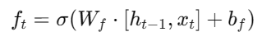
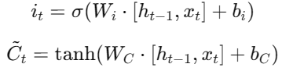
Input Gate:

Cell State Update:
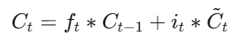
​
Output Gate:
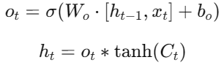

In this case, the input vector at time t is represented by x_{t}, the hidden state by _{ht_1}, the cell state by C_{t}, and the sigmoid activation function by σ. LSTM networks are perfect for evaluating sleep stage transitions because of this mechanism, which allows them to capture temporal dependencies in EEG data[7][17].Figure 1 depicts the LSTM architecture.
The LSTM network architecture used in the study that is shown in Figure (1). There are two LSTM layers in the model:
- with 100 units in the first layer set up to return sequences for further processing.
- The second LSTM layer can summarize the temporal information that the first layer extracted because it has 50 units and doesn't return sequences.
- For additional feature extraction, the architecture incorporates a Dense layer with 200 neurons and a ReLU activation function after the LSTM layers.
- Through experimentation, we found that the Dropout value of 0.3 is very suitable for reducing overfitting.
- In order to classify the five sleep stages, the Softmax activation function was adopted here in the output layer.
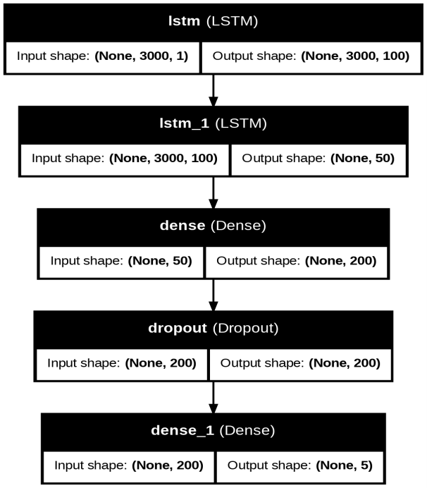
Figure 1. LSTM Architecture Visualization

3.1.2 CNN model
CNN One kind of deep learning algorithm that has shown great success in tasks like classification is CNN. Nonetheless, as used in this study, the mathematical underpinnings of CNNs and their architecture are described below.
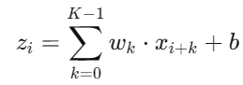
Convolutional layers: which employ filters to extract features from the input data, and pooling layers, which down sample the convolutional layers' output to lower the data's dimensionality, are the fundamental components of a CNN.[18][19]:

Where x_{i+k} is the Input data at position i+k ,w_{k} the Weights of the kernel (filter) ,b is Bias term and z_{i} is Output feature map.This operation enhances localized patterns, making CNNs adept at recognizing spatial features in data like EEG signals[20][21].

Activation Function: After the convolution, an activation function such as the Rectified Linear Unit (ReLU) is applied to introduce non-linearity:
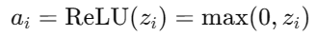

This non-linear transformation helps the network model complex data relationships[22].

Pooling Operation :The Max pooling, the most common type, selects the maximum value from each sub-region of the feature map:
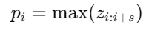
Where s is the size of the pooling window.[13].

Fully Connected Layers :At the final stage, the extracted features are flattened and passed through one or more fully connected layers, where each output neuron computes:
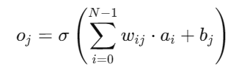

Where: N is the Number of input features , w_{ij} the Weight connecting input i to output j , denoted the b_{j}​: Bias for the j-th output neuron and σ is the Activation function (e.g., softmax for classification tasks)

Loss Function : For classification, the CNN typically uses a cross-entropy loss function:
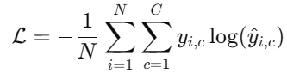

Where:N is the Number of samples ,C is the Number of classes , y_{i,c} is the True label for sample i and class c and y^​_{i,c}​: Predicted probability for sample i and class c.
CNNs are particularly effective in EEG signal analysis because they can learn spatial hierarchies of features, making them robust in handling noise and variations in the signals. Additionally, the ability to apply multiple layers of convolution enables CNNs to capture both low-level (e.g., wave patterns) and high-level (e.g., stage-specific features) information[23][24].
The Convolutional Neural Network (CNN) architecture employed in this work is designed to effectively extract spatial features from the EEG signals as in figure(2). As shown in figure 2, the model is composed of several layers, each of which aids in the feature extraction and classification procedure:
- Input Layer: To represent EEG signal segments, the input layer uses data of the shape given by input_shape.
- convolutional layers:First Convolutional Layer: Applies 32 filters with a kernel size of 3, using ReLU activation to capture local spatial patterns. Second Convolutional Layer: Utilizes 64 filters for further feature extraction. Third Convolutional Layer: Adds 128 filters to enhance the representation of high-dimensional spatial features.
- Batch Normalization and Max-Pooling: Each convolutional layer is followed by batch normalization to stabilize learning and max-pooling (pool size = 2) to reduce feature map dimensions while preserving critical information.
- Max-Pooling Layers: To lower the dimensionality of the feature maps and preserve the most important information, a max-pooling operation with a pool size of two is performed after each convolutional layer.
- Dropout: To avoid overfitting and improve the model's capacity for generalization, a dropout rate of 0.3 is applied following each pooling layer.
- Flattening Layer: To get ready for the thick layers, the feature maps from the last convolutional layer are flattened into a 1D vector.
- Densely Connected Layers: The first dense layer's 200 cells use the ReLU activation function to learn high-level data representations. The softmax activation function is employed in the output layer.
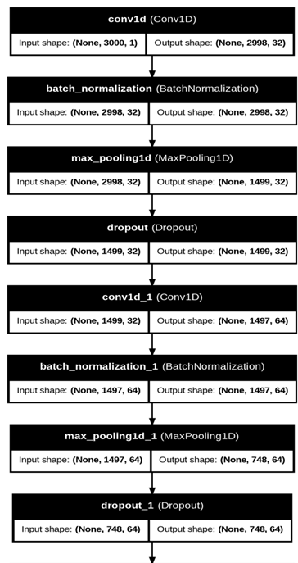
- The Glorot Uniform initializer is used to ensure proper signal flow and stop gradients from disappearing. .
1

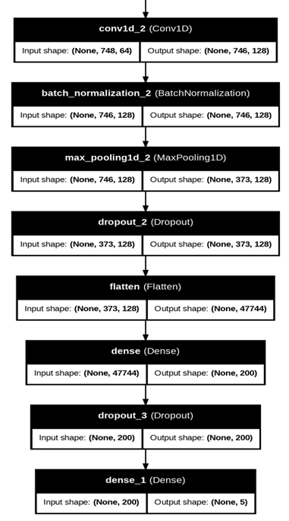
1
Figure 2. CNN Architecture Visualization

3.1.3 CNN+LSTM Model
A strong design that combines the extraction of spatial and temporal features is offered by the combination of Convolutional Neural Networks (CNNs) with LSTM networks [18].
CNN Part: Convolutional layers use convolution procedures to identify local patterns in the input EEG signal:
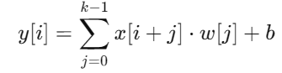

In this case, the input signal is denoted by x[i], the filter by w[j], the kernel size by k, and the bias term by b [19]. Below is a description of the CNN LSTM architecture adopted in this work, which has been tailored to fit the EGG signal specification for sleep activity. Here, of course, it means combining a set of features from each model to achieve the goal of suitability for sleep data classification..:
    - EEG signal segments are read using the specified input shape in the input layer, where input shape=length=3000.
- Convolutional Layers: To capture local spatial patterns, 32 filters with a kernel size of three are used for the first convolutional layer. These filters use the ReLU activation function.ِ And 64 filters are chosen for the second convolutional layer in order to maximize the quantity of features that are extracted. Then To get the best representation of these high-dimensional spatial data, 128 filters are positioned in the third convolutional layer.
- Batch Normalization and Max-Pooling: Each convolutional layer is followed by batch normalization to stabilize learning and max-pooling (pool size = 2) to reduce feature map dimensions while preserving critical information.
- Dropout: Dropout layers with a rate of 0.3 are inserted after each pooling layer to prevent overfitting.
- LSTM Layers:
  - First LSTM Layer: Contains 100 units, processes sequences, and returns sequential outputs for further temporal feature learning.
  - Second LSTM Layer: Consists of 50 units, focusing on capturing refined temporal dependencies.
- Fully Connected Layers:
  - First Dense Layer: Composed of 200 neurons with ReLU activation to learn high-level features.
  - Output Layer: A dense layer with num_classes neurons and a softmax activation function to predict sleep stage probabilities.
- Initialization: The weights in all layers are initialized using the Glorot Uniform initializer, ensuring a stable optimization process.
This architecture integrates spatial and temporal learning effectively, making it well-suited for analyzing the sequential nature of EEG data to classify sleep stages accurately ,see figure 3.

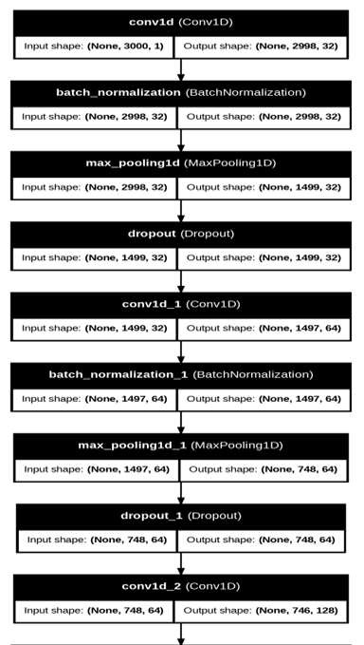
2

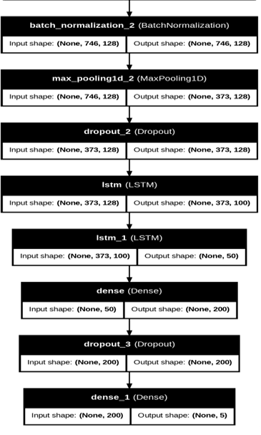
2
Figure 3. CNN+LSTM Architecture Visualization

3.2. Data and Preprocessing
The study utilized the publicly available Sleep-EDF database, which consists of 150 files of EEG signals collected from multiple subjects. Each file contains recordings of various sleep stages, including Wake (W), Non-REM stages (N1, N2, N3), and REM, providing a comprehensive dataset for sleep analysis[25][26].

3.2.1 Data Description
Each EEG signal file contains the following key components:
- EEG Signal Data (x): Represents the brain's electrical activity recorded during the study.
- Labels (y): Corresponding annotations for the sleep stages, categorized into five distinct classes:
  - Wake (W)
  - Non-REM Stage 1 (N1)
  - Non-REM Stage 2 (N2)
  - Non-REM Stage 3 (N3)
  - REM (Rapid Eye Movement)
- Sampling Frequency (fs): Defines the signal acquisition rate, typically set at 100 Hz.
- Channel Labels (ch_label): Specifies electrode placements, such as (EEG Fpz-Cz) and (EEG Pz-Oz).
Example of a file: The file "SC4001E0.npz" includes:
  - Shape of x: (841, 3000, 1), which indicates 841 signal segments, each containing 3000 samples (30 seconds per segment at 100 Hz).
  - Shape of y: (841,), which contains the corresponding sleep stage labels for each segment.
  - Sample Signals:
[[[ 8.111 ],
[ 17.488 ],
[ 21.239 ],
...
[-10.361 ],
[-11.112 ],
[ -2.109 ]],
[[-10.736 ],
[-11.393 ],
[ -4.454 ],
...
[ 58.842 ],
[ 48.339 ],
[ 53.684 ]]]

3.2.2 Preprocessing Steps
The EEG signals were prepared for analysis through the following preprocessing steps:
- Signal Normalization: All signals were scaled to the range [-1, 1] to maintain numerical stability during model training.
- Segmentation: Signals were divided into fixed-length windows of 30 seconds (3000 samples), in alignment with standard sleep study practices.
- Class Balancing:
  - The dataset exhibited an imbalance across the five sleep stages.
  - Techniques such as oversampling and SMOTE (Synthetic Minority Oversampling Technique) were used to ensure fair representation of all classes.
These steps ensured the EEG data were standardized, balanced, and ready for deep learning model training.

3.3 Implementation and Training
To evaluate the effectiveness of different deep learning architectures in analyzing EEG signals for sleep stage classification, three models were implemented and trained: LSTM, CNN, and a hybrid CNN+LSTM model. These architectures were chosen based on their complementary strengths in capturing temporal and spatial features from EEG data, providing valuable insights into brain activity during sleep.
The implementation was carried out using TensorFlow/Keras, following a structured training pipeline:
- Loss Function :Categorical cross-entropy loss was utilized for the multi-class classification task, as it is well-suited for handling the five distinct sleep stages.
- Optimizer: A learning rate scheduler was incorporated to dynamically modify the learning rate in response to training progress, and the Adam optimizer was utilized due of its effectiveness in managing sparse gradients.
- Preprocessing: To guarantee sufficient temporal resolution, the EEG signals were preprocessed and divided into overlapping time periods. These windows were transformed into forms appropriate for each model's input after being normalized.
- The data training was split into 70% training, 15% validation, and 15% testing to guarantee the model's dependability..
- Hyperparameter adjustment is essential ,because it has a direct impact on the model's accuracy, generalization, and other performance measures, here the grid search method was applied.
- Each model was trained for a predetermined number of epochs (50), with a batch size of 64. An early stop mechanism was used to end training when the model reached the stationary state.

3.3.1 Experimental Setup
In this section, the progress of the test results of the LSTM model, the CNN model, and the CNNLSTM model are presented, and a comprehensive analysis of these three models is given, and the strength of each model is explained in distinguishing between the five stages of sleep.

Results and Discussion
In the problem of classifying different sleep signal stages in this paper, well-known evaluation metrics were used to evaluate the performance of LSTM, CNN, and CNN+LSTM networks, respectively. The evaluation metrics were applied to both the training and test sets, as shown in the analysis presented in the following paragraphs..

4.1. LSTM Model
When the LSTM model was implemented, an accuracy rate of 82.64%. was achieved. The following are highlighted by its performance metrics:
1. Advantages:
- The model's capacity to distinguish between these stages was demonstrated by the highest precision (0.93 and 0.90, respectively) and recall (0.89 and 0.96, respectively) of Stage 0 (Wakefulness) and Stage 3 (Deep Sleep).
- The F1-score for Stage 3 (0.93) confirms consistent and accurate predictions.
- Weaknesses:
  - Stages 1 and 2 had the lowest performance, with F1-scores of 0.70 and 0.77, respectively. These stages, being transitional, are inherently harder to distinguish due to their similarity in EEG patterns.
  - The weighted average F1-score (0.83) suggests room for improvement in overall classification consistency.
To illustrate the distribution of predictions across stages, the Figure (4) and Figure (5) are showed the confusion matrix and (training and validation) accuracy curve to show the convergence and generalization performance of the LSTM model during training .
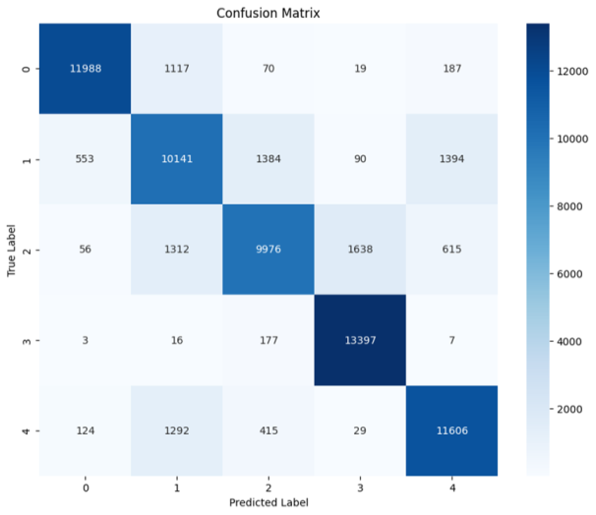
Figure 4: confusion matrix of LSTM model

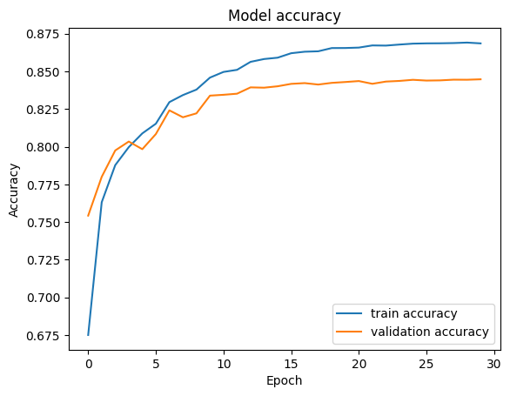
Figure 5:training and validation accuracy curve of LSTM model

4.2. CNN Model
The CNN model outperformed the LSTM model with a test accuracy of 87.13%, reflecting a significant improvement in classification performance.
- Strengths:
  - The precision and recall for Stage 0 (Wakefulness) were 0.96 and 0.85, respectively, while Stage 3 achieved the highest F1-score of 0.95, showcasing the model's superior ability to distinguish these stages.
  - Stages 1, 2, and 4 showed better balance compared to the LSTM model, with F1-scores of 0.82, 0.81, and 0.87, respectively.
  - The higher weighted average F1-score (0.87) reflects more consistent performance across all stages.
- Weaknesses: Stage 0 (Wakefulness) had a slightly lower recall (0.85) compared to its precision, indicating that some wakefulness instances were misclassified into other stages.
Figure (6) is Inserted the CNN confusion matrix here to provide a clear comparison of predicted and true labels. And Figure (7) is showed the training and validation accuracy curve to show the convergence and generalization performance of the CNN model during training.
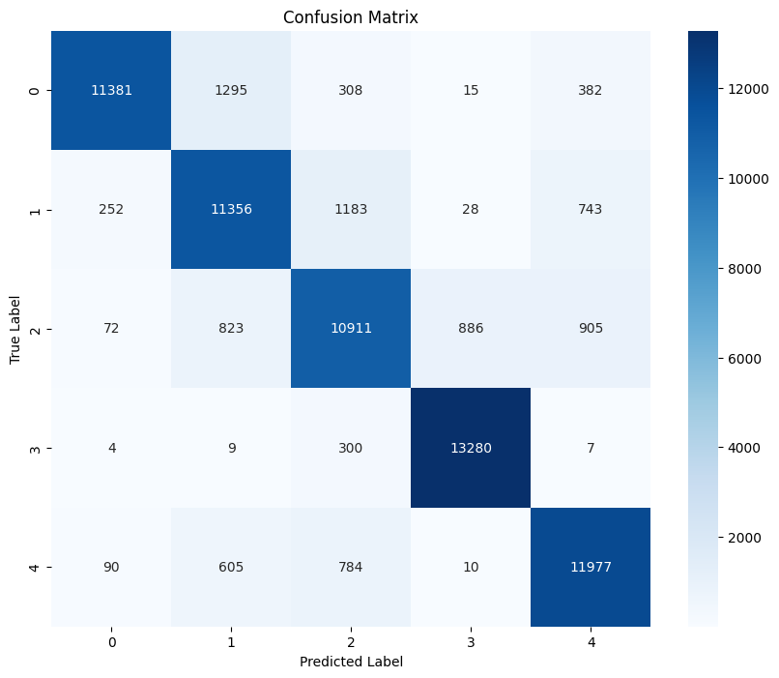
Figure 6:confusion matrix of CNN model

.

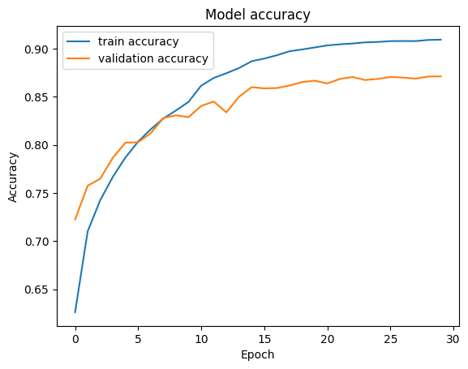
Figure 7:training and validation accuracy curve of CNN model

4.3. CNN+LSTM Model
The hybrid CNN+LSTM model achieved a test accuracy of 84.47%, which lies between the performances of the standalone CNN and LSTM models.

- Strengths:
  - Stage 3 (Deep Sleep) achieved the highest recall (0.99) and a strong F1-score of 0.93, confirming the model's ability to detect this stage with high confidence.
  - Stages 0 and 4 also demonstrated consistent results, with F1-scores of 0.92 and 0.85, respectively.
- Weaknesses:
  - Similar to the LSTM model, transitional stages (1 and 2) showed lower F1-scores (0.74 and 0.78, respectively), suggesting challenges in learning their complex EEG patterns.
  - The weighted average F1-score (0.84) indicates slightly lower consistency compared to the CNN model.

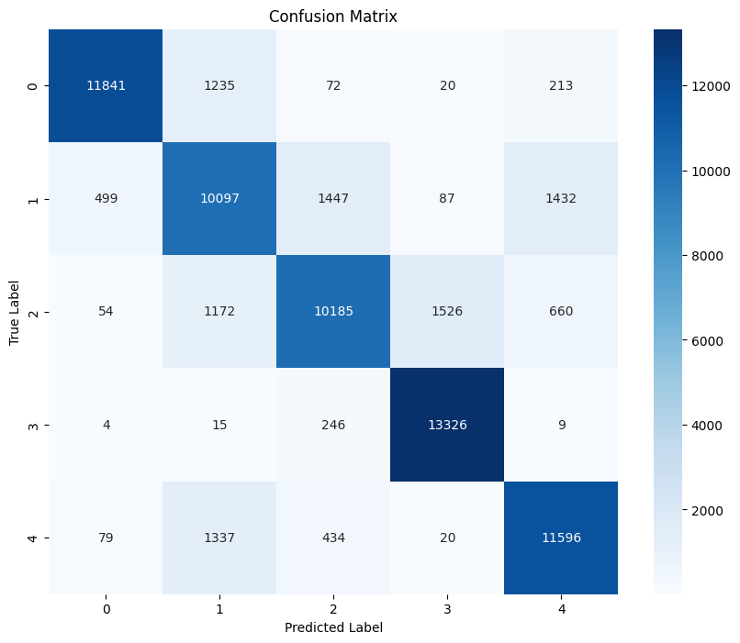
The Figure (8) and Figure (9) are showed the confusion matrix and (training and validation) accuracy curve to show the convergence and generalization performance of the CNN+ LSTM model during training .
Figure 8: confusion matrix of CNN+LSTM model

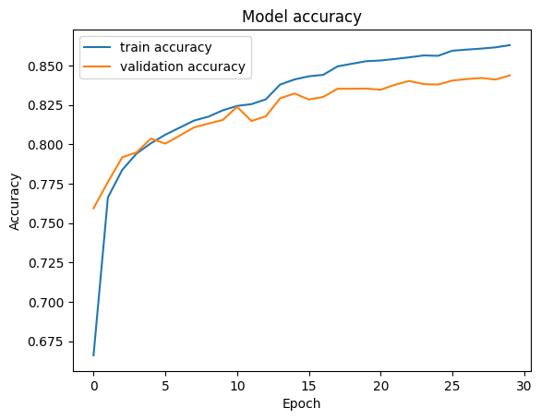
Figure 9:training and validation accuracy curve of CNN+LSTM model

There are some key Insights of this work:

- Model Comparison:
  - The CNN model exhibited the highest test accuracy (87.13%) and the best overall performance in terms of precision, recall, and F1-score.
  - The hybrid CNN+LSTM model, while improving slightly upon the LSTM model's performance, did not outperform the standalone CNN. This could suggest that CNN alone is better suited for extracting spatial features from EEG data in this context.
  - The LSTM model, despite its lower accuracy, still showed good performance in identifying stages with long-term temporal dependencies, such as Stage 3 (Deep Sleep).
- Challenges in Stages 1 and 2:
  - All models struggled to classify Stages 1 and 2 due to their similar and overlapping EEG features. This indicates the need for additional preprocessing steps, feature engineering, or enhanced model architectures to improve distinction between these stages.
- Overfitting Prevention:
  - Training and validation accuracy curves for all models indicate effective generalization, with no signs of overfitting. The use of a learning rate scheduler and regularization techniques played a vital role in achieving these results.

The following Table (1), Table (2) and Table (3) are the tables Summarized Metrics for each model that Include a summary table to present test accuracy, precision, recall, and F1-scores for LSTM, CNN and CNN+LSTM models:
Table 1: classification report of LSTM
No. of sleep stage | precision | recall | f1-score | support
0 | 0.93 | 0.89 | 0.91 | 13381
1 | 0.69 | 0.72 | 0.70 | 13562
2 | 0.80 | 0.75 | 0.77 | 13597
3 | 0.90 | 0.96 | 0.93 | 13600
4 | 0.82 | 0.82 | 0.82 | 13466
Table 2: classification report of CNN model
No. of sleep stage | precision | recall | f1-score | support
0 | 0.96 | 0.85 | 0.90 | 13381
1 | 0.81 | 0.84 | 0.82 | 13562
2 | 0.81 | 0.80 | 0.81 | 13597
3 | 0.93 | 0.98 | 0.95 | 13600
4 | 0.85 | 0.89 | 0.87 | 13466

Table 3: classification report of CNN+LSTM model
No. of sleep stage | precision | recall | f1-score | support
0 | 0.94 | 0.90 | 0.92 | 13381
1 | 0.73 | 0.75 | 0.74 | 13562
2 | 0.83 | 0.73 | 0.78 | 13597
3 | 0.88 | 0.99 | 0.93 | 13600
4 | 0.84 | 0.86 | 0.85 | 13466

5 CONCLUSIONS
The results indicate that the CNN model is the most effective architecture for classifying the five sleep stages based on EEG signals, achieving the highest accuracy and F1-scores. However, the LSTM model's strengths in identifying long-term dependencies and the CNN+LSTM hybrid's ability to integrate spatial and temporal features provide valuable insights for future improvements. Further research could explore advanced hybrid architectures or additional preprocessing techniques to enhance classification performance for transitional sleep stages.

References
- Walker, M. P. (2017). Why We Sleep: Unlocking the Power of Sleep and Dreams. Scribner, Publisher: Scribner , Length: 368 pagesISBN13: 9781501144325
- Siegel, J. M. (2005). Clues to the functions of mammalian sleep. Nature, 437(7063), 1264–1271. https://doi.org/10.1038/nature04285
- Rechtschaffen, A., & Kales, A. (1968). A manual of standardized terminology, techniques and scoring system for sleep stages of human subjects., U.S. Department of Health, Education, and Welfare.
- Iber, C., Ancoli-Israel, S., & Chesson, A. (2007). The AASM manual for the scoring of sleep and associated events. Medicine , American Academy.
- Sanei, S., & Chambers, J. A. (2013). EEG Signal Processing. John Wiley & Sons, 1118691237, 9781118691236.
- Lopes da Silva, F. (2005). "Electroencephalography: Basic principles, clinical applications, and related fields",Lippincott Williams&Wikins,
- Hochreiter, S., & Schmidhuber, J. (1997). Long short-term memory. Neural computation, 9(8), 1735-1780. http://dx.doi.org/10.1162/neco.1997.9.8.1735.
- Chengfan L., Yueyu Q. and Xuehai D. (2022). A "Deep Learning Method Approach for Sleep Stage Classification with EEG Spectrogram", PMCID: PMC9141573 PMID: 35627856. . https://doi.org/10.3390/ijerph19106322

- Tsinalis, O., Matthews, P. M., & Guo, Y. (2016). Automatic sleep stage scoring using time-frequency analysis and stacked sparse autoencoders. Annals of Biomedical Engineering. https://doi.org/10.48550/arXiv.1610.01683

- Sasai, S., Koike, T., Sugawara, S. K., Okazaki, S., Watanabe, K., Sadato, N., & Iguchi, Y. (2017). "Network-wide reorganization of procedural memory during NREM sleep revealed by fMRI". eLife, 6, e24987. https://doi.org/10.7554/eLife.24987
- Nicola M., U.Rajendra A., Filippo M. (2019). Cascaded LSTM recurrent neural network for automated sleep stage classification using single-channel EEG signals. Computers in Biology and MedicineVolume 106,Pages 71-81. https://doi.org/10.1016/j.compbiomed.2019.01.013
- Asma Salamatian and Ali Khadem . (2022
).Automatic Sleep Stage Classification Using 1D Convolutional Neural Network. Frontiers in Biomedical Technologies.Vol. 7, No. 3. http://dx.doi.org/10.18502/fbt.v7i3.4616
- Huijun Y., Zhuqi C., Wenbin G., Lin S. and Yidan D. (2024). " Research and application of deep learning-based sleep staging: Data, modeling, validation, and clinical practice." Sleep Medicine Reviews.Volume 74, 101897.
https://doi.org/10.1016/j.smrv.2024.101897
- Luic A., Takashi A.and Marta Molinas (2023):" EEG-based 5- and 2-class CNN for Sleep Stage Classification." , IFAC-PapersOnLine ,Volume 56, Issue 2, Pages 3211-3216. https://doi.org/10.1016/j.ifacol.2023.10.1458
- Enes E., Seral O. (2023). "CoSleepNet: Automated sleep staging using a hybrid CNN-LSTM network on imbalanced EEG-EOG datasets." Biomedical Signal Processing and Control ,Volume 80, Part 1, February, 104299. https://doi.org/10.1016/j.bspc.2022.104299
- Kotla R. and Polavarapu N. and Safa P. (2023)." A CNN-LSTM Model for Sleep Stage Scoring Using EEG Signals": 2023 International Conference on Communication, Circuits, and Systems (IC3S). https://doi.org/10.1109/IC3S57698.2023.1016917
- Ralf C. Staudemeyer and Eric R. (2019). " Understanding LSTM -- a tutorial into Long Short-Term Memory Recurrent Neural Networks", arXiv:1909.09586v1 [cs.NE] 12 Sep 2019. http://dx.doi.org/10.48550/arXiv.1909.09586
.
- Lecun, Y., Bottou, L., Bengio, Y., & Haffner, P. (1998). "Gradient-based learning applied to document recognition." Proceedings of the IEEE.
- Krizhevsky, A., Sutskever, I., & Hinton, G. E. (2012). "ImageNet classification with deep convolutional neural networks." Advances in Neural Information Processing Systems.
- Goodfellow, I., Bengio, Y., & Courville, A. (2016). Deep Learning. MIT Press. https://doi.org/10.1007/s10710-017-9314-z
- Ghita A. ,Amina A., and Mohammed B. (2022). " EEG signal analysis using deep learning: A systematic literature review." 2021 Fifth International Conference On Intelligent Computing in Data Sciences (ICDS). https://doi.org/10.1109/ICDS53782.2021.9626707
- Roy, Y., & Banville, H. (2019). " Deep learning-based electroencephalography analysis: a systematic review" Frontiers in Neuroscience. https://doi.org/10.1088/1741-2552/ab260c
- G. Sudhamathy, N. Valliammal, P. Subashini, T. T. Dhivyanrabha and R. G. Sneha, "Hybrid Convolutional Neural Network - Long Short-Term Memory Model for Automated Detection of Sleep Stages," 2023 International Conference on Intelligent Systems for Communication, IoT and Security (ICISCoIS), Coimbatore, India, 2023, pp. 510-515,
https://doi.org/10.1109/ICISCoIS56541.2023.10100489
- Phan, H., et al. (2019). "SeqSleepNet: End-to-end hierarchical recurrent neural network for sequence-to-sequence automatic sleep staging." IEEE Transactions on Neural Systems and Rehabilitation Engineering. https://doi.org/10.1109/TNSRE.2019.2896659.
- Kemp, B., Zwinderman, A. H., Tuk, B., Kamphuisen, H. A., & Oberye, J. J. (2000). Analysis of a sleep-dependent neuronal feedback loop: The slow-wave microcontinuity of the EEG. IEEE Transactions on Biomedical Engineering, 47(9), 1185–1194. https://doi.org/10.1109/10.867928
- Goldberger, A. L., Amaral, L. A. N., Glass, L., et al. (2000). PhysioBank, PhysioToolkit, and PhysioNet: Components of a New Research Resource for Complex Physiologic Signals. Circulation, 101(23), e215-e220. http://dx.doi.org/10.1161/01.CIR.101.23.e215

