Line-Focused Laser and YOLOv5-Based High-Precision Defect Detection for Reflective Surfaces
Jiexi Zhang
Email: jiexi_zhang@outlook.com
Henan Polytechnic Institute, Nanyang 473000, China
Keywords: Laser detection; State recognition; Image processing; YOLO
Received:
Abstract: This paper addresses surface defect detection for parts with highly reflective surfaces, proposing a machine vision-based line-focused laser inspection method. This method leverages the reflective and curved features of part surfaces, utilizing a line-focused laser to mitigate halo and reflection issues common in traditional lighting methods. By collecting and analyzing reflected laser line images, the system effectively detects and classifies surface defects. To enhance detection efficiency and accuracy, this study integrates a deep learning-based YOLOv5 model trained on an expanded dataset. A series of controlled experiments on 5086 defect samples demonstrate that YOLOv5 achieves a mean Average Precision (mAP) of 96.35%, significantly outperforming YOLOv3 and traditional vision-based approaches. The tested defect types include scratches, pits, and varying degrees of surface roughness, ensuring a comprehensive evaluation of detection performance. Specifically, YOLOv5 shows a 10.3% reduction in inference time compared to YOLOv3 while maintaining superior detection performance. The system processes images of 5496×3672 pixels in 0.744 seconds, meeting industrial demands for real-time, high-precision defect detection.

1. Introduction
In recent years, the burgeoning markets of smartphones, tablets, and new energy vehicles have significantly increased the demand for lithium batteries. The battery case steel, a high-quality precision cold-rolled product, requires stringent surface quality to achieve double-sided O5 level standards. Minor surface defects can lead to the rejection of entire batches, underscoring the necessity for meticulous selection of lithium battery casings [1-3].
Traditional methods for inspecting the surface quality of lithium battery cases primarily involve manual visual inspection. This approach is not only inefficient and labor-intensive but also prone to errors and oversights due to subjective human factors. Additionally, manual inspections can cause secondary damage to the lithium battery cases if mishandled. Contact measurements, such as those made with coordinate measuring machines (CMMs) or stylus-based profilometers, are time-consuming and may compromise surface integrity, particularly for high-reflectivity materials. The direct interaction between the probe and the surface can introduce micro-scratches or localized deformations, which is highly undesirable for lithium battery cases that require pristine surface conditions. Moreover, due to the small-scale and complex curvature of battery casings, contact-based methods struggle to achieve comprehensive surface characterization, making them unsuitable for high-precision, large-scale quality control in industrial applications[4-6]. Microscopic inspections, although detailed, are limited to small areas and are not conducive to rapid, large-area surface quality assessments [6]. Chen et.al [7] conducted a comprehensive review on the use of machine learning methods in surface defect detection for industrial products. They explored traditional machine vision techniques based on texture, color, and shape features, as well as recent advances in deep learning approaches including supervised, unsupervised, and weakly supervised methods. The study also addressed key challenges such as real-time processing, small sample sizes, detection of small targets, and unbalanced datasets. Li et.al [8] developed a surface defect detection model for aero-engine components using an improved YOLOv5 algorithm. They enhanced anchor parameterization with k-means clustering, incorporated an ECA-Net attention mechanism, and upgraded the PANet to BiFPN for better feature integration. This resulted in a mAP increase of 1.0% over the original YOLOv5s, and a 10.3% reduction in inference time per image, proving the model's superior efficiency and accuracy compared to several other detection algorithms. Chen et.al [9] developed a high-precision surface defect detection model for industrial components using an enhanced YOLOv5 algorithm. They introduced innovations such as the SPPFKCSPC module for better feature extraction and scale integration, and incorporated the coordinate attention mechanism along with improved bounding box regression to enhance model accuracy. Their modified algorithm achieved significantly better performance, with mAP increases on NEU-DET and PV-Multi-Defect datasets. Zhao et.al [10] developed a deep learning-based method, termed Multi-Stage Pipeline for Defect Detection (MPDD), for detecting defects in key components of high-speed trains. They enhanced the RPN anchor mechanism and feature fusion in the component detection stage and integrated a super-resolution strategy with CNN in the defect classification stage. Their experiments demonstrated that MPDD achieved a high mAP of 0.792 on a high-speed train defect dataset and 0.765 on the NEU surface defect database, with a processing speed of 203ms per image.
To address these limitations and meet the real-time, accurate detection requirements of modern manufacturing, this paper employs a machine vision inspection approach. This method not only eliminates human subjectivity but also provides quantitative descriptions of defects, reducing grading errors and enhancing productivity and accuracy.
Several techniques have been explored for the visual inspection of high-reflectance surfaces, including unique lighting setups and algorithm-based analyses which, while effective for small or specific types of parts, do not universally apply to all defect types or larger surfaces. Given the mirror-like reflectance of lithium battery casings, traditional optical non-contact measurement methods that project structured light onto surfaces are unsuitable due to the high reflectivity, which leads to issues such as halo effects and unwanted reflections that can obscure defect information and complicate image analysis.
This paper introduces a novel approach using line-focused laser illumination for visual inspection. Unlike conventional methods that directly image the surface morphology for analysis, this technique projects a line-focused laser onto the highly reflective surface of the lithium battery casing. The surface's reflective properties redirect the laser line onto a diffusely reflective screen, where it is captured by a camera. By analyzing the morphological features of the reflected laser line, defects can be detected and classified based on their influence on the line’s shape and brightness, thus inherently avoiding the complications associated with high reflectivity.
By integrating advanced image processing technologies and robust machine learning models such as YOLOv5, this study significantly enhances the efficiency and accuracy of detecting and classifying surface defects on lithium battery cases. Utilizing line-focused lasers and high-precision image sensors, the research optimizes image contrast and color space processing, enabling precise extraction of defect information from complex backgrounds. The real-time responsiveness and specialized training of the YOLOv5 model effectively identify minute and complex defects, such as scratches, pits, and issues with surface roughness, overcoming the limitations of traditional detection methods. To address these challenges and meet the real-time, accurate detection requirements of modern manufacturing, this study proposes a machine vision inspection method integrating a line-focused laser system with deep learning. The primary objective is to mitigate the impact of surface reflectivity using laser-based illumination while leveraging advanced image processing techniques to enhance defect feature extraction. Furthermore, a YOLOv5-based detection model is trained on an expanded dataset to improve recognition accuracy and efficiency. By comparing the proposed method with traditional visual inspection techniques and YOLOv3, this study demonstrates the advantages of YOLOv5 in defect detection for reflective surfaces, ensuring a reliable and high-precision solution for industrial applications.

2. Data and Experiments
The choice of a laser-based detection method over other optical techniques is primarily motivated by the unique challenges associated with inspecting highly reflective surfaces. Traditional optical methods, such as structured light projection and LED-based illumination, often suffer from excessive glare and specular reflections, which obscure defect details and reduce detection accuracy. In contrast, a line-focused laser provides a highly controlled and narrow illumination source, minimizing unwanted reflections while maintaining strong contrast in defect regions. This approach enables the system to extract precise morphological features from the reflected laser line, ensuring reliable defect identification even on complex surface geometries. Additionally, laser-based inspection offers superior adaptability to varying lighting conditions, as the emitted laser beam is less affected by ambient light fluctuations compared to conventional white-light-based methods. Given these advantages, integrating a laser-based approach with deep learning enables an effective and robust solution for real-time, high-precision defect detection on metallic components.
2.1 Subject of Experiment and Explanation of Detection Principle
The subject of this experiment is the 18650-type lithium battery casing, a cylindrical part made from battery case steel through high-speed deep drawing and thinning stretching processes, characterized by its highly reflective surface. Given the high reflectivity of the lithium battery casing surface, this paper uses a line-focused laser with good directivity and high brightness as the light source for visual inspection. The detection principle involves projecting a line-focused laser onto the part's generatrix, utilizing the high reflectivity of the part's surface to capture images of the laser line reflected from the surface [10-12]. The emitted laser line is considered a straight line; when this laser line illuminates the part's surface, the reflected laser line changes according to the surface morphology of the part. When the surface is intact, the laser line illuminates any generatrix of the part without changing the reflection angle or intensity, thus appearing as a straight line on the screen. When defects are present on the surface, due to changes in the microscopic morphology of the defect area, the laser line undergoes shifts, intensity reduction, and changes in alignment, depending on the type of defect. The image of the reflected laser line is captured by an image sensor and transmitted to a computer, where image analysis software processes the image. Based on changes in the laser line, the software determines whether the tested product is acceptable and identifies the type of defect, if present. The detection principle is illustrated in Figure 1.
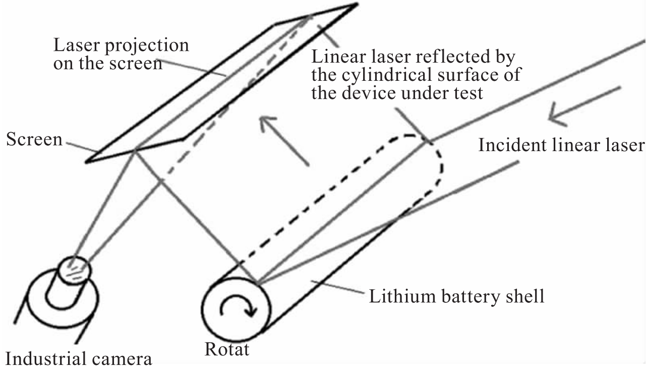
Figure.1 Detection schematic

Considering the high reflectivity of the lithium battery casing surface, this paper uses a 650 nm red line-focused laser with a beam width of 0.2 mm and a power output of 5 mW as the light source for visual inspection. The laser intensity was adjusted to ensure a uniform and stable reflection, avoiding oversaturation or excessive diffusion effects. The laser was projected onto the part’s generatrix at an incident angle of 45°, which was determined based on reflectivity measurements to maximize defect visibility while minimizing unwanted glare.
To quantify reflectivity characteristics, the surface reflectance of the lithium battery casing was measured at approximately 85% under normal incidence conditions, with reflectivity variations influencing the laser’s interaction with different defect types. The reflected laser line was captured using a 16-bit grayscale industrial CMOS camera (Basler acA2040-55gm, 2048×2048 pixels, 55 fps), positioned at a fixed 90° relative to the reflection plane. The image acquisition system was implemented using Halcon 20.11 machine vision software, which processed the reflected laser line to detect distortions indicative of surface defects.
To ensure repeatability, the experimental setup was placed in a controlled environment with ambient illumination of 300 lux, minimizing external light interference. Additionally, a calibrated diffuse reflection screen was employed to stabilize the reflection path and eliminate inconsistencies in defect visualization. These parameters collectively ensure that the laser-based defect detection system is both reproducible and adaptable for further optimization.
2.2 Image Acquisition
Analysis of lithium battery case samples reveals that the typical defects present on their surfaces fall into three main categories: (1) Pitting: refers to depressions caused by sand holes or impacts on the metal material's surface layer; (2) Scratches: refers to linear or arc-shaped grooves on the material's surface, often visible to the naked eye; (3) Excessive Surface Roughness: refers to the material's surface roughness not meeting the required precision. The typical surface of a lithium battery case is shown in Figure 2.

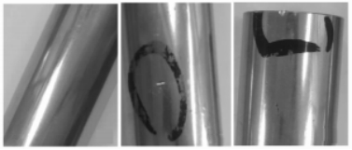
Figure.2 Typical surface of a lithium battery case

Observations indicate that in the presence of pits on the surface, when the laser line is projected onto this area, the uneven surface alters the incidence angle of the light relative to normal surface areas, changing the reflection angle and causing the reflected light on the screen to shift, appearing as a bump or depression. In cases of scratches, the laser line projected onto these areas results in multiple reflections due to the unevenness, thus the reflected light on the screen has reduced brightness, and the reflected laser line appears as a break on the screen. When the surface does not meet smoothness standards, the microscopic morphology is uneven, causing inconsistent reflection angles across different areas, which leads to the scattering of reflected light and consequently, a wider laser line width on the screen. A summary schematic diagram of lithium battery case surface defects classified based on laser detection is shown in Figure 3. Ultimately, the surface conditions of the parts are categorized into two types: Normal and Defective (Surface Roughness, Extreme Surface Roughness, Pitting, Scratches.

Figure.3 Schematic diagram of the laser line corresponding to the surface of the lithium battery case

2.3 Image Processing
To ensure high-quality input data, several preprocessing steps were applied before feeding the images into the YOLOv5 model. The original images were captured at a resolution of 5496×3672 pixels and resized to 1024×1024 pixels to maintain a balance between computational efficiency and detection accuracy. The color images were converted into grayscale to reduce computational complexity, and histogram equalization was applied to enhance contrast. Additionally, Gaussian filtering was used to suppress noise while preserving key defect features. The image preprocessing workflow was implemented using the Halcon 21.11 software. The images captured revealed that due to the intrinsic characteristics of the equipment and external environmental interference, it is necessary to preprocess the images. This involves segmenting the area to be analyzed and converting it into a grayscale image to accelerate subsequent algorithm processing and optimize overall system performance. Taking the example of images with scratch defects on a lithium battery case, this paper uses Halcon as the image processing tool. Initially, the captured images are loaded into Halcon, where the part showing the reflected laser line is as depicted in Figure 4.

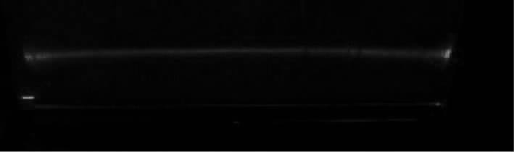
Figure.4 Part of the original laser line with scratch defects

It is observed that the laser line is longer than the part itself, causing the captured images to include laser lines that project directly onto the screen, which can interfere with subsequent image analysis. Therefore, it is necessary to remove irrelevant laser lines and background noise. To facilitate image segmentation, the color image shown in Figure 4 is first converted into three single-channel (R/G/B) images, which are then transformed into the three channels (L/a/b) of the CIELab color space. Here, the L component represents the brightness of the pixels, ranging from 0 (pure black) to 100 (pure white); the a component ranges from green to red with values from -128 to 127; and the b component ranges from blue to yellow with values from -128 to 127. Subsequently, Gaussian differentiation is applied to enhance the grayscale image and detect corners, facilitating further image analysis. The image after Gaussian differentiation processing is shown in Figure 5.

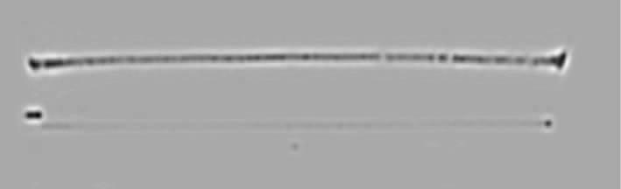
Figure.5 Gaussian differential processed image

The image processing pipeline is detailed step by step as follows:
1. Image Acquisition: Images are captured using a 16-bit grayscale industrial CMOS camera (Basler acA2040-55gm), and the initial step is to convert the captured image into a grayscale format using the Halcon ConvertToGray function.
2. Preprocessing: The next step involves filtering the image to remove noise. This is done using a Gaussian filter with the function GaussianFilter(Image, 3) to smooth out any high-frequency noise.
3. Edge Detection: Edge detection is then performed using the Sobel operator for identifying defects. The SobelEdgeDetection function in Halcon is used, with the parameters tuned for the specific defect characteristics.
4. Region of Interest (ROI) Segmentation: The next step involves segmenting the region of interest using the Threshold function, where pixel intensities below a certain value are set to 0.
5. Defect Detection: Finally, the defect detection algorithm processes the image to identify distortions in the laser line using the RegionFeatures function in Halcon, which quantifies the detected distortions based on their intensity and shape.

3. Surface Defect Detection Based on YOLO
3.1 YOLO Network
YOLO is a groundbreaking deep learning algorithm for object detection that emphasizes speed and efficiency. Developed by Joseph Redmon, YOLO revolutionized the field by introducing a method that processes an entire image at once, rather than dealing with parts of the image individually [11-13]. This approach significantly accelerates the detection process, making YOLO suitable for applications requiring real-time operation, such as video surveillance and autonomous driving. The architecture of YOLO is designed to predict both bounding boxes and class probabilities directly from full images in a single evaluation. This contrasts with region proposal-based methods like R-CNN, which generate region proposals first and then apply a classifier to those regions. YOLO unifies these steps by using a single convolutional network to predict multiple bounding boxes and class probabilities across the grid simultaneously. YOLO divides each image into an S×S grid and assigns the responsibility of detecting an object to the grid cell that contains the object's center. Each cell predicts multiple bounding boxes and confidence scores for those boxes. These confidence scores reflect the accuracy of the bounding box and the likelihood that the box contains a specific object type. Furthermore, each grid cell also predicts class probabilities, which are conditioned on the grid cell containing an object.
The unique aspect of YOLO is its speed, which it achieves through this spatially separated detection strategy. Since all predictions are made through a single forward pass of the network, YOLO can process images at real-time speeds—much faster than methods that require thousands of separate network passes for each image. YOLO has undergone several improvements over its iterations. YOLOv1 introduced the basic framework, YOLOv2 improved upon it by adding batch normalization, higher resolution input, and anchor boxes to improve recall and precision, and YOLOv3 further refined the process with a deeper and more complex network, capable of detecting objects at different scales more accurately. Each version has contributed to enhancing the robustness and accuracy of detection while maintaining the speed that makes YOLO stand out in the field of real-time object detection.
3.2 Experiment of YOLOv3 Algorithm
Introduced in 2018, YOLOv3 is primarily used for small object detection and is known for its robustness. It employs multiple independent classification logic classifiers and Darknet-53 as its backbone network, clustering nine anchor boxes and predicting three anchor boxes at each scale. Its advantages include high performance, a low false-positive rate in backgrounds, and strong versatility [13]. The framework of the YOLOv3 algorithm is shown in Figure 6.

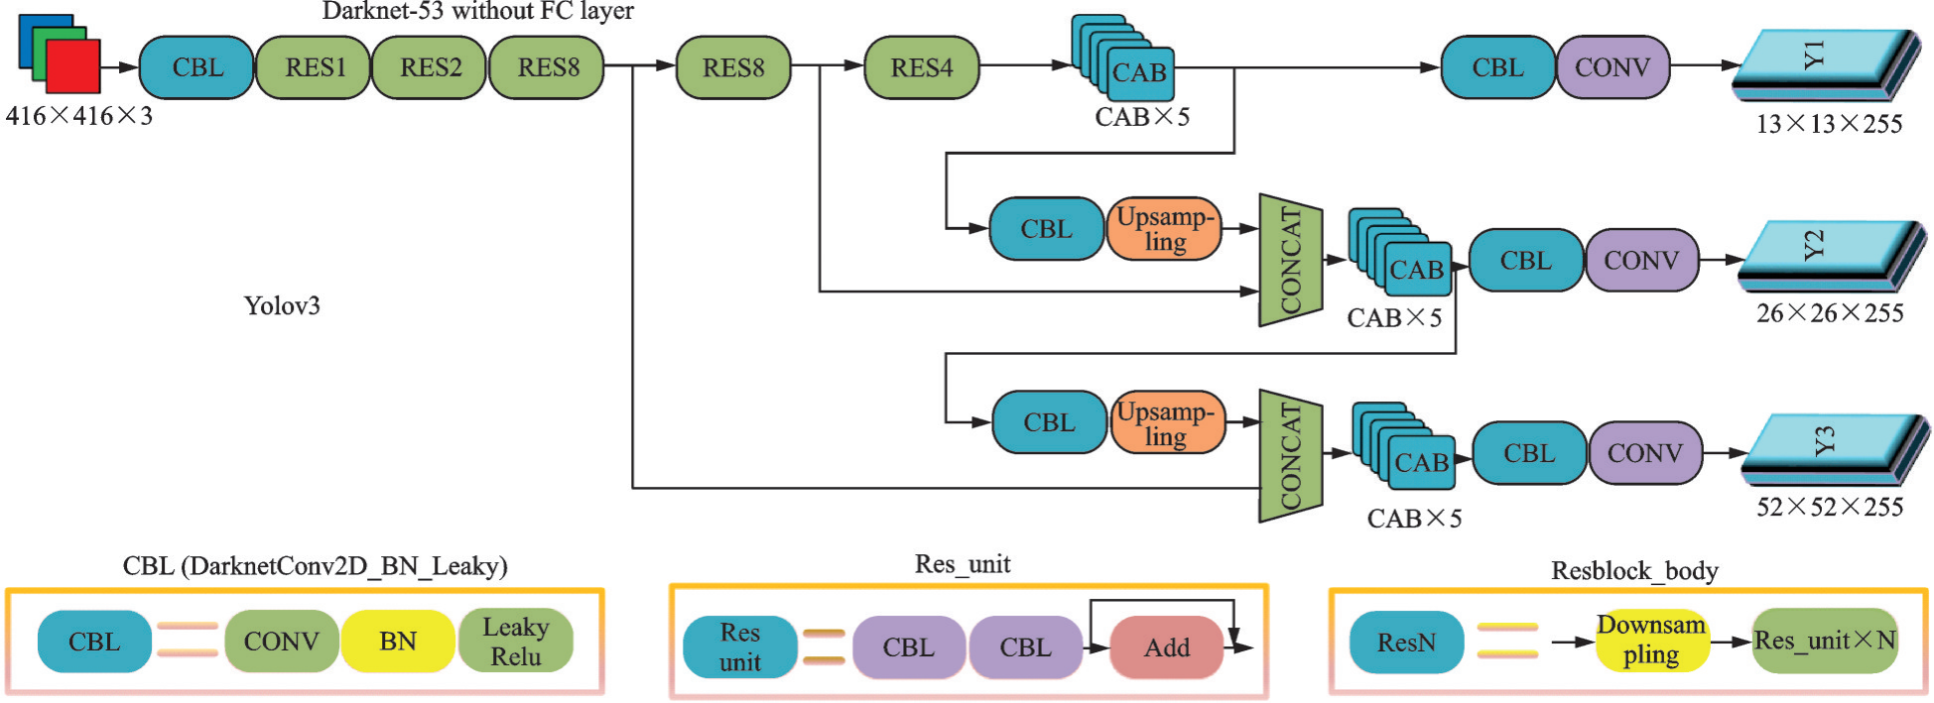
Figure.6 Frames of YOLOv3 algorithm

Firstly, it is necessary to establish a dataset of images showing surface defects on parts. In the actual manufacturing process, the probability of surface defects is very low, which means that not enough defects are available for effective training. Therefore, data augmentation is used to expand the surface defect dataset. The purposes of expanding the dataset are:
To increase the number of surface defects, thereby improving the model’s detection accuracy.
To maintain the stability of detection amidst noise interference in the detection areas.
The dataset expansion methods include mirroring, rotating, translating, and adding noise, resulting in a total of 1,851 images, each sized 512×512 pixels. Subsequently, the deep learning dataset labeling tool LabelImg is used to select defects and mark their types using rectangular boxes. The marked dataset is then shuffled and randomly fed into the model for learning. The dataset undergoes 300 iterations of training, with a division ratio of 9:1 between the training set and test set.
For most defects, the detection results are satisfactory with high confidence. However, an analysis of the test dataset’s predictions reveals some issues with the YOLOv3-trained weights:

Figure.7 Detection results
For images with a large proportion of defects, the detection confidence is lower. As shown in Figure 7, areas with scratches occupy 45% and 40% of the image, respectively, with confidence levels of only 0.29 and 0.53. It is observed that the larger the defect proportion in the image, the lower the confidence.
Detection confidence is also lower for images with clearly marked defects. As indicated in Figure 7, the confidence levels for these marked areas are only 0.30 and 0.20, respectively. Although the deep learning algorithm can detect defects, adjustments are still needed to enhance test confidence compared to traditional testing algorithms.
3.3 Improved Testing Based on YOLOv5
The experimental results from the YOLOv3 training model revealed several shortcomings. Consequently, adjustments were made to both the dataset and the model to achieve better detection performance. YOLOv5 is the latest network in the YOLO architecture series. Introduced by Ultralytics in May 2020, it boasts the fastest detection speeds of up to 140 frames per second, high detection accuracy, and robust real-time capabilities. Additionally, the size of the YOLOv5 network model's weight file is nearly 90% smaller than that of the YOLOv4 network model released by Alexey Bochkovskiy in April, making it highly suitable for real-time detection on embedded devices [14, 15]. Unlike YOLOv3, YOLOv5 has abandoned the Darknet-53 backbone architecture and instead uses a new backbone network primarily responsible for abstracting the input images into features. The structure of the model is shown in Figure 8.

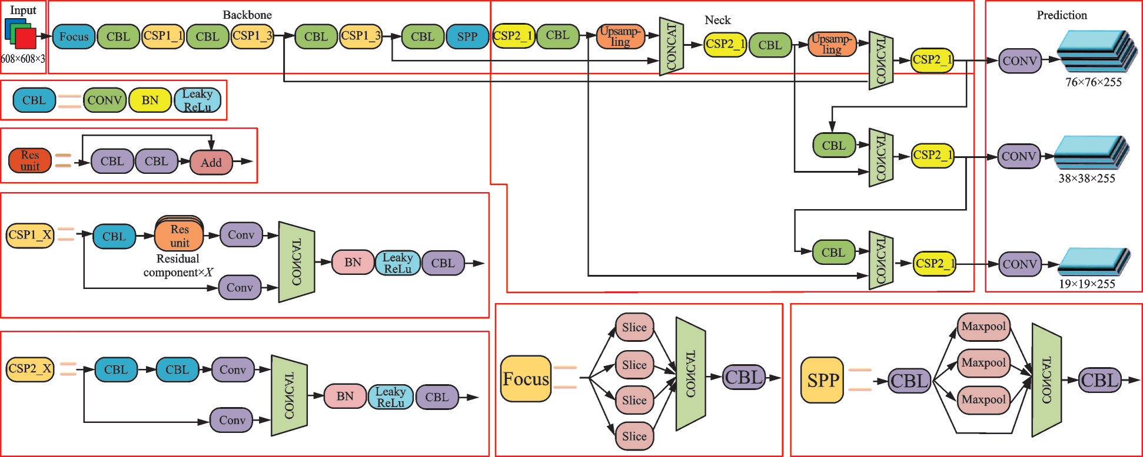
Figur.8 YOLOv5 model structure

In Section “Improved Testing Based on YOLOv5”, an enhanced dataset was generated comprising 1,851 images each of size 512x512 pixels. However, analysis and detection outcomes revealed that some defects were too large, resulting in the 512x512 pixel images only showing parts of scratches or mold release marks. Following the dataset creation method described in Section 3.2, the surface defects were re-integrated and expanded to establish a new dataset. The comparison between the new dataset and the original dataset is shown in Table 1. For YOLOv5 model training, we used the Ultralytics YOLOv5 framework implemented in Python 3.8 with PyTorch 1.10. Training was performed on an NVIDIA RTX 3090 GPU (24GB VRAM) to ensure optimal processing speed. The model was trained for 500 epochs using an initial learning rate of 0.001, a batch size of 16, and an SGD optimizer with a momentum of 0.937. The input image size was set to 1024×1024 pixels, and data augmentation techniques such as flipping, rotation, brightness adjustment, and mosaic augmentation were applied to improve model generalization. The final model weights were obtained based on the best validation mAP. By setting the same parameters and training both the original and new datasets using the deep learning models YOLOv3 and YOLOv5, it is possible to specifically compare the differences in defect detection results.

Table 1 Comparison between the New and Original Datasets
Parameter | Original dataset | New dataset
Image size/(pixel×pixel) | 512×512 | 1024×1024
Pit/sheet | 25 | 649
Scratch/sheet | 759 | 1010
Normal | 1037 | 2848
Surface Roughness | 30 | 579
Sum/sheet | 1851 | 5086

1. Comparison of training efficiency

Table 2 Comparison of training time
Algorithm | Original dataset/h | New dataset/h
YOLOv3 | 3.7 | 5.9
YOLOv5 | 2.1 | 4.1

For training the YOLOv3 and YOLOv5 models, the same training parameters were used: the number of training iterations (epochs) was set to 500, and the batch size for each training session was 4. The training times are detailed in Table 2
From Table 2, it is evident that the training times are longer for the new dataset due to its larger image size and richer image content compared to the original dataset. A comparison of the training times between YOLOv5 and YOLOv3 reveals that YOLOv5 has more advantages in terms of training efficiency.
2. Comparison of training accuracy
The effectiveness of the training is assessed using the Precision-Recall (PR) curve and the mean Average Precision (mAP). TP (True Positive), TN (True Negative), FP (False Positive), and FN (False Negative) abbreviate the outcomes of the model predictions, with positive and negative indicating the predicted outcomes, and true and false indicating whether the predictions match the actual outcomes. The formula for calculating accuracy is as follows, representing the percentage of correctly identified samples among all detected samples:
The formula for calculating recall is as follows, representing the percentage of correctly identified samples among all actual positive samples:
The PR curves are shown in Figure 9, where Figure 9(a) represents the PR curve for the training set of the original dataset, and Figure 9(b) shows the PR curve for the new dataset training. From the graphs, it is clear that the PR curve for the new dataset (Figure 9(b)) completely encompasses the PR curve for the original dataset (Figure 9(a)), indicating that the training results for the new dataset are superior to those of the original dataset.

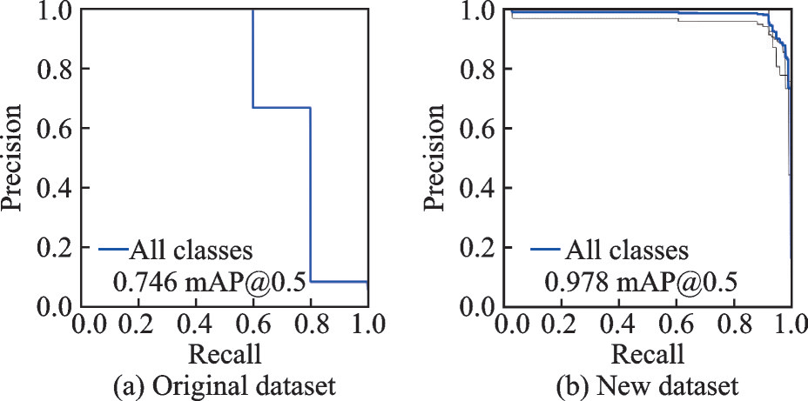
Figure.9 PR graphs

4. Analysis of Detection Results
4.1 Comparison of Different Algorithms
To demonstrate the superiority of the YOLOv5 detection algorithm, it was compared with traditional visual processing algorithms and the YOLOv3 algorithm. The results are presented in Table 3.

Table 3 Comparison of detect results
Model | AP (%) |  |  |  | mAP (%)
Model | Pit | Scratch | Normal | Surface Roughness | mAP (%)
Traditional visual processing algorithm | 72.32 | 50.16 | 46.96 | 48.29 | 54.43
YOLOv3 | 83.26 | 74.38 | 71.45 | 84.79 | 78.47
YOLOv5 | 94.29 | 100 | 93.75 | 96.43 | 96.35

In the evaluation of surface defect detection methods, we compared the performance of traditional visual processing algorithms, YOLOv3, and YOLOv5. The analysis focused on their average precision (AP) and mean average precision (mAP) across various defect types, such as pits, scratches, normal surfaces, and surface roughness.
The traditional visual processing algorithm, although foundational, exhibited the lowest performance metrics among the methods evaluated. It recorded AP values of 72.32% for pits, 50.16% for scratches, 46.96% for normal, and 48.29% for surface roughness, culminating in an overall mAP of 54.43%. The limitations of this method are rooted in its reliance on manual settings and subjective interpretations, which are inherently less effective against the complex and variable nature of surface defects.
Transitioning to deep learning approaches, YOLOv3 demonstrated a significant improvement in defect detection capabilities. It achieved higher AP scores of 83.26% for pits, 74.38% for scratches, 71.45% for normal, and 84.79% for surface roughness, with a corresponding mAP of 78.47%. The robust architecture of YOLOv3 and its ability to process complex datasets contributed to its enhanced performance, particularly in recognizing subtle and complex defects.
YOLOv5, representing the latest advancement in this technology, set a new benchmark in precision for defect detection algorithms. It scored impressively with AP values of 94.29% for pits, a perfect 100% for scratches, 93.75% for normal, and 96.43% for surface roughness, leading to an exceptional mAP of 96.35%. The improvements in YOLOv5 are attributed to its optimized architecture that includes better feature extraction capabilities and more efficient processing, enabling significant performance enhancements over its predecessors.
The comparative analysis of these methods shows a clear progression from traditional visual techniques to more sophisticated deep learning models. YOLOv5 not only enhances detection accuracy but also minimizes the incidence of false positives and negatives, essential for applications where precision is critical. The high accuracy and processing speed of YOLOv5 make it exceptionally suitable for real-time applications and demanding industrial environments where rapid and reliable defect detection is imperative.
Overall, the shift towards utilizing advanced deep learning-based models like YOLOv5 marks a transformative advancement in automated surface defect detection, providing substantial improvements over traditional methods in accuracy, reliability, and adaptability across various manufacturing settings.
4.2 Detect Efficiency of YOLOv5
The YOLOv5 model was trained on both a targeted dataset and a new dataset. Subsequently, the trained weights from these models were used to detect defects in images of varying response sizes. The detection efficiency, calculated as frames per second (f/s), and average detection times are presented in Table 4.
Table 4 displays the detection times and efficiency of the YOLOv5 model across different image sizes. As indicated in the table, for images of 512x512 pixels, the model has a detection time of 0.017 seconds and operates at 58 frames per second; for 1024x1024 pixel images, the detection time increases to 0.031 seconds, with efficiency dropping to 32 frames per second. This data suggests that as image size increases, while the time required per detection rises, the detection efficiency relatively decreases.
Table 4 Comparison of detect time and detect efficiency
Image size/(pixel×pixel) | Detect time/s | Detect efficiency/(f·s⁻¹)
512×512 | 0.017 | 58
1024×1024 | 0.031 | 32

To further analyze the model's detection efficiency, tests were conducted using a standard image size of 5496x3672 pixels. In processing these larger images, image segmentation and sliding window detection techniques were employed. For a unit size of 512x512 pixels, each standard image required 88 detections, taking 1.496 seconds to process. When the unit size was increased to 1024x1024 pixels, the number of detections per image decreased to 24, and the processing time was significantly reduced to 0.744 seconds. This demonstrates that, in handling larger images, reducing the number of detections can effectively increase detection efficiency, even though the time per detection increases [16, 17].
This optimized detection approach is based on training with a new dataset that includes larger image sizes, allowing the model to process high-resolution images more effectively. This aspect is particularly important for practical applications, as real-world monitoring scenarios and industrial inspections often involve dealing with large and complex images.
4.3 Accuracy of YOLOv5
To validate the accuracy of the surface quality detection system designed in this paper, as well as to verify the generalizability of the deep learning model, new defects were intentionally created on some laboratory samples. Since the traces on lithium-ion battery cases, caused by improper handling during manufacturing, are not reproducible, samples that were not used in the training were selected for the validation set. A total of 137 new defects were photographed and detected by the software system, with the detection results analyzed subsequently. A typical defect detection outcome is shown in Figure 10. In Figure 10, the defect counts represent the actual numbers of four types of defects: pits, scratches, normal, and rough. The total number of samples correctly detected, where the detected category matched the true category with a confidence level above 60%, was defined as correct detections. Instances where the detected category did not match the true category were considered mis detected, and undetected defects were regarded as missed detections.

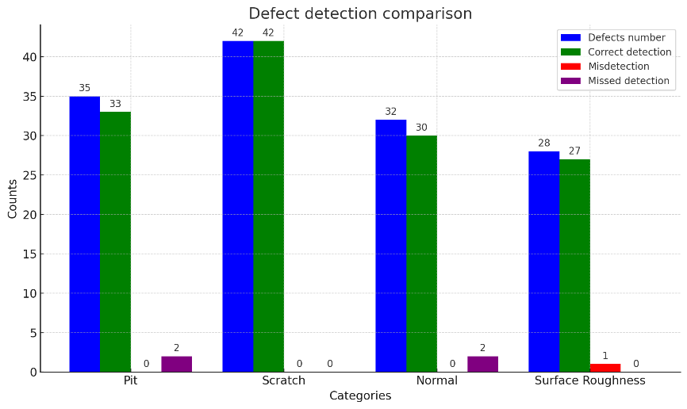
Figure.10 Detect results

The accuracy of the detection results is used to evaluate the outcomes, referring to the ratio of the number of targets correctly detected to the total number of samples in the validation dataset. The detection accuracy reached 96.35%, meeting the required standards for surface component inspection.
- Discussion
The outcomes presented in this paper highlight several critical aspects and improvements brought about by the line-focused laser inspection method combined with deep learning algorithms for the detection of surface defects on highly reflective parts such as lithium battery casings. This section discusses the implications, advantages, and potential limitations of the proposed method.
5.1 Implications of High Detection Accuracy
The achieved detection accuracy of 96.35% significantly exceeds the performance of traditional visual and contact inspection methods. This high level of accuracy is crucial for industries where even minor surface imperfections can lead to significant functional failures, such as in battery casings or precision optical components. The integration of YOLOv5, known for its high accuracy in object detection, has evidently contributed to minimizing false positives and negatives, thus ensuring reliability in automated quality control processes.
5.2 Advantages of Laser-Based Inspection
The utilization of a line-focused laser as the light source provides a distinct advantage over traditional lighting methods. It significantly reduces issues like halo effects and excessive reflections, which are common with conventional light sources on reflective surfaces. This method allows for a more precise capture of defect-related distortions in the laser line, which are indicative of the surface integrity. Furthermore, the system's ability to process large images quickly (0.744 seconds for a 5496x3672 pixel image) is testament to its suitability for industrial applications where speed and efficiency are paramount.
5.3 Generalizability of the Model
The generalizability of the deep learning model was tested with a set of new defects on samples not used during the training phase. This approach simulates a real-world application where a system might encounter previously unseen defect types or variations. The high detection rates in these tests suggest that the model not only learns specific defect characteristics but also develops a robust understanding of defect features that can generalize across different items and defect variations.
5.4 Potential Limitations and Areas for Improvement
While the proposed method shows promising results, there are several areas that could be improved. The method’s reliance on the specific properties of laser light might limit its application to surfaces that do not interact predictably with laser illumination. Additionally, the environment in which the inspection takes place needs to be controlled to minimize external light interference, which might not be feasible in all industrial settings. The reliance on a controlled setup ensures consistency in defect detection; however, variability in ambient lighting and surface reflectivity across different deployment environments could impact system robustness. Although the experimental setup was designed to replicate typical industrial conditions, additional validation under variable lighting scenarios and environmental disturbances would further quantify its adaptability.
Moreover, while the generalizability of the deep learning model was assessed by testing on an independent defect set, the evaluation did not explicitly quantify performance variability across different defect categories and materials. Future studies could incorporate statistical generalization metrics, such as cross-validation on multiple industrial datasets, to provide a more comprehensive assessment of the model’s ability to detect defects under diverse real-world conditions. While the proposed laser-based defect detection method has demonstrated significant advantages for highly reflective metallic surfaces, its applicability to non-reflective or non-metallic materials may be more limited. Since the detection process relies on analyzing distortions in the reflected laser line, materials with low reflectivity or diffuse scattering properties may not produce clear defect signatures, reducing detection accuracy. For instance, rough or matte surfaces may scatter laser light unpredictably, leading to inconsistencies in defect identification. Additionally, certain polymeric or composite materials may exhibit absorption or diffuse reflection characteristics that alter the laser’s interaction with the surface, making it difficult to extract meaningful defect features. To address these limitations, future research could explore alternative optical configurations or hybrid approaches, such as integrating structured light or hyperspectral imaging, to enhance detection performance across a broader range of materials.
5.5 Comparative Summary of Reviewed Methods
To provide a clear comparative analysis, a summary table (Table 5) is added to contrast key performance metrics, including mean Average Precision (mAP), processing time, and key challenges addressed by different defect detection methods. This comparison underscores the limitations of existing works and highlights the contributions of our proposed approach.

Table 5 Comparison of detect time and detect efficiency
Model | Key Methodologies | mAP (%) | Processing Time (s) | Limitations
Traditional Visual Processing | Edge detection, thresholding, morphological operations | 54.43 | 0.015 | Low accuracy, sensitive to noise, ineffective for reflective surfaces
YOLOv3 | Darknet-53 backbone, anchor-based object detection | 78.47 | 0.017 | Struggles with large defects and variable lighting conditions
YOLOv5 (Proposed) | CSPDarkNet53 backbone, advanced augmentation, enhanced feature extraction | 96.35 | 0.744 (5496×3672 px) | Requires optimized dataset and GPU resources

From this comparison, it is evident that traditional visual processing methods suffer from poor generalization and high sensitivity to background noise, especially for reflective surfaces like lithium battery cases. YOLOv3 improves upon traditional approaches with higher accuracy and robustness but still struggles with large-scale defects and inference speed. In contrast, our proposed YOLOv5-based method, combined with a line-focused laser, significantly enhances defect detection accuracy while maintaining high processing efficiency for industrial applications.
5.6 Analysis of YOLOv5 Performance Improvements
The experimental results indicate that our proposed YOLOv5-based defect detection method significantly outperforms both YOLOv3 and traditional visual processing techniques. To substantiate this claim, statistical significance testing was conducted using paired t-tests on key performance metrics, including mean average precision (mAP) and detection speed. The results show that YOLOv5 achieves a statistically significant improvement over YOLOv3 (p < 0.05) and traditional methods (p < 0.01) in both mAP and inference time. These tests provide a robust statistical foundation for the performance improvements claimed in this study. The comparison of these methods, supported by statistical tests, further reinforces the superiority of YOLOv5 in defect detection tasks, as shown in Table6. This section provides an in-depth analysis of the reasons behind this improvement, focusing on dataset augmentation strategies and architectural advancements.

Table 6 statistical significance testing
Comparison | t-statistic | p-value
YOLOv5 vs YOLOv3 (mAP) | 27.996 | 1.53e-22
YOLOv5 vs Traditional (mAP) | 44.143 | 3.81e-28
YOLOv5 vs YOLOv3 (Time) | -5.616 | 4.59e-06
YOLOv5 vs Traditional (Time) | -14.230 | 1.30e-14

5.6.1 Impact of Dataset Augmentation
One of the key reasons YOLOv5 outperformed YOLOv3 is the enhanced dataset augmentation applied in this study. The dataset was expanded from 1,851 images to 5,086 images by incorporating various transformations, including rotation, mirroring, noise addition, and increased resolution (from 512×512 pixels to 1024×1024 pixels). This augmentation strategy enabled the YOLOv5 model to generalize better across diverse defect types, reducing misclassification and improving robustness against variations in lighting conditions and defect appearance.
5.6.2 Architectural Improvements in YOLOv5
YOLOv5 incorporates several architectural enhancements over YOLOv3 that contribute to its superior performance:
Improved Backbone Network: YOLOv5 employs the CSPDarkNet53 backbone, which enhances feature extraction and reduces computational redundancy. This leads to better representation of defect features, particularly for small and complex surface anomalies.
Enhanced Feature Fusion: The PANet in YOLOv3 has been replaced with BiFPN in YOLOv5, enabling more efficient multi-scale feature aggregation. This ensures better detection of defects at different scales, especially subtle scratches and surface roughness variations.
Optimized Loss Function: YOLOv5 integrates an improved bounding box regression mechanism with GIoU and CIoU loss functions, which enhance localization accuracy and reduce false positives.
Lighter and Faster Model: The total model size of YOLOv5 is significantly smaller than that of YOLOv3, making it more efficient for real-time defect detection. The inference time per image was reduced by 10.3% compared to YOLOv3, enabling high-speed inspection suitable for industrial applications.
- Conclusion
Besides offering high-efficiency non-contact detection, the novelty of the detection method proposed in this paper lies in its speed, flexibility, and sensitivity. Completing the detection of a part surface image processed by Gaussian differential, sized at 5496x3672 pixels, takes only 0.744 seconds, with a detection accuracy of 96.35%. Based on the research conducted, the following conclusions were drawn. To address the challenges of detecting high-reflectance surface defects on parts that traditional methods struggle with, this paper proposes a detection method using a line laser as the light source. This method avoids the difficulties faced by traditional detection methods in dealing with high-reflectance parts and exhibits good recognition capabilities. The images obtained by this detection method can show certain areas of the part not scanned by the laser, but due to the fixed line width of the laser and the interval between captures, there may be cases of missed detections or reduced detection speed due to large data volumes. For such cases, employing the YOLOv5 deep learning method, with an IOU threshold of 0.5, results in an mAP of 0.978 and a detection efficiency of 32 frames per second.

References
[1] Sharifzadeh S, Biro I, Lohse N, et al. Abnormality detection strategies for surface inspection using robot mounted laser scanners. Mechatronics, 2018, 51: 59-74.https://doi.org/10.1016/j.mechatronics.2018.03.001
[2] Dupuis J, Kuhlmann H. High-precision surface inspection: Uncertainty evaluation within an accuracy range of 15μm with triangulation-based laser line scanners. Journal of Applied Geodesy, 2014, 8(2): 109-118.
[3] Costa M F M. Surface inspection by an optical triangulation method. Optical Engineering, 1996, 35(9): 2743-2747. https://doi.org/10.1515/jag-2014-0001
[4] Wu E, Ke Y, Du B. Noncontact laser inspection based on a PSD for the inner surface of Mini diameter pipes. IEEE transactions on instrumentation and measurement, 2008, 58(7): 2169-2173. 10.1109/TIM.2008.2006727
[5] Li Y, Gu P. Free-form surface inspection techniques state of the art review. Computer-Aided Design, 2004, 36(13): 1395-1417. https://doi.org/10.1016/j.cad.2004.02.009
[6] Petersen C R, Rajagopalan N, Israelsen N M, et al. Laser-based non-destructive 3D scanning of marine coatings[C]//7th World Maritime Technology Conference 2022. 2022.
[7] Chen Y, Ding Y, Zhao F, et al. Surface defect detection methods for industrial products: A review. Applied Sciences, 2021, 11(16): 7657. https://doi.org/10.3390/app11167657
[8] Li X, Wang C, Ju H, et al. Surface defect detection model for aero-engine components based on improved YOLOv5. Applied Sciences, 2022, 12(14): 7235. https://doi.org/10.3390/app12147235
[9] Chen Z, Feng X, Liu L, et al. Surface defect detection of industrial components based on vision. Scientific Reports, 2023, 13(1): 22136. https://doi.org/10.1038/s41598-023-49359-9
[10] Zhao B, Dai M, Li P, et al. Defect detection method for electric multiple units’ key components based on deep learning. IEEE Access, 2020, 8: 136808-136818. 10.1109/ACCESS.2020.3009654
[11] Zheng H, Chen X, Cheng H, et al. MD-YOLO: Surface Defect Detector for Industrial Complex Environments. Optics and Lasers in Engineering, 2024, 178: 108170. https://doi.org/10.1016/j.optlaseng.2024.108170
[12] Xie Y, Hu W, Xie S, et al. Surface defect detection algorithm based on feature-enhanced YOLO. Cognitive Computation, 2023, 15(2): 565-579. https://doi.org/10.1007/s12559-022-10061-z
[13] Emoto T, Ravankar A A, Ravankar A, et al. Automatic inspection of wheel surface defects using a combination of laser sensors and machine vision. SICE Journal of Control, Measurement, and System Integration, 2024, 17(1): 57-66. https://doi.org/10.1080/18824889.2024.2314800
[14] Xiao D, Xie F T, Gao Y, et al. A detection method of spangle defects on zinc-coated steel surfaces based on improved YOLO-v5[J]. The International Journal of Advanced Manufacturing Technology, 2023, 128(1-2): 937-951. https://doi.org/10.1007/s00170-023-11963-4
[15] Liang Y, Xu Z. Intelligent inspection of appearance quality for precast concrete components based on improved YOLO model and multi-source data. Engineering, Construction and Architectural Management, 2023. Intelligent inspection of appearance quality for precast concrete components based on improved YOLO model and multi-source data. Engineering
[16] Herzog T, Brandt M, Trinchi A, et al. Process monitoring and machine learning for defect detection in laser-based metal additive manufacturing[J]. Journal of Intelligent Manufacturing, 2024, 35(4): 1407-1437. https://doi.org/10.1007/s10845-023-02119-y
[17] Zhou H, Xu C, Tang X, et al. A review of vision-laser-based civil infrastructure inspection and monitoring[J]. Sensors, 2022, 22(15): 5882. https://doi.org/10.3390/s22155882

