A Modified Emperor Penguin Algorithm for Solving Stagnation in Multi-Model Functions
Ahmed Serag¹, Hegazy Zaher², Naglaa Ragaa³, Heba Sayed⁴
E-mail: ahmede.serag1978@gmail.com, hgsabry@cu.edu.eg, naglaa777subkiii@yahoo.com, hmhmdss@yahoo.com
¹Operations Research, faculty of graduate studies for statistical research, Cairo University, Giza, Egypt
²Mathematical Statistics, Faculty of Graduate Studies for Statistical Research, Cairo University
Keywords: Optimization, Metaheuristics, Emperor Penguin Algorithm
Received:
Abstract: Metaheuristic algorithms have gained attention in recent years for their ability to solve complex problems that cannot be solved using classical mathematical techniques. This paper proposes an improvement to the Emperor Penguin Optimizer algorithm, a population-based metaheuristic. The original algorithm often gets stuck in local optima for multi-modal functions. To address this issue, this paper presents a modification in the relocating procedures that allows the algorithm to utilize information gained from the previous positions of each penguin. To demonstrate the effectiveness of the modified algorithm, 20 test optimization functions from well-known benchmarks were selected. The results show that the proposed algorithm is highly efficient, especially in multi-modal functions.
Povzetek:
- Introduction
Problem-solving can be approached in various ways, such as trial and error, experimental design, or mathematical techniques [1]. Operations research is a field that employs mathematical formulation to solve complex engineering and management problems and gain insight into potential solutions [2]. Mathematical approaches used in this field can be classified into classical techniques like simplex method and dynamic programming, and heuristic and metaheuristic methods like the Emperor Penguin Optimizer algorithm (EPO) [3].
EPO is a population-based metaheuristic algorithm proposed by Dhiman & Kumar [4], inspired by the behavior of emperor penguins in utilizing crowds to survive the Antarctic winter. While the original algorithm is efficient in solving unimodal problems, it stagnates with complex problems like multi-local minima problems. Previous work on EPO in the literature includes the binary version by Dhiman et al. [5], multi-objective optimization by Kaur et al. [6], photovoltaic system optimization by Sameh et al. [7], support vector machine optimization for face recognition by Yang and Gao [8], RGB image threshold optimization by Jia et al. [9], and energy-efficient residential building design by Tang et al. [10]. However, these studies focused on applying the EPO algorithm to solve real-world problems and did not address its stagnation issue in multi-modal problems.
Therefore, this paper proposes a modification to the EPO algorithm to increase its efficiency. The second section discusses the original algorithm's main steps, followed by the proposed modification in the third section. The fourth section presents comparative results between the original and modified EPO, and the fifth section concludes the paper.
- The Original Emperor Penguin Optimizer Algorithm
The Emperor Penguin Optimizer (EPO) is a population-based metaheuristic inspired by the crowd behavior of emperor penguins. The algorithm's steps include calculating the ambient temperature, distances toward the emperor penguins, and effective movers. To calculate the temperature around the crowd ($TA$), the temperature of each penguin ($T$) is considered, depending on the radius ($R$) that surrounds the crowd. The temperature profile around the crowd can be calculated using Equation (1), where the iteration number ($Itr$) and the maximum number of iterations ($MaxItr$) are taken into account.
$$TA=T-\frac{MaxItr}{Itr-MaxItr} , ∀Itr<MaxItr$$ | (1)
$$T= \left\{\begin{aligned}\begin{matrix}0, if R>1 \\ 1, if R<1\end{matrix}\end{aligned}\right.$$
The distance between the penguins and their emperor ($D$) is to be calculated using some sort of parameters related to avoiding collision between penguins ($A$), the position of the best penguin ($P_{best}$), the position of each penguin ($P$), the ambient temperature, $TA$, and the social force ($S$) that forces the penguins to move towards the direction of best solution. The parameter $A$ is to be calculated for the position $P_{i}$using the movement parameter ($M$), which is set to 2, in equation (2).
$$A=M×\left(TA+\left|P_{best}-P_{i}\right|×rand\right)-TA$$ | (2)
Equation (3) is used to calculate the social force. This equation is a decreasing function that has three variables, $f$, $l$, and $Itr$. Both of $f$and $l$are random numbers that each as its lower and upper bound. Figure x shows an example of having $f$belongs to the interval $\left[2, 5\right]$ and $l$belongs to the interval$[2, 10]$.
$$S= {\left(\sqrt{f . e^{-Itr/l}-e^{-Itr}}\right)}^{2}$$ | (3)
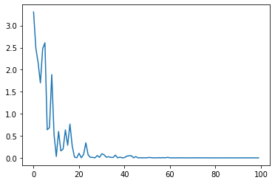
Figure 1 Social force parameter’s graph
The parameter $S$is used to calculate the distance$D$, where it increases in the very first iterations to guarantee high locality and decrease it gradually until reaching very low locality in the higher iterations. So, the distance $D$is to be calculated using equation (4) as follows:
$$D=\left|S . P_{i}-rand P_{best}\right|$$ | (4)
Now, the position of the penguin in the next iteration ($P_{i+1}$) can be calculated using equation (5) as follows:
$P_{i+1}=P_{i}-A . D$ | (5)

The best position is updated by changing the penguin's position in each iteration until the stopping criteria is met, and then the best solution is returned. The pseudocode for the algorithm can be summarized as follows:
1 | $$Input the Populatin size (N), MaxItr, and R parameters$$
2 | $$Generate the initial population$$
3 | $$Evaluate each solution in population and store the$$  $$best solution (P_{best})$$
4 | $$Itr=1$$
5 | $$While Itr≤MaxItr do:$$
6 |  | $$i=1$$
7 |  | $$While i≤N do:$$
8 |  |  | $$TA=T-\frac{MaxItr}{Itr-MaxItr}$$
9 |  |  | $$A=M×\left(TA+\left|P_{best}-P_{i}\right|×rand\right)-TA$$
10 |  |  | $$S= {\left(\sqrt{f . e^{-Itr/l}-e^{-Itr}}\right)}^{2}$$
11 |  |  | $$D=\left|S . P_{i}-rand P_{best}\right|$$
12 |  |  | $$P_{i+1}=P_{i}-A . D$$
13 |  |  | $$if f\left(P_{i+1}\right)≤f\left(P_{best}\right) then:$$
14 |  |  |  | $$P_{best}=P_{i+1}$$
15 |  |  | $$i=i+1$$
16 |  | $$Itr=Itr+1$$
17 | $$Return Gbest$$
- The Proposed Modified EPO Algorithm
In this section, a new modification to the EPO algorithm is proposed, which involves utilizing information gained from the current position of each penguin before relocating it. This modification constructs an information vector using a threshold selected from the interval $[0, 1]$. The current position, $P_{i}$, and the position generated using equation (5) are used to create the information vector, $P_{IV}$. The new procedure selects the components of $P_{IV}$ using the threshold. The first step of the new procedure is to generate a uniform random number that will be compared to the selected threshold. If the generated uniform random number is greater than the threshold, then component $j$is selected from $P_{i+1}$; otherwise, it is selected from $P_{i}$. The following steps show the procedure for creating the $P_{IV}$position:
1 | $$j=1$$
2 | $$While j≤\dim\left(P\right) do:$$
3 |  | $$if rand>threshold:$$
4 |  |  | $$P_{IV}\left[j\right]=P_{i+1}\left[j\right]$$
5 |  | $$else:$$
6 |  |  |  | $$P_{IV}\left[j\right]=P_{i}\left[j\right]$$
7 |  | $$j=j+1$$
After creating the information vector, $P_{IV}$, it will be evaluated using the objective function, and if its evaluation is better than both $P_{i}$and $P_{i+1}$, then $P_{IV}$will replace $P_{i}$ to be used in the next iteration of the algorithm. The full steps of the Modified Emperor Penguin Algorithm Optimizer (MEPO) can be shown as follows:
1 | $$Input the Populatin size (N), MaxItr, and R parameters$$
2 | $$Generate the initial population$$
3 | $$Evaluate each solution in population and store the best solution (P_{best})$$
4 | $$Itr=1$$
5 | $$While Itr≤MaxItr do:$$
6 |  | $$i=1$$
7 |  | $$While i≤N do:$$
8 |  |  | $$TA=T-\frac{MaxItr}{Itr-MaxItr}$$
9 |  |  | $$A=M×\left(TA+\left|P_{best}-P_{i}\right|×rand\right)-TA$$
10 |  |  | $$S= {\left(\sqrt{f . e^{-Itr/l}-e^{-Itr}}\right)}^{2}$$
11 |  |  | $$D=\left|S . P_{i}-rand P_{best}\right|$$
12 |  |  | $$P_{i+1}=P_{i}-A . D$$
13 |  |  | $$j=1$$
14 |  |  | $$While j≤\dim\left(P\right) do:$$
15 |  |  |  | $$if rand>threshold:$$
16 |  |  |  |  |  | $$P_{IV}\left[j\right]=P_{i+1}\left[j\right]$$
17 |  |  |  | $$else:$$
18 |  |  |  |  | $$P_{IV}\left[j\right]=P_{i}\left[j\right]$$
19 |  |  |  | $$j=j+1$$
20 |  |  | $$if f\left(P_{i+1}\right)≤f\left(P_{best}\right) then:$$
21 |  |  |  | $$P_{best}=P_{i+1}$$
22 |  |  | $$i=i+1$$
23 |  | $$Itr=Itr+1$$
24 | $$Return Gbest$$
- Comparative Results
Both algorithms, EPO and MEPO, were implemented using Python programming language on a PC equipped with a Core i5 processor clocked at 3.40GHz and 4 gigabytes of RAM. To evaluate their performance, a set of benchmark problems available at https://www.sfu.ca
/~ssurjano/optimization.html were selected as shown in Table 1. The parameters of both algorithms were set as high as possible to demonstrate their effectiveness in finding the global minimum. Specifically, the population size ($N$) was set to 100, the maximum number of iterations ($MaxItr$) was set to 100, and $R$ was randomly selected for each solution in each iteration from the interval $\left[0, 50\right]$.
Table 1 Selected test optimization problems

No. | Function Name | $$f(x)$$ | Global Minimum
1 | Ackley | $$20 \left(e^{-0.2 \sqrt{\frac{1}{d}\sum_{i=1}^{d}{{x_{i}}^{2}}}}\right)-\left(e^{\frac{1}{d}\sum_{i=1}^{d}{\cos\left(2πx_{i}\right)}}\right)+20+e, x_{i}∈\left[-33, 33\right]$$ | $$f\left(x^{*}\right)=0, x^{*}=(0, …, 0)$$
2 | Bent Cigar | $$x_{1}^{2}+{10}^{6}\sum_{i=2}^{n}{x_{i}^{2}}, x_{i}∈\left[-100, 100\right]$$ | $$f\left(x^{*}\right)=0, x^{*}=(0, …, 0)$$
3 | Bohachevsky | $${x_{1}}^{2}+2{x_{2}}^{2}-0.3\cos\left(31πx_{1}\right)-0.4\cos\left(31πx_{2}\right)+0.7, x_{i}∈\left[-100, 100\right]$$ | $$f\left(x^{*}\right)=0, x^{*}=(0, 0)$$
4 | Booth | $${(x_{1}+2x_{2}-7)}^{2}+{(2x_{1}+x_{2}-5)}^{2}, x_{i}∈\left[-10, 10\right]$$ | $$f\left(x^{*}\right)=0, x^{*}=(1, 3)$$
5 | Bukin | $$100\sqrt{\left|x_{2}-0.01{x_{1}}^{2}\right|}+0.01\left|x_{1}+10\right|, x_{i}∈\left[-15, 3\right]$$ | $$f\left(x^{*}\right)=0, x^{*}=(-10, 0)$$
6 | Cross-in-Tray | $$-0.0001{\left(\left|sin\left(x_{1}\right) sin\left(x_{2}\right)e^{\left|100 - \frac{\sqrt{x_{1}^{2}+x_{2}^{2}}}{π}\right|}\right|+1\right)}^{0.1}, x_{i}∈\left[-15,15\right]$$ | $$f\left(x^{*}\right)=-2.06261, x^{*}=\left(1.3491, -1.3491\right)$$
7 | Drop Wave | $$-\frac{1+\cos\left(12\sqrt{x_{1}^{2}+x_{2}^{2}}\right)}{0.5\left(x_{1}^{2}+x_{2}^{2}\right)+2}, x_{i}∈[-5.12, 5.12]$$ | $$f\left(x^{*}\right)=-1.5, x^{*}=(0,0)$$
8 | Discus | $${10}^{6}x_{1}^{2}+\sum_{i=2}^{D}{x_{i}^{2}}, x_{i}∈\left[0, 100\right]$$ | $$f\left(x^{*}\right)=0, x^{*}=(0, …, 0)$$
9 | Easom | $$-\cos\left(x_{1}\right)\cos\left(x_{2}\right) e^{\left(-{\left(x_{1}-π\right)}^{2}-{\left(x_{2}-π\right)}^{2}\right)}, x_{i}∈\left[-100, 100\right]$$ | $$f\left(x^{*}\right)=-1, x^{*}=(π, π)$$
10 | Eggholder | $$-\left(x_{2}+47\right)\sin\left(\sqrt{\left|x_{2}+\frac{x_{1}}{2}+47\right|}\right)-x_{1}\sin\left(\sqrt{\left|x_{1}-\left(x_{2}+47\right)\right|}\right), x∈\left[-500, 500\right]$$ | $$f\left(x^{*}\right)=-959.6407, x^{*}=\left(512, 404.2319\right)$$
11 | Griewank | $$\sum_{i=1}^{d}{\frac{x_{i}^{2}}{4000}-\prod_{i=1}^{d}{\cos\left(\frac{x_{i}}{\sqrt{i}}\right)+1}}, x∈\left[-600, 600\right]$$ | $$f\left(x^{*}\right)=0, x^{*}=(0, …, 0)$$
12 | Holder Table | $$-\left|\sin\left(x_{1}\right)\cos\left(x_{2}\right)e^{\left(\left|1-\frac{\sqrt{x_{1}^{2}+x_{2}^{2}}}{π}\right|\right)}\right|, x_{i}∈\left[-10, 10\right]$$ | $$f\left(x^{*}\right)=-19.2085, x^{*}=\left(8.05502, -9.66459\right)$$
13 | Michalewicz | $$-\sum_{i=1}^{d}{\sin\left(x_{i}\right)\sin^{20}\left(\frac{ix_{i}^{2}}{π}\right)}, x∈\left[0, π\right]$$ | $$f\left(x^{*}\right)=-1.8013, x^{*}=(2.20,1.57)$$
14 | Modified Schwefel | $$418.9829×D-\sum_{i=1}^{D}{g\left(z_{i}\right)}, z_{i}=x_{i}+4.209687462275036e+002, x_{i}∈\left[-500, 500\right]$$  $$g\left(z_{i}\right)=\left\{\begin{aligned}\begin{matrix}z_{i}\sin\left({\left|z\right|}^{\frac{1}{2}}\right), if \left|z_{i}\right|≤500 \\ \left(500-mod\left(z_{i}, 500\right)\right)\sin\left(\sqrt{500-\left|mod\left(z_{i}, 500\right)\right|}\right)-\frac{{\left(z_{i}-500\right)}^{2}}{1000D}, if z_{i}>500 \\ \left(mod\left(\left|z_{i}\right|, 500\right)-500\right)\sin\left(\sqrt{\left|mod\left(\left|z_{i}\right|, 500\right)-500\right|}\right)-\frac{\left(z_{i}+500\right)}{1000D}, if z_{i}<-500\end{matrix}\end{aligned}\right.$$ | $$f\left(x^{*}\right)=0, x^{*}=[0, …, 0]$$
15 | Rastrigin | $$10d+ \sum_{i=1}^{d}{\left[x^{2}-10\cos\left(2π x_{i}\right)\right]}, x_{i}∈\left[-5, 5\right]$$ | $$f\left(x^{*}\right)=0, x^{*}=[0, …, 0]$$
16 | Rosenbrock | $$\sum_{i=1}^{d-1}{\left[100{\left(x_{i+1}-{x_{i}}^{2}\right)}^{2}+{\left(x_{i}-1\right)}^{2}\right]}, x_{i}∈\left[-5, 10\right]$$ | $$f\left(x^{*}\right)=0, x^{*}=(1, …, 1)$$
17 | Schwefel | $$418.9829d-\sum_{i=1}^{d}{x_{i}\sin\left(\sqrt{\left|x_{i}\right|}\right)}, x_{i}∈\left[-500, 500\right]$$ | $$f\left(x^{*}\right)=0, x^{*}=(420.9687, …, 420.9687)$$
18 | six-hump | $$\left(4-2.1{x_{1}}^{2}+\frac{{x_{1}}^{4}}{3}\right){x_{1}}^{2}+x_{1}x_{2}+\left(-4+4{x_{2}}^{2}\right){x_{2}}^{2}, x_{i}∈\left[-3, 3\right]$$ | $$f\left(x^{*}\right)=-1.0316, x^{*}=(0.0898, -0.7126)$$
19 | Sphere | $$\sum_{i=1}^{n}{{x_{i}}^{2}}, x_{i}∈\left[-5, 5\right]$$ | $$f\left(x^{*}\right)=0, x^{*}=[0, …, 0]$$
20 | Zakharov | $$\sum_{i=1}^{d}{{x_{i}}^{2}}+{\left(\sum_{i=1}^{d}{0.5ix_{i}}\right)}^{2}+{\left(\sum_{i=1}^{d}{0.5ix_{i}}\right)}^{4}, x_{i}∈\left[-5, 10\right]$$ | $$f\left(x^{*}\right)=0, x^{*}=(0, …, 0)$$

The selected optimization test functions were chosen to cover functions with different shapes, including those with many local minima, bowl-shaped, plate-shaped, steep ridges/drops, and valley-shaped. Figure 2 and Figure 3 present a comparison between EPO and MEPO. The figure shows that the modified version exhibits high efficiency in terms of convergence and the number of iterations. Moreover, Table 2 presents the results of the implementation for each algorithm. The optimized results are shown in bold, and all of them are associated with the MEPO algorithm. MEPO shows significant improvement in mini local minima functions such as the Schwefel function, where EPO was usually stuck in local optima without any improvement towards the global minimum.
Table 2 The results of algorithms
Function | MEPO | EPO | optimal
Ackley | 0.225684 | 2.542436 | 0
Bent Cigar | 1.196785 | 1382.235 | 0
Bohachevsky | 0.00735 | 0.257789 | 0
Booth | 0.00000069 | 0.000012 | 0
Bukin | 0.233874 | 1.592558 | 0
Cross in tray | -2.06261 | -2.06261 | -2.06261
Drop Wave | -1.5 | -1.46803 | 1.5
Discus | 4.628834 | 339.8925 | 0
Easom | -0.99999 | -0.82946 | -1
Eggholder | -957.88 | -943.112 | -959.6407
Griewank | 1.056911 | 22.50355 | 0
Holder Table | -19.2085 | -19.2048 | -19.2085
Michalewicz | -9.59914 | -8.06316 | -1.8013
Modified Schwefel | 4.788313 | 1174.038 | 0
Rastrigin | 0.024432 | 0.265543 | 0
Rosenbrock | 6.752897 | 9.624557 | 0
Schwefel | 17.40855 | 1567.621 | 0
Six hump | -1.03163 | -1.03163 | -1.316
Sphere | 0.0000766 | 0.000666 | 0
Zakharov | 0.023173 | 0.421517 | 0
- Conclusion
This paper presents a new improvement to the EPO algorithm presented by Dhiman and Kumar [4]. After coding the algorithm using Python programming and implementing it on a set of test optimization problems with various shapes such as many local minima, bowl-shaped, plate-shaped, steep ridges/drops, and valley-shaped, it was found that the EPO algorithm stagnated in some functions without showing any improvement. The proposed modification provides more accurate results than the original algorithm in most of the considered test functions, making the proposed algorithm more reliable than the original one.
Future research may include one of the following points:
- Developing further improvements to increase the efficiency of the algorithm and apply it to CEC2017 problems.
- Applying the algorithm to solve real-world problems, such as transshipment, transportation, and job shop scheduling problems.
- Optimizing the parameters of the algorithm using design of experiments.
- Hybridizing the algorithm with other metaheuristic algorithms to improve its efficiency.

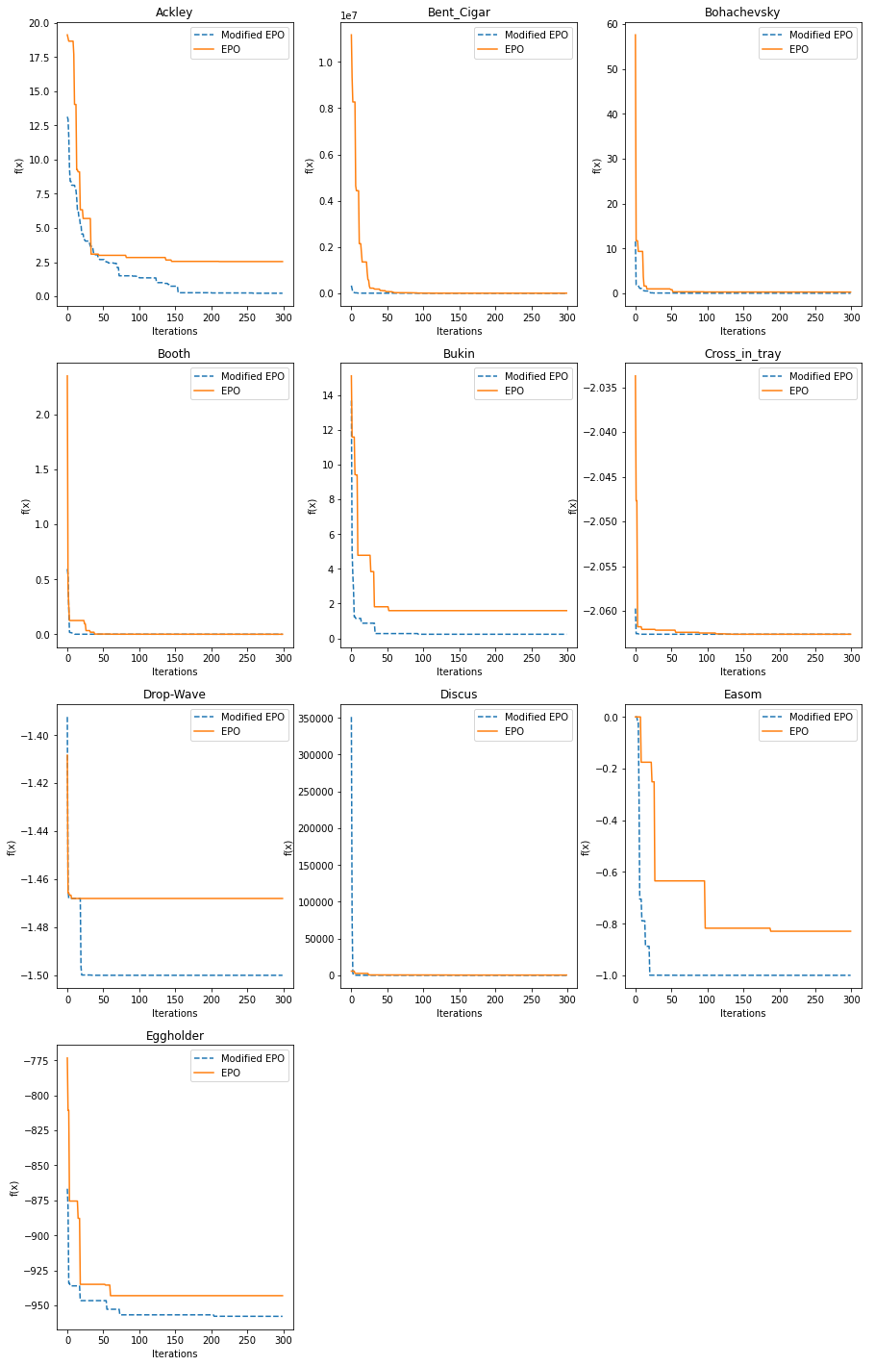
Figure 2 the results of the first 10 functions

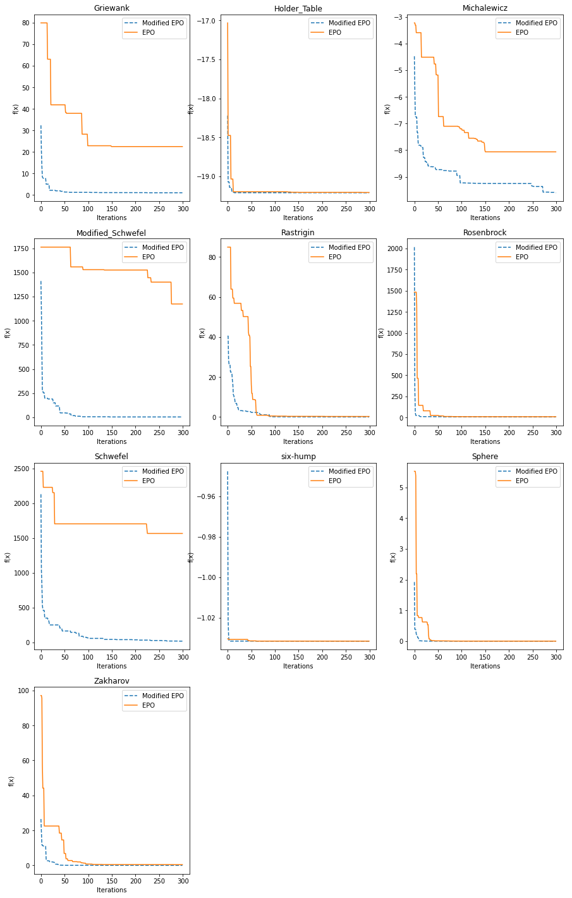
Figure 3 The results of the second 10 functions

References
[1] M. A. Kader, K. Z. Zamli, and B. S. Ahmed, “A systematic review on emperor penguin optimizer,” Neural Comput. Appl., vol. 33, no. 23, pp. 15933–15953, 2021, doi: 10.1007/s00521-021-06442-4.
[2] P. R. Murthy, Operations research (linear programming). bohem press, 2005.
[3] L. M. Abualigah, A. T. Khader, and E. S. Hanandeh, “Hybrid clustering analysis using improved krill herd algorithm,” Appl. Intell., vol. 48, no. 11, pp. 4047–4071, 2018, doi: 10.1007/s10489-018-1190-6.
[4] G. Dhiman and V. Kumar, “Emperor penguin optimizer: A bio-inspired algorithm for engineering problems,” Knowledge-Based Syst., vol. 159, pp. 20–50, 2018, doi: 10.1016/j.knosys.2018.06.001.
[5] G. Dhiman et al., “BEPO: A novel binary emperor penguin optimizer for automatic feature selection,” Knowledge-Based Syst., vol. 211, p. 106560, 2021, doi: 10.1016/j.knosys.2020.106560.
[6] H. Kaur, A. Rai, S. S. Bhatia, and G. Dhiman, “MOEPO: A novel Multi-objective Emperor Penguin Optimizer for global optimization: Special application in ranking of cloud service providers,” Eng. Appl. Artif. Intell., vol. 96, p. 104008, 2020, doi: 10.1016/j.engappai.2020.104008.
[7] M. A. Sameh, M. I. Marei, M. A. Badr, and M. A. Attia, “An optimized pv control system based on the emperor penguin optimizer,” Energies, vol. 14, no. 3, p. 751, 2021, doi: 10.3390/en14030751.
[8] J. Yang and H. Gao, “Cultural Emperor Penguin Optimizer and Its Application for Face Recognition,” Math. Probl. Eng., vol. 2020, 2020, doi: 10.1155/2020/9579538.
[9] H. Jia, K. Sun, W. Song, X. Peng, C. Lang, and Y. Li, “Multi-Strategy Emperor Penguin Optimizer for RGB Histogram-Based Color Satellite Image Segmentation Using Masi Entropy,” IEEE Access, vol. 7, pp. 134448–134474, 2019, doi: 10.1109/ACCESS.2019.2942064.
[10] F. Tang, J. Li, and N. Zafetti, “Optimization of residential building envelopes using an improved Emperor Penguin Optimizer,” Eng. Comput., vol. 38, no. 2, pp. 1395–1407, 2022, doi: 10.1007/s00366-020-01112-w.

