A REVIEW: INVESTIGATION OF AUGMENTED REALITY –BIM BENEFITS IN DESIGN PROCESS IN AEC INDUSTRY

SADEER AL-DHIAMESH ¹, NOORIATI TAIB ² ⃰
E-mail addresses
(Sadeer Hel AL-Dhaimesh) Sadeer9091@gmail.com, 00962797621666
(Nooriati Taib) nooriati@usm.my , 0060123646644
*corresponding author
¹ Institute of housing, building and planning, university sains Malaysia, 11800 Penang, Malaysia
² Institute of housing, building and planning, university sains Malaysia, 11800 Penang, Malaysia

Keywords: augmented reality (AR), building information modeling (BIM), design process, visualization.
Received: 8-2-2023
The industry of Architecture, Engineering, Construction, has long been known as dynamic and complicated. A Growing demands on building projects in areas such as safety, energy, time, and financial management have driven the sector toward new tools and processes, including more effective utilization digital technology, in recent years. Building Information Modelling (BIM) is gradually establishing itself as a core technique among the several accessible digital solutions, with its practices and technologies being progressively used. The existing barriers to BIM adoption, on the other hand, give an opportunity for the creation of supporting technologies. The current article examines Augmented Reality (AR) as a tool in this regard. A comprehensive study was carried out to investigate existing research in the domain of BIM-based AR, revealing insight on its integration in the AEC industry. PRISMA-P is the reviewing approach that was adopted. A total of 79 articles were chosen for the study from a sample of 120 articles. This assessment demonstrates that AR implementation is far from complete, with various constraints such as connectivity and localization issues, a lack of non-geometric information, and other difficulties in employing AR techniques on the building site. The motivation of this paper comes from the lack of attention in augmented reality through BIM among previous studies adding that previous theorist included augmented reality adoption alone. This paper distinguished by its content for AR application into BIM from conceptual stage, architecture stage, construction stage and maintenance stage.

Povzetek: Industrija arhitekture, inženiringa in gradbeništva je že dolgo znana kot dinamična in zapletena. Naraščajoče zahteve pri gradbenih projektih na področjih, kot so varnost, energija, čas in finančno upravljanje, so sektor v zadnjih letih usmerile k novim orodjem in procesom, vključno z učinkovitejšo uporabo digitalne tehnologije. Informacijsko modeliranje stavb (BIM) se postopoma uveljavlja kot osrednja tehnika med številnimi dostopnimi digitalnimi rešitvami, njegove prakse in tehnologije pa se postopoma uporabljajo. Obstoječe ovire za prevzem BIM pa dajejo priložnost za ustvarjanje podpornih tehnologij. Ta članek obravnava obogateno resničnost (AR) kot orodje v zvezi s tem. Izvedena je bila obsežna študija, da bi raziskala obstoječe raziskave na področju AR, ki temelji na BIM, in razkrila vpogled v njegovo integracijo v industrijo AEC. PRISMA-P je pristop k pregledovanju, ki je bil sprejet. Za študijo smo iz vzorca 120 člankov izbrali skupno 79 člankov. Ta ocena kaže, da implementacija AR še zdaleč ni dokončana, z različnimi omejitvami, kot so težave s povezljivostjo in lokalizacijo, pomanjkanje negeometrijskih informacij in druge težave pri uporabi tehnik AR na gradbišču. Motivacija tega prispevka izhaja iz pomanjkanja pozornosti razširjeni resničnosti prek BIM med prejšnjimi študijami in dodaja, da je prejšnji teoretik vključil samo sprejetje razširjene resničnosti. Ta dokument se razlikuje po svoji vsebini za uporabo AR v BIM od konceptualne stopnje, stopnje arhitekture, stopnje gradnje in stopnje vzdrževanja.

- INTRODUCTION

Architecture, Engineering, Construction sector is known for its growing difficulty and competitive nature, which is largely due to tight timeframes, complicated tasks, and limited cost , which has driven the exploration for automatically generated and technically sophisticated solutions and methods. the architecture design process is the sequential development and analysis of a building project (Kirschke, 2015). This procedure is often divided into seven phases to offer control to the project by establishing review intervals, developing a systematic distribution of design information, and identifying the natural stages of design. This is why design process is critical; it organizes project management and provides effective communication on design purpose. The stages of the design process provide for effective and transparent production planning, reducing risks that might lead to costly, time-consuming delays(Nanisa et al., 2021).
Automation and digitization have recently provided this industry with the capabilities to achieve improved performance and reliability, lowering costs and updating operations (Matarneh & Hamed, 2017). The attempts to spread and integrate Building Information Modelling (BIM) are a prime illustration of the company's radical transformation(Doan et al., 2019). The adoption of BIM approach has yielded evident benefits in terms of cooperation, budgeting, 3D designs, maintenance, quantities, and material categorization, besides other aspects(Moum, 2010).As a result, more integrating and adaptable techniques that can leverage on the diverse characteristics and established on the basis of construction project participants, personnel, everyday activities, and understanding are needed(Ibrahim, 2011).
BIM-based Augmented Reality (AR) innovations in the AEC industry have been documented, with a variety of applications. Recent researchers have defined AR as a subset of Virtual Reality (VR) that might also provide a real-world environment with both the incorporation of virtual elements. Moreover, AR technology has progressed beyond marker-based implementations to tracking solution systems(Kara, 2015). AR/VR market valuations are anticipated to be $18.8 billion through 2020 as well as $60.55 billion as for 2023, with an annual growing rate of 40.29 present. AR has also been listed as one of the primary BIM-related study disciplines(Ahmed, 2019).
This research offers an outline of building information modelling as well as the current state of the art inside the application of augmented reality in different building information modelling user situations. It covers many issues that must be solved, in addition to a range of end-user applications and use-cases for AR applications in design, engineering, including construction (AEC).
- Literature review

Augmented Reality overview
Augmented Reality (AR) is a computer-generated multimedia overlay over the actual world that may interact with the environment in real time. There is no occlusion among computer-generated information and real-world stuff in AR. In most situations, computer-generated information can only be seen on smartphones or tablets (Albahbah et al., 2021). The immersive viewing environment provided by phone-based AR devices is quite restricted. Furthermore, limited wearable AR technologies and Google Glasses are meant to overlay information objects or digital items on top of the real-world surroundings (Davila Delgado et al., 2020).
AR is classified into four types: 1. maker-based AR (for example, scanning a QR code); 2. Location-based AR (for example, integrated with GPS for location information); 3. Projection-based AR (as projecting illumination on to the actual surfaces). And 4. Implementing innovation AR (for example, the Furniture app that positions virtual object in a real environment) (Guney, 2015).
AR is a setting in which computer-generated data is supplied into the operator’s view of a real scene. AR allows viewers to access, visualize, and communicate with complicated information in the sense of the environment (Nassereddine et al., 2022). In other phrases, computer-generated components have been got to add to the real world situation. observed reality (Hadjri, 2001).
AR systems are often divided into three stages: data input, computing, and visualization. The data input phase focuses on the generation, processing, and structuring of data. As in framework of BIM-related activities, this entails creating a BIM model that can be utilized to augment reality (Kocaturk et al., 2013). Integrating virtual information as 3D geometry, particular element data, and so on) and actual settings is a very complicated phase that can occur on the mobile device or on a distant server. Furthermore, the mixed visualizations may be displayed on portable mobile devices such as smartphones or tablet devices, as well as head mountable gadgets(Azhar, 2011).With the advancement and development of AR applications, developments for education, design, production, construction, and enjoyment become more feasible help enhance educational outcomes(Al-matarneh & Fethi, 2017).

Building information modelling
Building Information Modelling (BIM) may be traceable to the initial thoughts regarding ways to employ the notion of product models in architecture design employing multiple media, as stated by previous theorists discussing the emergence of BIM further into AEC industry (Dinh, 2020). Along this progression, the Industry Alliance for Interoperability (IAI) was founded in 1995, with the goal of developing a standard for characterising buildings that would enable the sharing of information about structures without losing its semantic content. This functional style is known as Industry Foundation Classes (IFC), and it was initially released in 1997 (Kocaturk & Kiviniemi, 2016).
BIM digitized symbolizes the physical and functional characteristics of a building, allowing different stakeholders to collaborate all across the project life to input, update, or adjust information inside the BIM process (J. Kim & Kim, 2023)BIM is continually changing, trying to seek to optimize new tech in response to the sophistication of civil construction procedures, as well as the construction municipality has always been searching to keep innovating with BIM thru all the particular work - flow techniques including such AR / VR, that are currently being implemented straightforwardly to solve real-life issues such as configuration verifying and assessing (Y. Chen et al., 2020). Table 1 illustrates a comparison between VR, AR, MR in real and virtual environment. The basis of building information modelling is the capacity to add meaningful information employing Building information models that go beyond geometric representation; hence, they can also be examined in many levels, including 3D (designs planning), 4D (schedule), 5D (expected to cost), 6D (product lifecycle information), to 7D (facility managing), the data structures used vary ranging from based on the format used both to organize the information and the model language to transfer the data (Cristina et al., n.d.).

TABLE 1
VR, AR, MR COMPARASION
VR-AR-MR | Virtual environment | Real environment | Interaction | Type  Mobile  Standalone  desktop
Virtual reality | high | low | low | Desktop-standalone -mobile
Augmented reality | low | high | middle | Desktop-standalone
Mixed reality | middle | high | high | standalone

Augmented reality based BIM
augmented reality can be defined as a system where a BIM is employed to augment the real world(Riera & Diagonal, 2012). AR increased BIM modeller, in which BIM model information is modified in an AR environment may also be anticipated. AR is nowadays being regarded as a "New Golden age" of information thru all the sophisticated tech by scholars and professionals in the field of knowledge, due to the beneficial impacts of its developing technologies that its accurate use offers to the construction sector, particularly during the construction phase, supplying considerably impacts the efficiency of projects, performance, safety and health. And thus the project costs and duration, optimistically. However, integrating real-world and virtual objects can indeed be complicated(Nushi & Basha-jakupi, 2017).Investigators identified four key issues that must be addressed: (1) the traceability system's origin also isn't associated with the world's coordinate system; (2) the shift from origin to item is not precise; (3) the simulated camera's placement is not accurate - mainly due to gravity and kinetic sensor mistakes; and (4) virtual webcam mapping doesn't really appropriately model the proper camera(Bozoglu, 2016) .
First, it is necessary to create geo - spatial characteristics for each BIM element so that the mobile AR system can use location data to determine the current location of the user and, as a result, be able to provide information about the regarded item (Arkitek, 2019).Second, from the point that the data demonstrated in mobile AR relates to a user's position, a few points survey conducted inside of BIM also must be recognised. Third, for BIM to be workable in a smartphone AR environment (Kotecha et al., 2021).

Design process phases
The design process is the fundamental basis upon which any component is built; it investigates how we accomplish what we accomplish. Mainly, it is a set of procedures that creative types use to create functional processes and products(Abowardah, 2016).The design process is the sequential development and analysis of a construction project. This method is usually divided into seven five phases to provide sequence to the project by recognising review periods, cycles developing a structured transfer of design documentation, and establishing the stages of construction. That is how the design process is critical; it organises project work and provides effective communication on design aim (Ulug, 2010). The stages of the architectural design process enable fast and straightforward production order, minimizing risk that might lead to costly, time-consuming disruptions. The architectural design process is consisted of main five phases; conceptual design, design, pre-construction, construction, operation and maintenance. as for each stage there are set of checklist included in(S. A. Kim & Kim, 2007) . Figure below clarifies design stages and main checklist for each stage.
Conceptual phase: The conceptual design stage formalises the preliminary concept. It helps to absorb engineering to give organisations a reliable assessment of commonly performance, potential looks, and a basic knowledge of the field of view of the on-going development, such as marketability, labour, and anticipated costs (Gericke & Blessing, 2012)
Design phase :A process concerns about a lifecycle of the project, concepts, procedures, materials, and milestones Discover how project design can enhance the productivity of a team with thorough resources and graphic elements (Aburamadan & Trillo, 2020).
Pre-construction phase: Includes developing a project strategy, designing the project, obtaining permits or allowances, and assembling the labour and resources needed for construction. Pre-construction solutions may provide shareholders a structured approach to working to evolve cost, scope, and timetable in order to complete the building on time and within budget. it is critical to the success of a project(Wang & Kang, 2011).Throughout this process, the development team organises, becomes associated in their perception,
And the basis of effective communication as well as process is set. A building project could indeed rapidly become unorganised without a solid foundation, resulting in ineffective communication, gaps in the process, and prospective project delay (Mukkavaara & Sandberg, 2020).
Construction phase: the construction phase is a physical procedures of building, as well as all related processes including such landscaping, renovating, site preparation, and demolition(Rezaei et al., 2019).
Operation and maintenance phase :The Operations and Maintenance Phase's goal is to guarantee that the data system is fully operational and performing optimal way until the construction end of life(Basbagill et al., 2013).

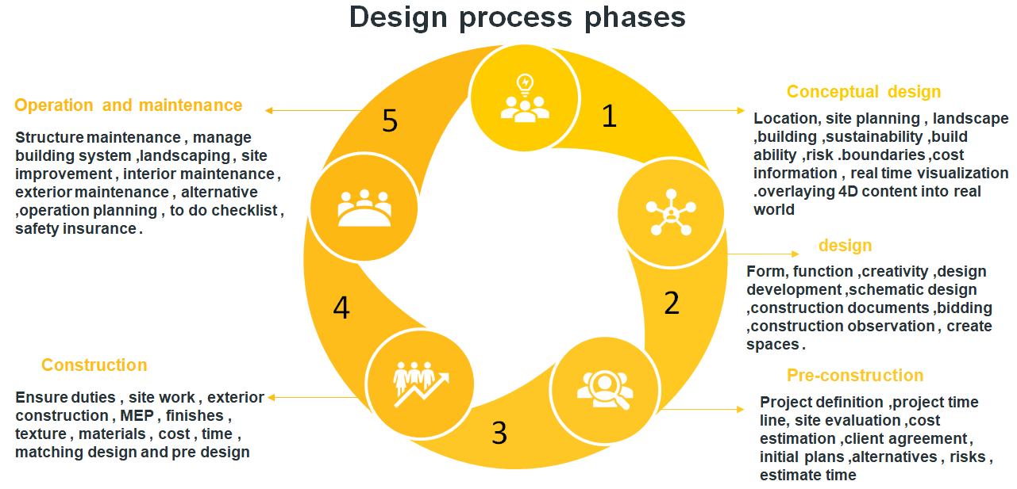
Fig.1: design process phases duties from previous studies by author

Previous theorist conducted augmented reality application separated without considering the transition towards BIM., as for that this paper distinguished in including case studies of AR through design stages as multi aspects ; architecture design and other (pre design ,interior design ,construction ,maintenance) . (Calderon-hernandez & Brioso, 2018)(Zollmann et al., 2013)(Morton, 2001). The objectives of this paper a to investigate potentials of AR_BIM in AEC industry, and compare the adoption percentage of AR_BIM in AEC in design phase.

2. Methodology
PRISMA-P approach has been used to conduct this systematic review. Preferred Reporting Items for Systematic Reviews and Meta-Analyses (PRISMA), it is a minimal collection of evidence-based elements for reporting in systematic reviews and meta- analyses (Kamioka, 2019). This method was developed in 2009 and, owing to its repeatability and It is employed in an expanding variety of scientific and technology research domains due to its capacity to facilitate the creation of increased syntheses(Donthu et al., 2021). All relevant research processes were detailed, including information source materials, search method, inclusion and exclusion criteria, as well as the primary instruments for assessing bias in eligible research(Stewart et al., 2015).
The purpose of this study is to establish a framework for and classification of AR applications in architectural design. Researchers adopted a systematic literature review by the investigation of augmented reality-BIM in AEC .The major two academic sources, Scopus and Web of Science, were employed for the study As shown in Table 2. Procedure were AUGMENTED REALITY, BUILDING INFORMATION MODELLING, BIM BASED –AR, AEC, PRACTICE. The rules for research was based on :( augmented reality), (BIM Bases AR), and (AR adoption in AEC). All articles with the above keywords in the title/abstract/keywords were selected to this study .A 79 articles were selected from total 120 after inclusion criteria for further analysis.

TABLE 2
Inclusion and exclusion criteria
Inclusion Criteria | Exclusion Criteria
Related to AR | Related concepts as VR and MR
Related to BIM | Non BIM concept
Published from 2010-2022 | Published before 2010
English language | Publication as non-English
Peer reviewed | Non peer reviewed
Published article | Unpublished article

As for inclusion criteria the bolometric method was adopted as following steps:
1. identify key words; BIM, Augmented reality, construction, design process.
2. Include articles from the period 2010 to 2022
3. Include articles which are published
4. Articles from web of science, science of direct and Scopus
5. Include articles in English language
However the adopted PRISMA method is shown in figure 2 the articles were extracted from multiple databases in about 120 articles, after the inclusion criteria it was about 79 articles for the study.

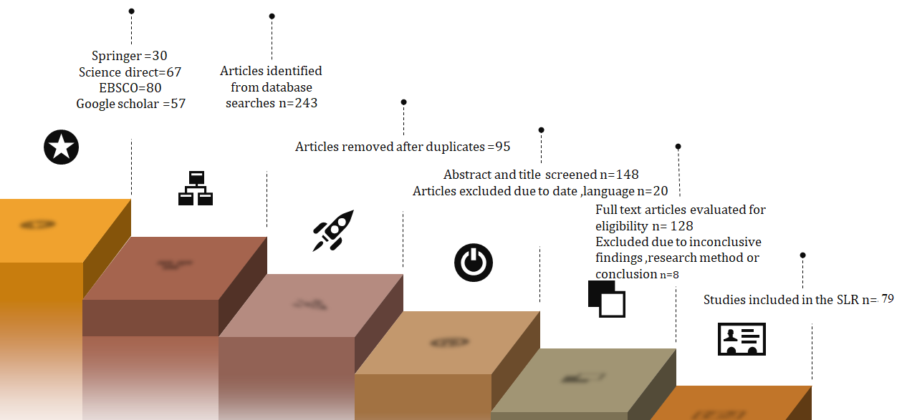

Fig 2 : Bolometric analysis of the selected keywords and prisma method (J. Grant, 2015)

After adopting PRISMA method about 234 articles were found associated with the identified keywords and from 2010 to 2022.as figure 3.
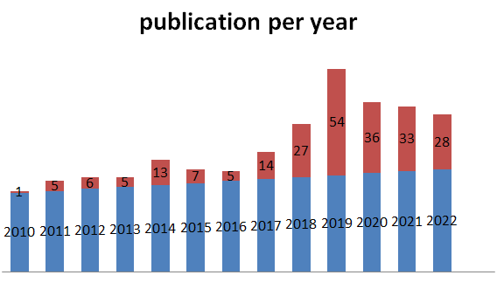
Fig 3: Publication articles per year of the keywords “BIM”AND AUGMETED REALITY

The following chart illustrates the selected articles from the previous method, before applying inclusion and exclusion criteria. Moreover these articles are categorized into five phases based on design process that includes conceptual design, design, pre-construction, construction, operation and maintenance .Figure 4 illustrates numbers of articles based on design process.
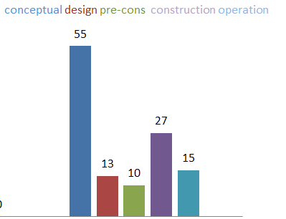
Fig 4: Number of articles based on design process

Data collection: this research is focused on identifying AR research and applications in architectural practice and education based on previous studies. Academic journal and conference publications from 2010 to 2022 were primarily evaluated for paper retrieval. For scanning, the most comprehensive academic databases, Scopus and Web of Sciences, were employed. The keywords set including AR, AEC industry, architecture education, BIM aided AR
Data analysis: A few keywords are used to examine the selected papers. The keywords were taken from a few previous content analysis studies. This study's keywords include augmented reality in AEC, the concept of augmented reality, and applications. Data is categorized under the architectural discipline, where augmented reality is deployed.
3. Augmented Reality: Use-Cases, and Beneﬁts
This study will focus on AR_BIM through design stage among different projects it will be divided into architecture design cases and engineering and construction Including design phase revisit of suggested solution, and construction stage tracking of project construction.However other pertinent utilise scenarios, such as layout enhancement, excavation, placement, inspection, cooperation, supervisory, commenting, , must be considered, as noted by earlier theorists(Al-kazzaz, 2018).
Various representative utilise cases are defined throughout the preceding sub - sections. focused on construction projects (tunnel, railways and bridge) and an office complex A BIM-specific software device was used in each of the provided use cases to obtain BIM models in addition to use the fully integrated AR solution (Redondo et al., 2012).The phone applications make use of a BIM shared information environmental solution, which serves as a central gateway for all individual interaction, information sharing, and other functions (Elsamahy, 2016).
AR has evolved into a powerful visual tool for architectural learning and education, and it is currently undergoing significant growing research (Kopiec, 2018). AR models have been utilised in learning and design environments to present learners with previously unavailable real-life experiences. Once architectural designers use VR, they will be able to rapidly understand the spatial features of their projects(Brusaporci, Ruggieri, & Sicuranza, 2017) . It will be able to comprehend their creations by strolling around the augmented area and seeing the colouring and textures of the given materials, the proportion of the spatial structure, and the aesthetic representation.(Alizadehsalehi et al., 2020). Furthermore, interactive and immersive virtual augmented reality (AR) technology assisted its building industry clients in the design, simulation, branding, and new project sales by conducting a pre-construction walk-through in the augmented townhouse where last-minute design concepts were evaluated. AR will be crucial in the teaching of cultural structures. Designers can use AR technology to create a training application in which they can engage with virtual objects to learn how to construct traditional buildings. Furthermore, research on the adoption of AR revealed that the architecture was changed, employee happiness rose, and costs were reduced (Hajirasouli & Banihashemi, 2022).AR may encourage some of the same behaviour as virtual reality and practical mock-ups, such as decision-making, alternative , descriptive, interpretive, in design and build ability analysis sessions, and problem-solving actions (Sirror et al., 2021).

Case studies of augmented reality projects
This study includes fifteen case studies in AEC industry. Despite the fact that the construction sector is among the earliest and most vital in the world, new tools for the employment frequently perform poorly to gain traction. There is lack in articles which are consisted of AR_BIM cases studies and projects(Lee et al., 2020) . From the other hand author have collected the most significant and available case studies in this field .case studies selected and justified by Table 3:

Table 3
Design problem solving through case studies

Case | Real site problem
1 | Provide data before going to the high safety risk zone underground the construction site
2 | Hard Topography in the location to perceive design heights
3 | The shifting towards modernism architecture covered the importance of saving historical buildings
4 | The challenge of Different materials and components in one staircase
5 | There was concealed items under the plumping system which makes design imposed
6 | It was difficult to educate graduate in prototyping a specific design in a physical location by traditional learning
7 | The environment around this construction project was unsafe besides the infrastructure was covered with muds
8 | During Coved pandemic exhibition and galleries was shut off.
9 | Design waste by users was at the maximum stage
10 | Designers must present their works in a certain location ,users travelling was necessary
11 | Exhibition carbon emission was high at the physical enrolment.
12 | Project teams are from around the world and not in the same site.
13 | Coordination by Google map was not enough to design and positioning and scaling
14 | Imagination that was based on calculation is difficult to be generated by human
15 | Difficulties in site topography and perceptions in mocking up design.

The selection process of case studies and project is based on identify AEC projects of augmented reality which is implemented in design process .specifically as representation tool adding that the adoption of AR must be integrated into BIM .
1. Lukasz Carnot Mercantile Hotel
The planned structure is the current Mercantile Hotel. The suggested AR app process for monitoring and inspecting construction phase will be analysed by viewing the segmental accomplishment of construction operations on the projected development of the current Mercantile Hotel. AR technology employed to overlay the intended 3-D model on the actual world in order to lead the construction crew through the assessment and monitoring of planned worksite operations. The approach starts by combining the BIM with the construction programme to produce a construction sequences animations to observe and track construction phase enabled the identification of important project stages and the communication of the anticipated project timetable to all project participants (Ordóñez et al., 2020).
The application's key advantage is its marker-based innovation, which enables the user to rapidly and accurately match the suggested BIM with the actual environment, as illustrated in Figure 5. The following are the tasks conducted by the researcher to evaluate the procedure and the augmented reality app for tracking work progress.(Ordóñez et al., 2020)

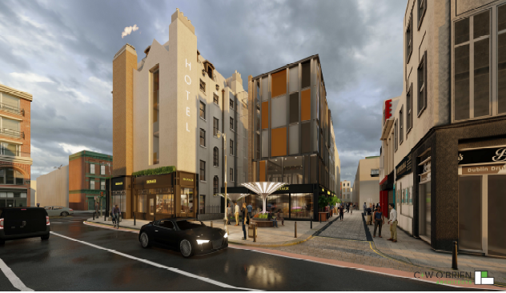
Fig5: Proposed hotel and marker based tech on the real environment

2. IGA 2017 Berlin channel
A digital walk by this area was created by radar .The RADAR-system was created by the Kaiserslautern Research Artificial Intelligence Centre (DFKI) as shown in figure 6. RADAR is a platform that allows people to place their own geo information on a map and link it to related information and material. The geo-referenced material may then be delivered to AR browsers such as Layer. The RADAR system provided clients with an easy programme that allowed them to quickly materialize their own concepts (Broschart & Zeile, 2015).

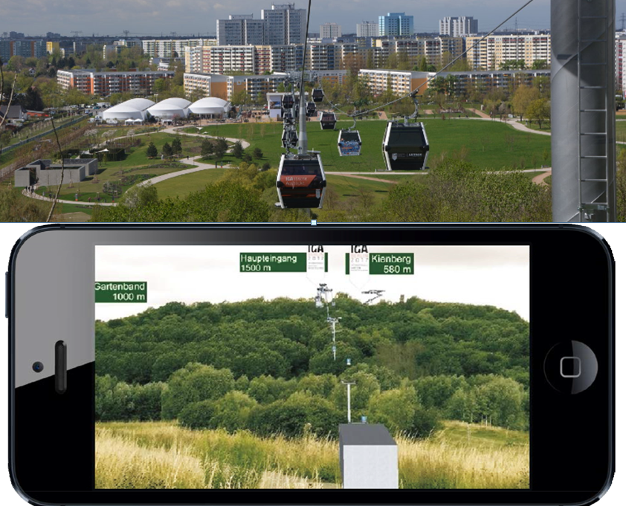
Fig 6: channel of IGA berlin 2017 between the conceptual AR and executed project

3. Building Culture Saarbrucken projects in 1950s (vision)
The town of Saarbrucken intended to employ innovative methods to educate and sensitize property owners about the unique features of this building. Especially with certain "poor" modernizations going on by the landlords, or a large amount of outdoor advertising on street level, the city's effort is critical to keeping the heritage alive(Nayyar et al., 2018). Original colour photos from of the 1950s were exhibited in the current scenario on the phone's screen to examine what the town looks like at the period. As augmented information upon that façade, features of 1950s design were emphasized. Images of the stairs were also presented as overlaying data on the exterior to indicate what type of treasure the structures hide on their insides. As shown in figure 7, the users can take a virtual walking through the project, gain a sense of the past, and learn how the town of Saarbrücken aims to bring the vibe again into modern-day life on the streets. Apart from the walking tour around Saarbrucken’s streets, there was additionally central information station in the market place that allowed everyone to stay informed before, during, and after the event through using augmented brochures and flyers. Individuals who were unable to attend the physical tour seemed to have the opportunity to explore the town as a virtual three - dimensional model. With common CAD application .every station that use AR seems to have four points marker which helps uses to enjoy light and shadow during day(Höhl, Wolfgang & Broschart, 2015).
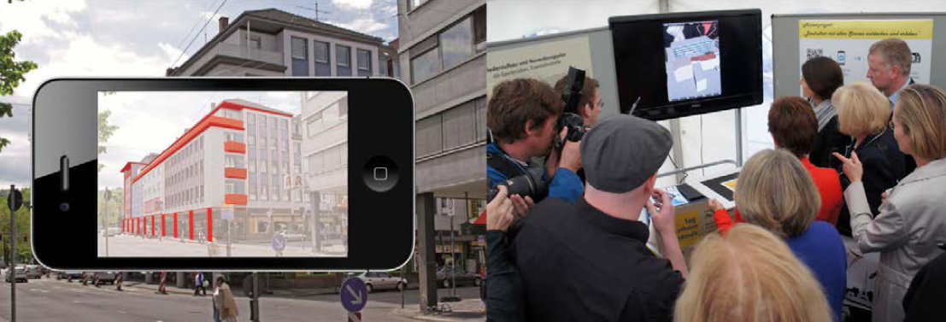
Fig 7 :Augmented architecture elements of 1950s structure in Saarbrucken

4. Railway Footbridges
Council members approved the second stage of the plan to preserve the railway line at Dawlish, which will result in significant advancements to a historic Brunel train station. Network Rail is adopting AR Technology to communicate future architectural projects into general public, designing city and allowing the audience to be actively engaged as from early stage of the design choice all the way through construction. AR enables the improved alignment between construction and design .also it supports the diversity in materials selection between clients and designer. The key variable in this design is the long span of the footbridge which was solved by the mock scaling that AR offers during design, each footbridge was visualized over various spans .Figure 8 shows the final design visualized on the real environment ,it shows alternatives for one design (Dawson et al., 2016).
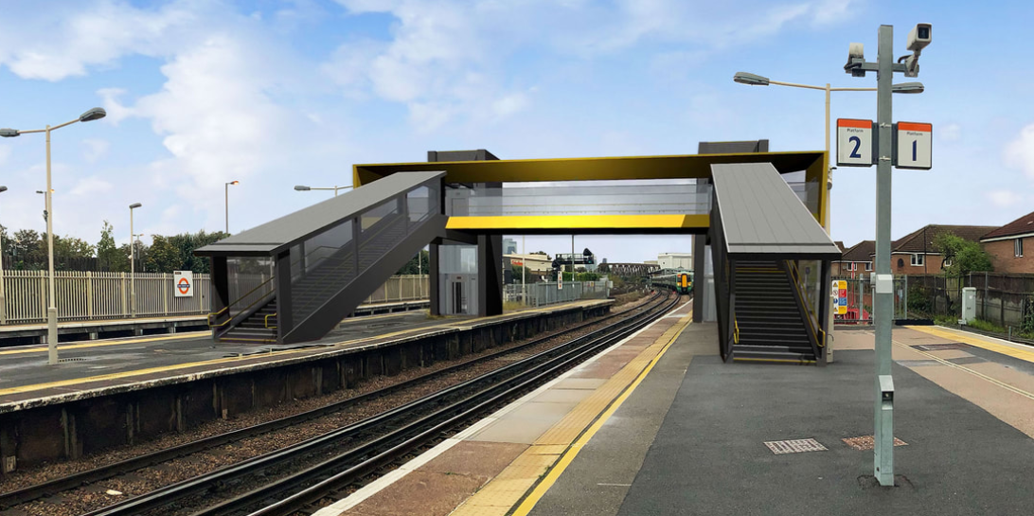
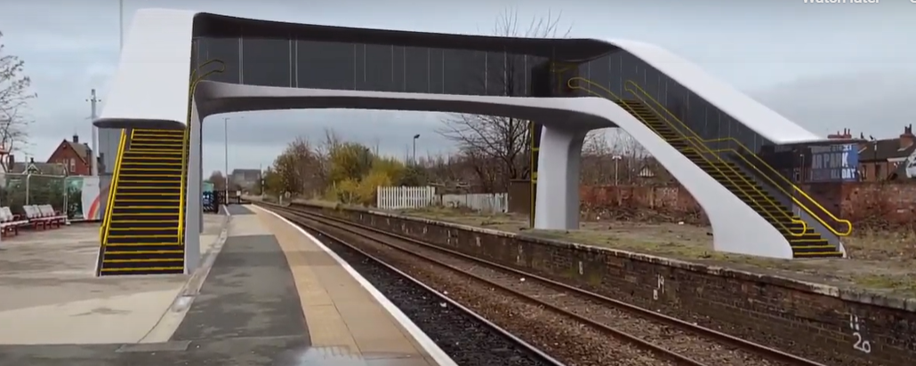
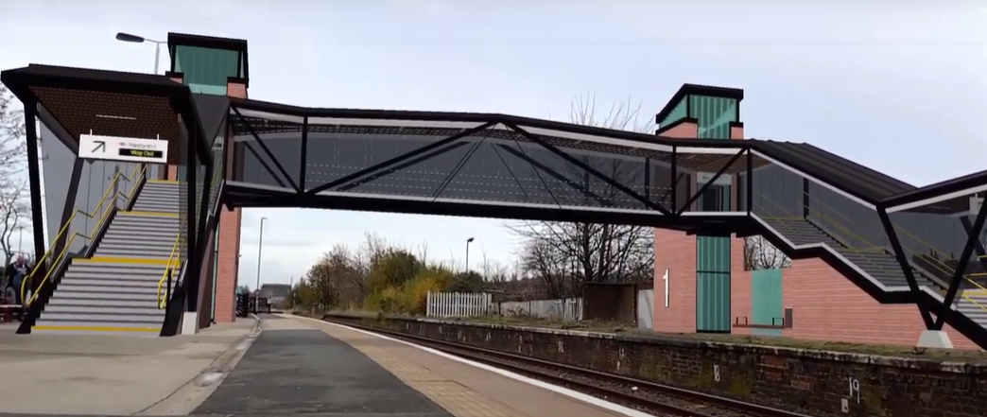
Fig 8: Railway foot bridge alternatives designed by AR_BIM

5. Plumbing system
Maintenance employees must quickly learn a wide range of skills. Instead of discovering usable data from a huge number of plans or damaging existing buildings, sophisticated technical tools may swiftly locate the maintenance location in a significant number of concealed engineering as shown in figure 9. As companies make improvements to buildings and outdoor areas, AR systems may allow maintenance personnel to avoid concealed items such as underground plumbing, electrical cables, and structural components. This has the potential to either accelerate maintenance and reconstruction activities while also reducing the amount of unintended harm they typically cause. A "see-through" component for tracking the position of piping and ventilation system behind walls and panel, as well as other hidden components like walls and beams, might make maintenance tech and reconstruction easier (Panuwatwanich et al., 2013).
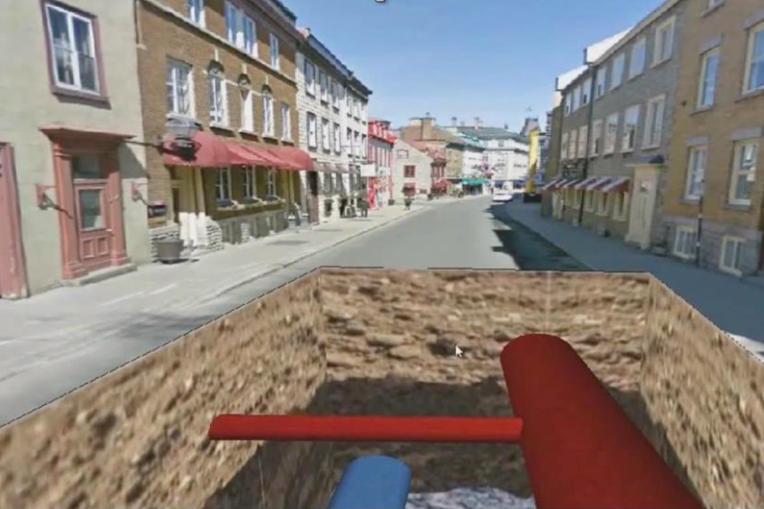
Fig 9: Review plumbing system mapping using AR_BIM in site
6. Studio project
This was a small project to educate architects in prototyping the same design using augmented reality, first the project modelled through BIM and then visualize through augmented reality, then multi options for the same design came based on location, and weather, Figure 10 illustrate that AR helps designer to set the scheduling step exactly where the green colour views the items that under process .the construction of this project was implemented on time by the help of mixing AR into BIM. As for this study some advantages were seen by AR implementation as follows: it sets the existing building beside the real environment, and identifies colours and materials .also it identifies construction materials in details. (Sandkuhl & Lehmann, 2017).
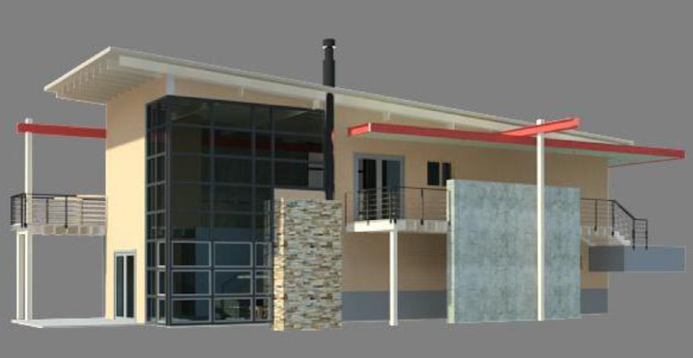 | 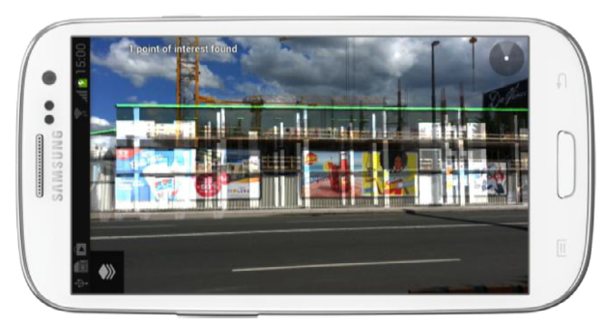
Fig 10: AR-BIM model for a studio project

7. Warsaw road swing bridge
Warsaw Road Swing Bridge was built in 1956. According to city employees, around 10,000 cars cross the Warsaw Road Swing Bridge per day. According to engineering examinations, this bridge was reaching the end of its usable life. Parks Canada offered a bridge repair as component of the infrastructure upgrades along the Waterway National Historical Site in 2020, following a period of study and design work. The goal of this initiative is to improve historical, tourist, waterway, and roadway assets inside national heritage landmarks, national parks, including national coastal nature preserves to provide safe, rising visitor experiences (Werner, 2017).Figure 11 illustrates the integration of AR_BIM in a real site plan.

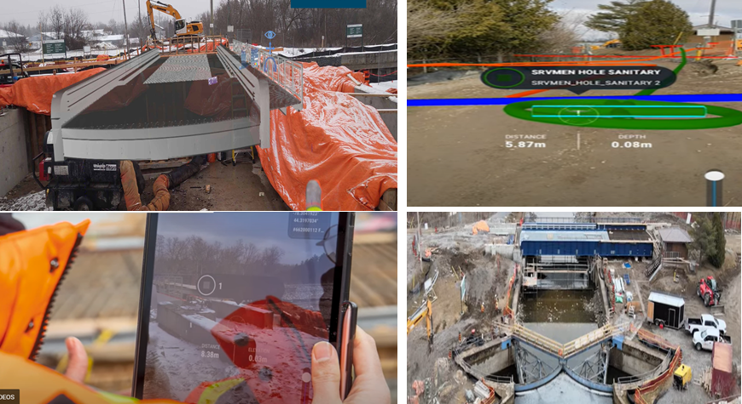
Fig11: Warsow road swing bridge design progress by AR

8. RIXC Centre for New Media Culture
Senses Art released by the RIXC Centre Culture in 2021. It is a Navigation augmented reality application that invites users to virtual exhibitions hosted outside. It presents digital art collections are housed close to the Latvian National Art museum near Riga. Figure 12 illustrates that Individuals may experience the outdoor exhibit securely and with their own time(Abboud, 2014).

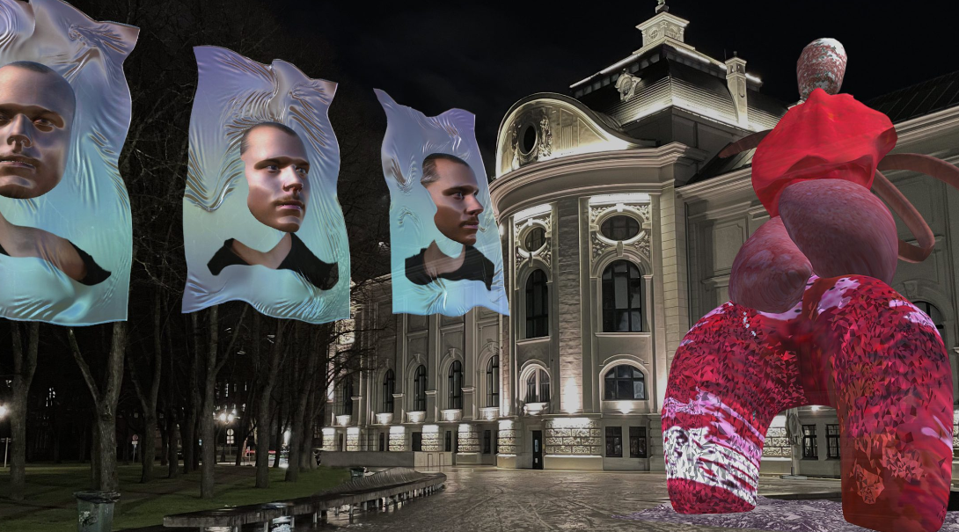
Fig 12: RIXC Center exhibition through AR

9. AUGMENTED BERLIN art work exhibition
Anika Meier have produced an augmented reality art show as in Figure 13; Fashion Week This interactive group show including augmented reality art encourages virtual guests using a phone or tablet to put eight artworks by Berlin artisans in public spaces or even in their local walls. Such augmented reality program does not necessitate users travelling. Rather, people all over the globe are encouraged to utilise the application in their local communities to bring artwork by Berlin designers out of their local homes or public space(Alessandro & Luigi, n.d.).
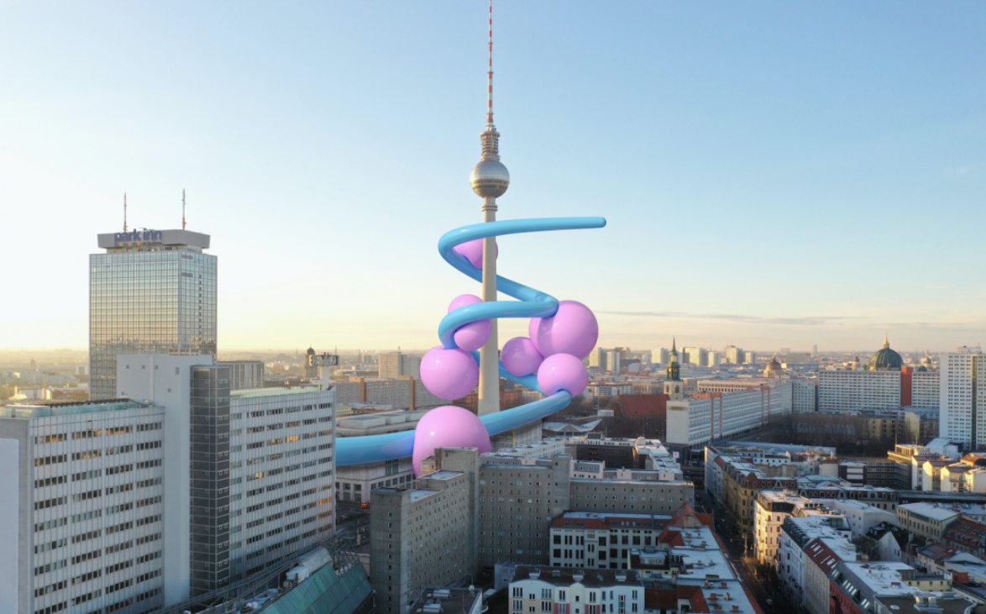
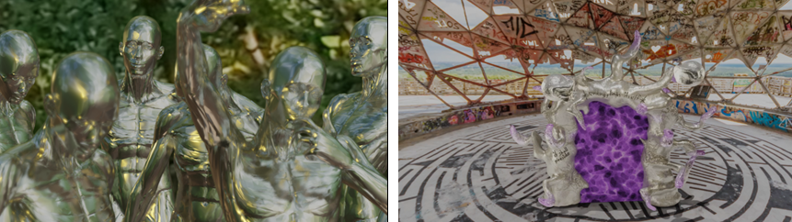
Fig 13: Berlin exhibition using AR

10. The Seeing the Invisible exhibition
the unique exhibition of its sort created in partnership with botanic garden as well as art organizations from all around the globe as seen in Figure 14, Seeing the Invisible is a collaboration between the Jerusalem Botanic Garden as well as the Outset Art Collection Found that will take place in Twelve gardens around the world between September 2021 to August 2022.The exhibition includes Thirteen pieces by artisans using augmented reality. Visitors can join the exhibition by using a tablet or smartphone application that is enabled at the local gardens. Despite the fact that all gardens feature the identical exhibition, the artworks are presented in different places, providing spectators with diverse viewpoints depending on their location in the world. Because of the structure of AR, there has been little disruption to the grounds of the participating botanic garden, and the exhibition's carbon emissions have been reduced to a minimal(Cucuzzella, 2021).

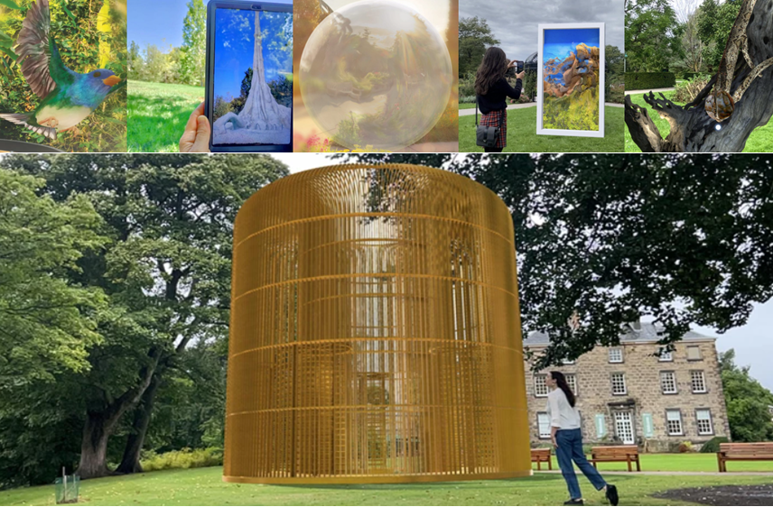
Fig 14: The seeing exhibition using AR

11. Historical story telling (L’Aquila Historical Centre)
Due to the 2009 earthquake, the town of L'Aquila's urban layout has changed dramatically. There is a distinct gap between the physical ultimate reality of places, the result of history which has brought it to the current, and the dimension of the invisible as the junction of memories and daily existence Figure 15 clarify AR application in designing façade .(Brusaporci, Ruggieri, Sicuranza, et al., 2017).

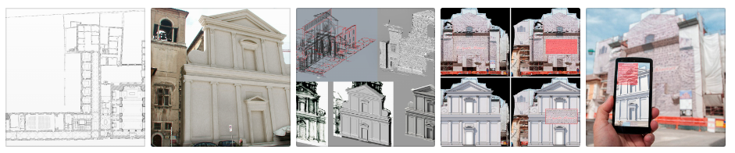
Fig15: L’Aquila Historical Centre using AR

12. Iskra Mehanizmi Brnik industrial building
“Industrial and commercial building Iskra Mehanizmi Brnik”is split into to three main blocks, the commercial part which includes reinforced structure, the other two part is regarding to storage and production units constructed by prefabricated concrete. This case study focuses on the office building part, this case clarify AR adoption along lifecycle as shown in Figure 16. Different data was available and includes BIM model connected with augmented reality part. BIM model includes geometrical and non-geometric design data including as geography through location (3D), technical requirements(4D) as doors and windows manufacturers, and professional maintenance (5D).The correlation of the three - dimensional model BIM and augmented reality is accomplished basically through three key components: the three - dimensional BIM on its own, the entire readout, and the transition of the information for analysis in AR via a suitable app on a portable device, as tablet for this case. The 3d BIM provides and receives BIM data, including such installation modification needs and project planning evaluation, to allow visualisation on the AR system, enabling the user to engage with three - dimensional model BIM as well as other participants of the construction team. in actual environments(Scoresby & Park, 2021).
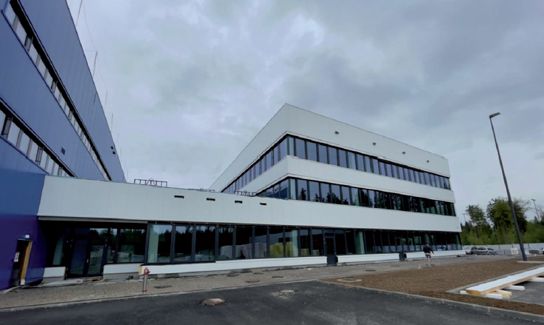
Fig 16: Industrial Building using AR

13. Railway project
This is a construction project as second railway track from Divaa to Koper, which comprises the construction of much more than 17.4 kilometres roads leading with different structures functioning as service areas for tunnels, retaining structures, and a 35-meter-long bridge. It is one of Slovenia's major infrastructural projects (Chi et al., 2013). This case study fits under design and planning stage of the whole life cycle, allowing AR to see the construction project structure in addition to the entire building in the real surroundings. the aim of this case was to investigate how AR and its application in the chosen smartphone app may be utilised in infrastructure projects which are largely defined by great distance(Dong et al., 2013).
To evaluate this case study, a tablet device with an augmented reality app was utilised in two distinct sites a few kilometres apart as shown in Figure 17. However, in a design model on the tablets .Both are mapped and correctly integrate the needed information in the three - dimensional model. It deploys AR technology to see 3D interactive simulations on site. It was able to inspect the tunnel entrance and MEP systems, in addition to the train line to be built, in addition to the overall magnitude and difficulty of the building site(H. M. Chen & Huang, 2013).

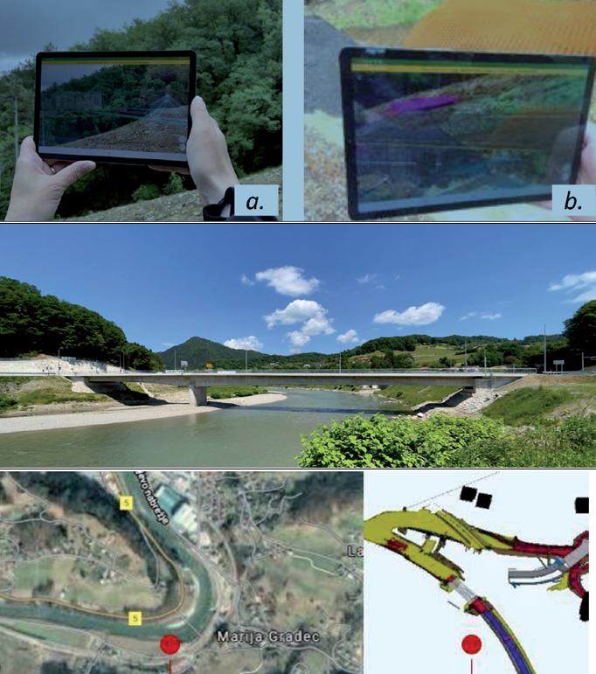

Fig17: Geo position by Google map and coordination by BIM model and AR

14. Gravity Garden by Ivo Ambrosi
Gravity Garden is a natural space created by applying external forces to a basic pre-defined shape as shown in Figure 18. The architecture is defined by the algorithm that describes its genetic code. The optimization of the mathematic algorithm that generates the structure, determined by software, defines its ultimate shape, much as nature uses the bones of a creature or the leaves of a tree. The size and dimensions are directly related to what is required for its own survival(Baumgartner-Kiradi et al., 2018).There is little opportunity for the architect's own creativity, and the "inventor" goes a step farther in this evolutionary process, watching and controlling the continual progress of his product from the outside. And manipulating project size and scale(Kerr & Lawson, 2020).

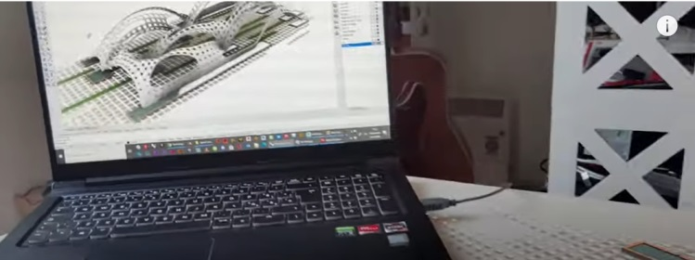 | 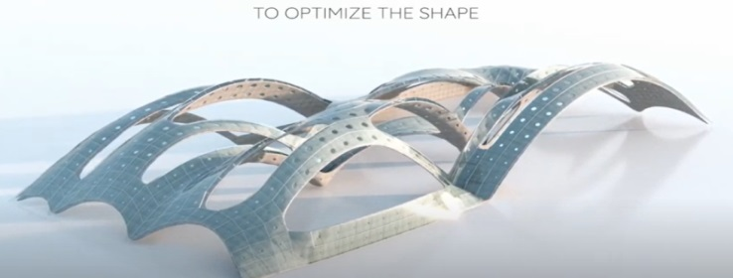
Fig 18: Gravity garden by AR –BIM

15. Extended building
Site Vision uses a BIM model to demonstrate how to envision a building using augmented reality, completely textured together with the environment. Because the house is on a slope, Site Vision displays how the model would seem in this difficult context as it seen in Figure 19. AR includes: - To use the "Create New Model" tool, place one of the border pegs. Setting up over a known point like this offers you a local coordinate system to operate with; the Sketch Up axes will be in this place. - Obtaining points - How the structure interacts with other structures. By AR it’s useful in assisting your design process and displaying how the design interacts with the real world with the location workflow (Agirbas, 2020).
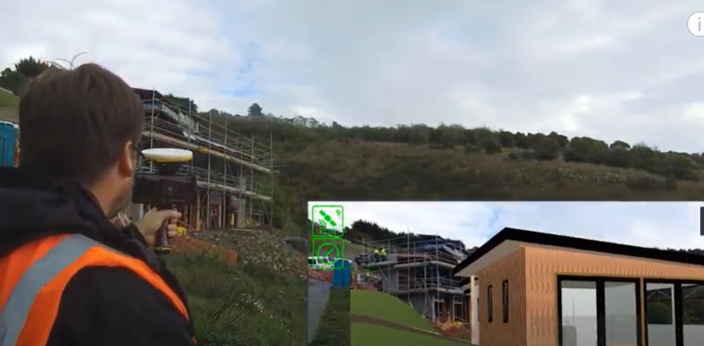
Fig 19: Building integration with site

According to previous studies AR_BIM benefits summarized into a list as shown in Table 3

TABLE 3
AR benefits through selected case studies

AR beneﬁt code | AR beneﬁt
B1 | Real time visualization
B2 | Design making
B3 | Improve collaboration
B4 | Spatial interaction
B5 | Detect errors
B6 | Problem solving
B7 | Clients feedback
B8 | Reduce waste
B9 | Improve productivity
B10 | Improve quality of design
B11 | Improve safety
B12 | Present details
B13 | Improve communication
B14 | Collect data easily
B15 | Spatial aspect detection

The fifteen cases are selected based on AR_BIM adoption, there are two main parameters that were fulfilled through; form and function, each parameter has a specific reflection in designing a project, as shown in table 4.
TABLE 4
AR case studies parameters
case | Parameters included through AR |  | case | Parameters included through AR
case | parameter | (A)Form/(B)function | case | parameter | (A)Form/(B)function
1 | Geometry alternatives- A |  | 8 | Reduce time and effort -A
2 | Movement track -B |  | 9 | Pick colours -A
3 | Geometry /shade/shadow- A,B |  | 10 | Pick plants /shade /shadow -B
4 | Accessibility - B |  | 11 | Track movement -B
5 | Infrastructure - B |  | 12 | Building orientation - A
6 | Geometry /materials/orientation-A,B |  | 13,14 | Façade reconstruction -A,B
7 | Ensure safety- B |  | 15 | Decrease waste - B

Figure 20 illustrates AR_BIM projects that concentrate on function, form, form and function together; this was an indication that the majority of AR_BIM cases are reflecting function issues
, the majority of these cases are related to construction and engineering as:
(Form)A: 5 cases almost 33 %
(Function)B: 7 cases almost 47 %
(Form and function)AB: 3 cases almost 20%

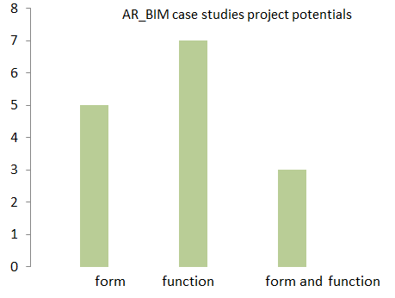
Fig 20:AR_BIM projects potentials in form, function, form and function

To discover the uses, advantages, and challenges of AR throughout the phases of the building project's lifetime, a literature review was accomplished involved thorough scan of the literature by using Google Scholar searching engine Several terms, including Augmented Reality, AR, utilization applications, advantages, literature evaluation, construction stages, construction projects lifecycle, design, construction, and maintenance to mention a few. This search produced With 120 papers gathered from conferences and journals between 2010-2022 as shown in Table 5 (Permodelan et al., 2019)(AlSawalqa et al., 2021)(Bekr, 2017).

TABLE 5
AR_BIM references in design phase including benefits
Reference  1-79 | AR-BIM phase code | AR-BIM benefits included in papers | Phase
25 | CD | _visual construction details (MEP system.  _underground visualisation  _system mock up  _real time project modelling  _connect project with surrounding  -conceptual layout  _overlay 3D design into physical world | Conceptual design
13 | D | _prepare 3D models  -select materials and colours | Design
10 | PRE | _Review along design  _clash detection  _sequence planning  _clarify design early  _operate equipment’s and set them  _full site scale  _safety orientation | Pre-construction
17 | CON | _visualising models in field  _layout preparation  _site layout  -4D simulation  _monitoring workflow | Construction
13 | OM | _locate building contents that needs maintenance  _compare alternatives pros and cons | Operation and maintenance

Table 6 illustrates the selected projects that adopted AR_BIM in design phase; each cases study has recorded specific benefits through adopting augmented realty application into BIM. The selected cases categorized as Architecture or construction. The project was varying into small projects, mega projects or details inside a project A small conclusion was defined by author correlated with AR-BIM.

TABLE 6
Design stage for the selected case studies

Case study (project) | Phase Architecture/construction | Main aspect that fulfilled through AR-BIM | conclusion
1.Mercantile Hotel | construction | 1.Project time line  2.presentation  3.montoring site progress  4.compare design workflow  5.geometric sequence | When the suggested workflows were compared to the existing ways, it was agreed that the construction industry may be ready for the use of augmented reality mixed with BIM models for day-to-day duties on a worksite. And developed solution for visualisation of construction site
.2.IGA 2017 Berlin | construction | 1.movement tracking for the chairlifts  2.check how building fit surrounding  3.site layering  4.put geo located information and heights | The level of details in AR model was highly adopted compared to real project
3.1950s architecture in Saarbrücken | Architecture, construction | 1.convinence way to persuade architects through AR to preserve the cultural style for this city  2.guided tour into the project  3. Adopted day lighting and shadow through the experiment. | The AR experiment includes project layering of colour, texture shade and shadow
4.staircases | Architecture | 1.identify the specific area as 3D design | AR helped the team in materials components as more exposes to design experiment
5.plumbing system | Architecture | 1.rapid maintenance  2.see behind hidden infrastructures | Maintenance through AR_BIM system easier than referring to large number of drawings
6.studio project | Architecture | 1.presentation technique better that traditional  2.prototyping based on weather and location  3.identify design scheduling  4.locating construction materials on site | 80% of architects who designed this studio affirms that design was constructed with time of scheduling by the aided AR
7. warsaw road swing bridge | construction | 1.reduce errors  2.improve productivity  3.simplify field work  4.redesign and renovation  5.improve heritage | AR simplified reconstruction of this bridge and ensure the safety of users
8.RIXC Center for New Media Culture | Architecture | 1.reduce efforts and time in visiting the station of this museum  2.give the sense of place for individuals who participate in this experience  3.propmots new forms of arts by AR | There is no need for the physical attendance to be audience in a museum
9.Berlin’s AR artwork | Architecture | 1.AR helps in designing Berlin fashion week  2.control colours  3.no physical attendance | The technology of AR make the social distance bearable
10.The Seeing the Invisible exhibition | Architecture | 1.presentation of arts through gardens  2.pick the appropriated kind of plants  3.check shade and shadow | Exhibition carbon emissions was reduced to about 35 % compared to the physical exhibition
11.Railway track | construction | 1.junction of memories and actual design  2.best design façade | AR enables full design planning with less design costs
12.Iskara commercial building | Architecture | 1.project planning evaluation  2.useres engagement in design | AR enables users and clients engagements
13.historical storytelling | Architecture | 1.facad reconstruction  2.intersection between history and memory | In this case AR carries façade design workflow step by step align historical points and hypothesis from design (layering )
14Gravity Garden by Ivo Ambrosi | Architecture | 1.generate design shapes  2.life size model  3.perform an assessment of light  4.walk through model | Walk through scale of project and
15.site extended building | Architecture | 1.facilitate workflow for construction site due to the difficult slope  2.provide accurate data to smooth design | Identify construction although slopes

This paper includes five design stages: conceptual, design. Pre-construction, construction and operation .each stage is given ten points including criteria that it concerns in. according to these criteria points are given for each phase in the selected cases as shown. Figure 21 illustrate design process checklist for conceptual design, design, preconstruction, construction, operation and maintenance .author conducted this checklist based on previous theorist.(Mahmoodi, 2001)

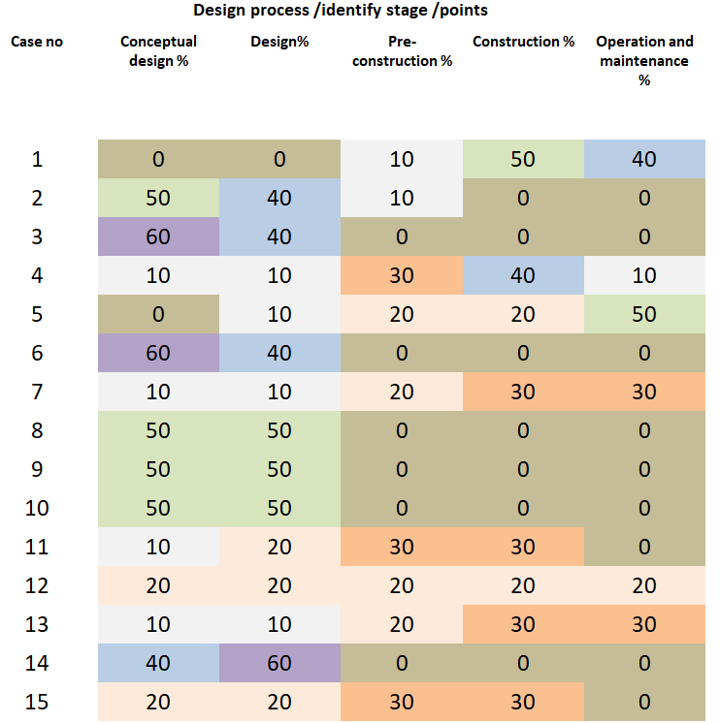
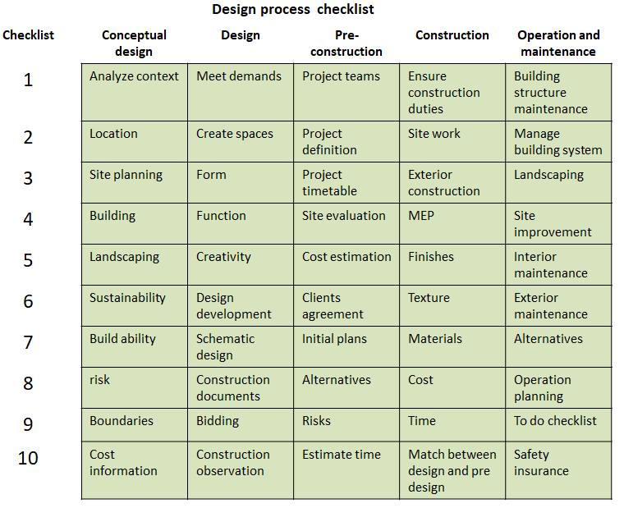

Fig 21: case studies design stage points, and main design process checklist

From the previous checklist of design process each case study has adopted Augmented reality with building information modelling along design process components .it was noted that the majority adoption was referred to conceptual design in about 33 percentage and to design phase which was about 28 percentage .followed by 17 percentage for construction .and 13 percentage related to pre-construction .as for operation and maintenance 9 percentage. As shown in Figure 22.
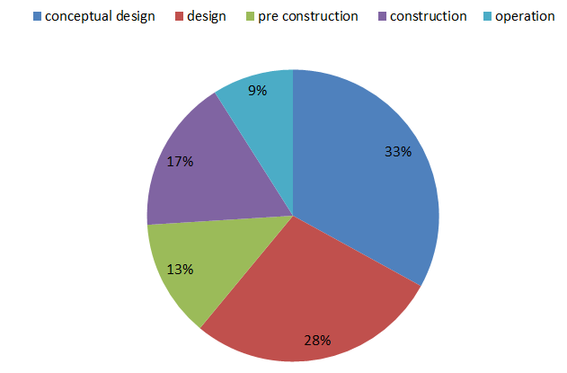

Fig 22: case studies and main aspect of AR_BIM adoption in design phase

Conclusion
This paper presents an overview of Augmented Reality (AR) applications associated with BIM across design process. According to the publications gathered from 2010 to 2022, AR offers a wide range of applications in architectural design, construction, and education. The primary applications included Many writers noted that architects found AR applications to be quite useful in overcoming a lack of time and other resources(Cannaerts, n.d). They also stated that AR assisted architects in understanding concepts in difficult courses such as buildings and surveys(Häkkinen et al., 2015).
Employing AR for architecture designers would allow them to comprehend the spatial aspects of their designs and understand their projects by walking around the virtual world. And visualize the texture as well as colour of the allocated materials(Wong, 2011). The ratios of the spatial structure and the artistic expression of the structural elements AR improves experiential learning and provides optimal engagement levels to successfully transmit knowledge to learners when it comes to improving construction education. Designers may use augmented reality (AR) technology to construct a learning tool that allows them to create conventional structures and interfacing with virtual models. Furthermore, research on the utilization of AR revealed that the architecture was changed, employee happiness rose, and expenditures were reduced. Improving construction education promoting practical learning using AR provides appropriate engagement levels to successfully convey knowledge to learners(M. P. Grant, 2012). Students and practitioners in construction must visualize various building approaches and attend field trips. This may necessitate visits to building sites to bridge the gap between theory and practice. AR enables researchers to follow, record, and evaluate human decision-making behaviours in a controlled setting with great precision and in short time periods.AR may integrate safety with construction materials and techniques instruction by offering a creative platform for spiritually enhancing hazard awareness ability, transmitting safety knowledge, and guiding learners. AR technologies have emerged for construction and have been utilized in architectural and design simulations, construction safety & health, in equipment’s and operational duties, and analysis. (Freitas & Ruschel, 2013).

References

Abboud, R. (2014). Architecture in an Age of Augmented Reality : March.
Abowardah, E. S. (2016). Design Process & Strategic Thinking in Architecture. March 2016. https://doi.org/10.17758/ur.u0316313
Aburamadan, R., & Trillo, C. (2020). Applying design science approach to architectural design development. Frontiers of Architectural Research, 9(1), 216–235. https://doi.org/10.1016/j.foar.2019.07.008
Agirbas, A. (2020). Teaching construction sciences with the integration of BIM to undergraduate architecture students. Frontiers of Architectural Research, 9(4), 940–950. https://doi.org/10.1016/J.FOAR.2020.03.007
Ahmed, S. (2019). A Review on Using Opportunities of Augmented Reality and Virtual Reality in Construction Project Management. Organization, Technology and Management in Construction: An International Journal, 11(1), 1839–1852. https://doi.org/10.2478/otmcj-2018-0012
Al-kazzaz, D. (2018). Freehand Drawings versus CAD Drawings in the Conceptual Architectural Design Phase. February 2014.
Al-matarneh, R., & Fethi, I. (2017). Assessing The Impact Of Caad Design Tool On Architectural Design Education. 5(1), 1–20.
Albahbah, M., Kıvrak, S., & Arslan, G. (2021). Application areas of augmented reality and virtual reality in construction project management: A scoping review. Journal of Construction Engineering, Management & Innovation, 4(3). https://doi.org/10.31462/jcemi.2021.03151172
Alessandro, R., & Luigi, C. (n.d.). VIRTUAL EXPERIENCE IN.
Alizadehsalehi, S., Hadavi, A., & Huang, J. C. (2020). Automation in Construction From BIM to extended reality in AEC industry. 116(December 2019).
AlSawalqa, H., AlSheikh, T., & AlTarawneh, D. (2021). The Notion of “Building Information Modeling” and its Role in the Jordanian Architecture Practice and Education: The Case of The University of Jordan. Research Journal of Applied Sciences, Engineering and Technology, 18(3), 86–91. https://doi.org/10.19026/rjaset.18.6067
Arkitek, P. (2019). A S YSTEMATIC R EVIEW OF BIM R EQUIREMENTS. 4(1), 164–167.
Azhar, S. (2011). Building information modeling (BIM): Trends, benefits, risks, and challenges for the AEC industry. Leadership and Management in Engineering, 11(3), 241–252. https://doi.org/10.1061/(ASCE)LM.1943-5630.0000127
Basbagill, J., Flager, F., Lepech, M., & Fischer, M. (2013). Application of life-cycle assessment to early stage building design for reduced embodied environmental impacts. Building and Environment, 60, 81–92. https://doi.org/10.1016/j.buildenv.2012.11.009
Baumgartner-Kiradi, B., Haberler, M., & Zeiller, M. (2018). Potential of augmented reality in the library. CEUR Workshop Proceedings, 2299, 30–37.
Bekr, G. A. (2017). Exploring barriers in implementing building information modeling: A preliminary study. ISEC 2017 - 9th International Structural Engineering and Construction Conference: Resilient Structures and Sustainable Construction, July 2017. https://doi.org/10.14455/isec.res.2017.29
Bozoglu, J. (2016). COLLABORATION AND COORDINATION LEARNING MODULES FOR BIM EDUCATION. 21(June), 152–163.
Broschart, D., & Zeile, P. (2015). ARchitecture : Augmented Reality in Architecture and Urban Planning. 111–118.
Brusaporci, S., Ruggieri, G., & Sicuranza, F. (2017). Augmented Reality for Historical Storytelling . The INCIPICT Project for the Reconstruction of Tangible and Intangible Image of L ’ Aquila Historical Centre †. December. https://doi.org/10.3390/proceedings1091083
Brusaporci, S., Ruggieri, G., Sicuranza, F., & Maiezza, P. (2017). Augmented Reality for Historical Storytelling. The INCIPICT Project for the Reconstruction of Tangible and Intangible Image of L’Aquila Historical Centre. December, 1083. https://doi.org/10.3390/proceedings1091083
Calderon-hernandez, C., & Brioso, X. (2018). Lean , BIM and Augmented Reality Applied in the Design and Construction Lean , BIM and Augmented Reality Applied in the Design and Construction Phase : A Literature Review. February. https://doi.org/10.18178/ijimt.2018.9.1.788
Cannaerts, C. (n.d.). Models of / Models for Architecture Physical and Digital Modelling in Early Design Stages. 781–786.
Chen, H. M., & Huang, P. H. (2013). 3D AR-based modeling for discrete-event simulation of transport operations in construction. Automation in Construction, 33, 123–136. https://doi.org/10.1016/j.autcon.2012.09.015
Chen, Y., Wang, Q., Chen, H., Nurli, I., Bistaman, M., Idrus, Z. S., & Abd, S. (2020). Application Research on BIM + AR Technology in Construction Safety Management Application Research on BIM + AR Technology in Construction. https://doi.org/10.1088/1742-6596/1648/4/042019
Chi, H. L., Kang, S. C., & Wang, X. (2013). Research trends and opportunities of augmented reality applications in architecture, engineering, and construction. Automation in Construction, 33, 116–122. https://doi.org/10.1016/j.autcon.2012.12.017
Cristina, A., Silva, D. H., & Gaber, M. (n.d.). We are IntechOpen , the world ’ s leading publisher of Open Access books Built by scientists , for scientists TOP 1 % Different BIM Workflows.
Cucuzzella, C. (2021). Making the invisible visible: Eco-art and design against the anthropocene. Sustainability (Switzerland), 13(7). https://doi.org/10.3390/su13073747
Davila Delgado, J. M., Oyedele, L., Demian, P., & Beach, T. (2020). A research agenda for augmented and virtual reality in architecture, engineering and construction. Advanced Engineering Informatics, 45(May), 101122. https://doi.org/10.1016/j.aei.2020.101122
Dawson, D., Shaw, J., & Roland Gehrels, W. (2016). Sea-level rise impacts on transport infrastructure: The notorious case of the coastal railway line at Dawlish, England. Journal of Transport Geography, 51, 97–109. https://doi.org/10.1016/j.jtrangeo.2015.11.009
Dinh, T. (2020). Remembering the City : An Augmented Reality Reconstruction of Memory , Power , and Identity in Ho Chi Minh City through Cartography & Architecture R emembering the C ity : A n A ugmented R eality R econstruction of M emory , P ower , and I dentity in H o .
Doan, D. T., Ghaffarianhoseini, A., Naismith, N., Zhang, T., Rehman, A. U., Tookey, J., & Ghaffarianhoseini, A. (2019). What is BIM? A Need for A Unique BIM Definition. MATEC Web of Conferences, 266(January), 05005. https://doi.org/10.1051/matecconf/201926605005
Dong, S., Feng, C., & Kamat, V. R. (2013). Sensitivity analysis of augmented reality-assisted building damage reconnaissance using virtual prototyping. Automation in Construction, 33, 24–36. https://doi.org/10.1016/j.autcon.2012.09.005
Donthu, N., Kumar, S., Mukherjee, D., Pandey, N., & Lim, W. M. (2021). How to conduct a bibliometric analysis: An overview and guidelines. Journal of Business Research, 133(April), 285–296. https://doi.org/10.1016/j.jbusres.2021.04.070
Elsamahy, E. (2016). MIXED REALITY FRAMEWORK FOR ARCHITECTURAL DESIGN. 23(2).
Freitas, M. R. De, & Ruschel, R. C. (2013). What is happening to virtual and augmented reality applied to architecture? Caadria, 407–416.
Gericke, K., & Blessing, L. (2012). An analysis of design process models across disciplines. Proceedings of International Design Conference, DESIGN, DS 70(December), 171–180.
Grant, J. (2015). an Introduction To Bibliometrics Learning Objectives and Key Messages. https://www.theinternationalschoolonria.com/uploads/resources/doha_school_2015/15_13_Pillar_3_Bibliometrics.pdf
Grant, M. P. (2012). The Development of Digital Architecture Modeling in the Malaysian Architecture Industry. 77–84.
Guney, D. (2015). The importance of computer-aided courses in architectural education. 176, 757–765. https://doi.org/10.1016/j.sbspro.2015.01.537
Hadjri, K. (2001). BRIDGING THE GAP BETWEEN PHYSICAL AND DIGITAL MODELS IN ARCHITECTURAL DESIGN STUDIOS Department of Architectural Engineering , College of Engineering , United Arab Emirates University ,. XXXIV, 1–6.
Hajirasouli, A., & Banihashemi, S. (2022). Augmented reality in architecture and construction education : state of the field and opportunities. International Journal of Educational Technology in Higher Education. https://doi.org/10.1186/s41239-022-00343-9
Häkkinen, T., Kuittinen, M., Ruuska, A., & Jung, N. (2015). Reducing embodied carbon during the design process of buildings. Journal of Building Engineering, 4, 1–13. https://doi.org/10.1016/j.jobe.2015.06.005
Höhl, Wolfgang & Broschart, D. (2015). Augmented reality in architecture and urban planning. Automation in Construction, 1. 20-29.
Ibrahim, M. (2011). Building Information Modeling in Architectural Education : The Case of the Middle East.
Kamioka, H. (2019). Preferred reporting items for systematic review and meta-analysis protocols (prisma-p) 2015 statement. Japanese Pharmacology and Therapeutics, 47(8), 1177–1185.
Kara, L. (2015). A critical look at the digital technologies in architectural education : when , where , and how ? 176, 526–530. https://doi.org/10.1016/j.sbspro.2015.01.506
Kerr, J., & Lawson, G. (2020). Augmented Reality in Design Education: Landscape Architecture Studies as AR Experience. International Journal of Art and Design Education, 39(1), 6–21. https://doi.org/10.1111/jade.12227
Kim, J., & Kim, J. (2023). BIM to AR matching technology of building maintenance plat- form using 5G-based AR. May 2021.
Kim, S. A., & Kim, Y. S. (2007). DESIGN PROCESS VISUALIZING AND REVIEW SYSTEM WITH ARCHITECTURAL CONCEPT DESIGN. AUGUST, 1–13.
Kirschke, H. (2015). BIM ( Building Information Modeling ) education at Universities. 1–8.
Kocaturk, T., & Kiviniemi, A. (2016). Challenges of Integrating BIM in Architectural Education Challenges of Integrating BIM in Architectural Education. September 2013.
Kocaturk, T., Kiviniemi, A., & Kingdom, U. (2013). Challenges of Integrating BIM in Architectural Education. 2, 465–473.
Kopiec, R. (2018). Digital Architecture - Augmented Reality. February. https://doi.org/10.13140/RG.2.2.22717.56808
Kotecha, K., Sandbhor, S., Thomas, A., Schranz, C., Urban, H., & Gerger, A. (2021). POTENTIALS OF AUGMENTED REALITY IN A BIM BASED BUILDING SUBMISSION PROCESS. 2(January), 441–457. https://doi.org/10.36680/j.itcon.2021.024
Lee, J. G., Seo, J., Abbas, A., & Choi, M. (2020). applied sciences End-Users ’ Augmented Reality Utilization for Architectural Design Review.
Mahmoodi, A. S. (2001). The design process in architecture: a pedagogic approach using interactive thinking. September, 353. http://etheses.whiterose.ac.uk/2155/1/uk_bl_ethos_543080.pdf
Matarneh, R., & Hamed, S. (2017). Barriers to the Adoption of Building Information Modeling in the Jordanian Building Industry. 325–335. https://doi.org/10.4236/ojce.2017.73022
Morton, D. (2001). Augmented Reality in architectural studio learning : How Augmented Reality can be used as an exploratory tool in the design learning journey. 1, 343–356.
Moum, A. (2010). Exploring interdisciplinary use of 3D object models in practice. Automation in Construction, 19, 554–569.
Mukkavaara, J., & Sandberg, M. (2020). Architectural design exploration using generative design: Framework development and case study of a residential block. Buildings, 10(11), 1–17. https://doi.org/10.3390/buildings10110201
Nanisa, S., Yusoff, S., Brahim, J., Yusoff, Z. M., Bhd, S., & Jaya, P. (2021). Incorporation of Building Information Modelling ( BIM ) in Malaysian Higher Education Institutions : A Review INSTITUTIONS ( HEIS ) IN MALAYSIA FOR HIGHER Overview of Building Information Modelling ( BIM ) Definitions Current Incorporation of BIM at Highe. 18(1), 15–22.
Nassereddine, H., Hanna, A. S., & Veeramani, D. (2022). Augmented Reality in the Construction Industry : Use-Cases , Bene fi ts , Obstacles , and Future Trends. 8(April), 1–17. https://doi.org/10.3389/fbuil.2022.730094
Nayyar, A., Mahapatra, B., Le, D. N., & Suseendran, G. (2018). Virtual Reality (VR) & Augmented Reality (AR) technologies for tourism and hospitality industry. International Journal of Engineering and Technology(UAE), 7(2), 156–160. https://doi.org/10.14419/ijet.v7i2.21.11858
Nushi, V., & Basha-jakupi, A. (2017). The integration of BIM in education : A literature review and comparative context The integration of BIM in education : a literature review and comparative context. November.
Ordóñez, M. D., Gómez, A., Ruiz, M., Ortells, J. M., Niemi-Hugaerts, H., Juiz, C., Jara, A., & Butler, T. A. (2020). IoT technologies and applications in tourism and travel industries. Internet of Things - The Call of the Edge: Everything Intelligent Everywhere, 367–386. https://doi.org/10.1201/9781003338611-8
Panuwatwanich, K., Wong, M. L., Stewart, R. A., & Mccarthy, T. J. (2013). Integrating building information modelling ( BIM ) into Engineering education : an exploratory study of industry perceptions using social network data.
Permodelan, I., Senibina, B., & Informasi, I. (2019). Sains Humanika Building Information Modelling in Architecture : Implication of Building Information Modelling in Education. 2, 59–64.
Redondo, E., Fonseca, D., Sánchez, P. A., Navarro, P. I., & Barcelona, C. Q. C. (2012). Augmented Reality in Architecture Degree New Approaches in Scene Illumination and User Evaluation. 1(1), 19–27.
Rezaei, F., Bulle, C., & Lesage, P. (2019). Integrating building information modeling and life cycle assessment in the early and detailed building design stages. Building and Environment, 153(January), 158–167. https://doi.org/10.1016/j.buildenv.2019.01.034
Riera, A. S., & Diagonal, A. (2012). Developing an Augmented Reality Application in the Framework of Architecture Degree. 37–42.
Sandkuhl, K., & Lehmann, H. (2017). Digital Transformation in Higher Education – The Role of Enterprise Architectures and Portals. 49–60.
Scoresby, R. B., & Park, H. (2021). The joint effects of individual and firm level knowledge attributes on inventor mobility to entrepreneurial and established firms. Journal of Business Research, 133(October 2020), 218–230. https://doi.org/10.1016/j.jbusres.2021.04.059
Sirror, H., Abdelsattar, A., Dwidar, S., & Derbali, A. (2021). A Review on Virtual Reality for Architecture Education. 944–950.
Stewart, L. A., Clarke, M., Rovers, M., Riley, R. D., Simmonds, M., Stewart, G., & Tierney, J. F. (2015). Preferred reporting items for a systematic review and meta-analysis of individual participant data: The PRISMA-IPD statement. JAMA - Journal of the American Medical Association, 313(16), 1657–1665. https://doi.org/10.1001/jama.2015.3656
Ulug, E. (2010). Design methods in architectural design process. November 2010, 15–19.
Wang, X., & Kang, S. J. (2011). Augmented Reality Research for Architecture and Design. January. https://doi.org/10.4018/978-1-61350-180-1.ch013
Werner, P. A. (2017). Augmented Reality and Perception of Analogue and Digital Images and Maps. January, 56. https://doi.org/10.3390/is4si-2017-03923
Wong, K. A. (2011). BUILDING INFORMATION MODELLING FOR CONSTRUCTION EDUCATION IN HONG KONG. 16, 467–476.
Zollmann, S., Hoppe, C., Kluckner, S., Poglitsch, C., Bischof, H., & Reitmayr, G. (2013). Augmented Reality for Construction Site Monitoring and Documentation. 1–16.

