An Analysis of Technology Issues in Mobile Augmented Reality

Tito Pinandita^{1,2}, Siti Nurul Mahfuzah Mohamad¹ and Farah Nadia Azman¹, Hidayatulah Himawan³
E-mail:titop@ump.ac.id,mahfuzah@utem.edu.my,farah@utem.edu.my, if.iwan@upnyk.ac.id
¹Fakulti Teknologi Maklumat dan Komunikasi, Universiti Teknikal Malaysia Melaka,Melaka,Malaysia
²Informatic Engineering, University Muhammadiyah of Purwokerto,Jawa-Tengah, Indonesia.
³Informatic, UPN Veteran Yogyakarta, Yogyakarta, Indonesia
Keywords: augmented reality, technology, application
Received:
Augmented reality technology is currently increasingly modern and growing rapidly, this research is a summary of the popularity of augmented reality technology to the present. augmented reality application is increasingly being used in the fields of education, health and even used for the military. other research describes combining augmented reality with other technologies. This study is to discover challenges and opportunities for future augmented reality applications. some studies illustrate that there are still some flaws in augmented reality technology. Hopefully in the future the deficiencies found in previous studies can be corrected.
Povzetek: Ta članek obravnava analizo razvoja tehnologije obogatene resničnosti.

- INTRODUCTION

In this time of increasingly sophisticated technology, the term Augmented Reality (AR) may still sound unfamiliar to some. Although in everyday life they often come across it and even use it. Augmented reality [1] is a technology that inserts 2D and 3D virtual objects into the real environment and projects them as reality in real time . Using Augmented Reality Technology. Your view of the real-world environment is augmented with computer-generated elements or objects. Augmented Reality is related to mediated reality [2] and augmented reality technology is now rapidly expanding not only in games but also in entertainment, health, business, tourism, military and education [3], etc. AR has already been combined with virtual or mixed reality, and now there are 3D AR displays [4]. Later, this reality can be applied to all senses, including hearing, smell and touch. Augmented Reality (AR) is one of the revolutionary fields, and it is becoming more and more advanced in the use of technology. Research and practice with AR focuses on placing information virtually in real-world environments. This process creates a different context than traditional learning and offers an entirely new vision of learning. This technology is widely used in areas of human life, in addition to healthcare, military, manufacturing and education. AR technology is also used to insert certain information into the virtual world and display it in the real world using additional devices such as webcams, computers, mobile phones, androids and glasses [5]. The use of today's Android-based mobile phones is very diverse for searching information and matching image patterns. One emerging image recognition technology is augmented reality. AR is a combination of objects. Virtual with real objects. This combination provides faster and more information about objects. One use of AR is pattern matching in the form of images or images. The survey shows that most are focused on usage, development, and initial evaluation. In AR learning environments, several studies have examined the impact of conducting ex perimental research to allow deeper conclusions [6]. A few years ago, researchers wondered how many studies could perform quasi-experimental or experimental studies on relatively mature AR commands to reveal their effects. Moreover, the affordability of AR has been extensively studied in the last decade since the concept of AR technology began to be developed.

Based on a search from research in the Scopus journal, 1582 documents were obtained with a research period from 2017 to 2022 as shown in picture 1. Document per year by any source from any researcher show in picture 2.

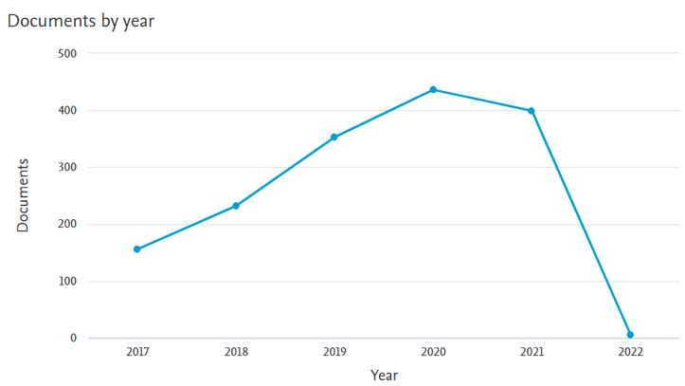
Picture 1. Document from 2017 – 2022
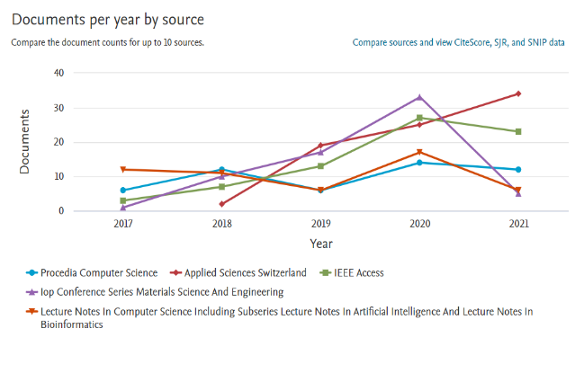Picture 2. Document per year by source

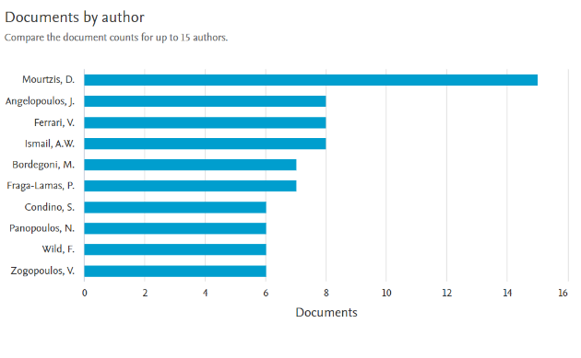 Picture 3. Documents by author

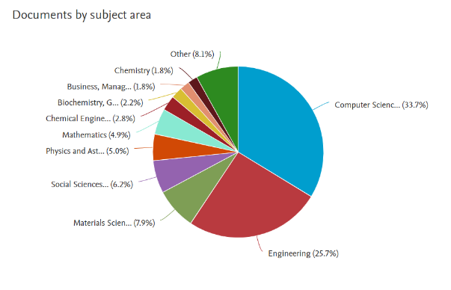
Picture 4. Documents by subject area

Picture 3 shows the process of searching for documents based on researchers. it can be seen that Mourtzis, D, produced 15 articles and Angelopoulos, J, produced 8 articles. This research can also be seen through the development of the subject based on the existing research year. It can be seen in picture 4 that computer science has 33.7% parts and engineering has 25.7%.
- RELATED WORK

Augmented Reality (AR) is a variation of Virtual Environments (VE), or more commonly called Virtual Reality. VE technology completely immerses the user in a synthetic environment [7]. AR can be used to help visualize abstract concepts for understanding and structure an object model. Some AR applications are designed to provide users with more detailed information than real objects. Media is a tool or object that serves as a liaison between the recipient and the sender of the message. When submerged, the user cannot see the real world around him. In contrast, AR allows users to see the real world, with virtual objects superimposed or combined with the real world. Therefore, AR complements reality, not completely replaces it [8]. or more simply Augmented reality (AR) aims to develop technology that allows real-time display of digital content generated by computers with the real world. Augmented reality allows users to see three-dimensional virtual objects that are superimposed on the real world. Thus Augmented Reality (AR) can be defined as a technology that is able to combine virtual objects in two dimensions or three dimensions into a real environment and then bring them up or project them in real time [9].

Simply put, mobile augmented reality is AR that you can take with you wherever you go. Most specifically, this means that the hardware required to implement an AR application is something that you take with you wherever you go [10]. Picture 5 show how to augmented reality with other technologies.

Picture 5. Virtuality Continum [7]

  - Marker Base

Different types of Augmented Reality (AR) markers are images that can be detected by a camera and used with software as the location for virtual assets placed in a scene. Most are black and white, though colours can be used as long as the contrast between them can be properly recognized by a camera. Simple augmented reality markers can consist of one or more basic shapes made up of black squares against a white background. More elaborate markers can be created using simple images that are still read properly by a camera, and these codes can even take the form of tattoos [11]. As show at Picture 6.
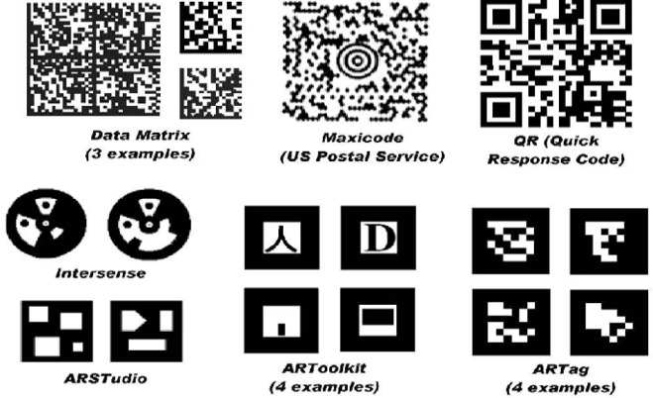

Picture 6. ARStudio and ARToolkit are patterns designed specifically for AR [12].
  - Markerless

In marker-less augmented reality the image is gathered through internet and displayed on any specific location (can be gathered using GPS). The application doesn’t require a marker to display the content. It is more interactive than marker based augmentation [11]. Picture 7 shows the application in use at the end of the building information.
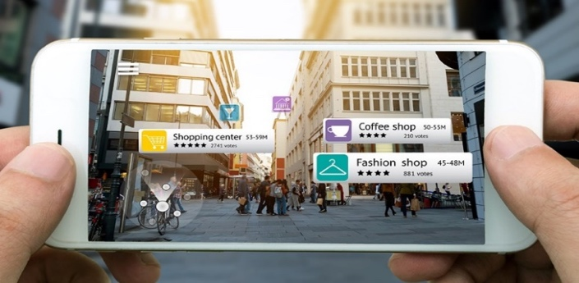
Pictutre 7. Marker less AR[13]

Table 1 shows a comparison of the models on AR Technology that is used in many applications today. There are 6 model for AR Technology : marker, face tracking, 3D Object Tracking, Motion Tracking, GPS Based Tracking and Infrared Model. In table 2 show the number of studies from statistically research technology augmented reality in the last 5 years. It is show 5 AR Technology : Mobile Device, AR Glasses, Virtual Retinal Display (VTR), Special AR Device and AR Contact Lenses.

Table 1. The Comparison of Model and Method on Augmented Reality

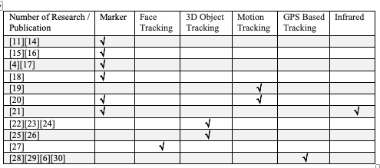

Table 2. Statistically research technology augmented reality in the last 5 years
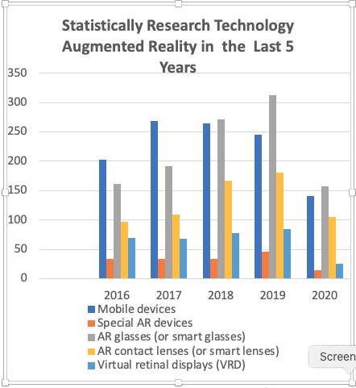

Table 3 shows the challenges and related problems that are found in many education applications related to student outcomes, pedagogical contribution, interactions, health , even in game applications [31].

Table 3. Summary of issue and challenge with regard [31]
Author | Issue / Problem And Challenge
[32] | AR is hard to use for the students
[33] | Problem of ergonomics
[34] | The broad file size restricts information sharing
[33] | Causes technological problems (indoor use, camera, internet)
[35] | Enhancing the achievement of learning
[36] | Boosting satisfaction
[35] | Strengthening trust
[37] | Boosts spatial capacity
[38] | Encourages self-learning
[35] | Allows multi-sensorial learning
[38] | Reduces prices for laboratory materials
[39] | Physical, technological, sociocultural, pedagogical, and management
[40] | Limitation of hardware
[41] | The optimal distance is 15 cm to 25 cm in front of the marker
[42] | Markers with room light conditions up to 1000lx can be read correctly by the application.

  - Augmented Reality Applications

Augmented reality applications are not only applied to mobile devices[43], but also special augmented reality devices[50][51][46], AR glasses (or smart glasses)[5], [47]–[49], AR contact lenses (or smart lenses)[2], [3], [50], Virtual retinal displays (VRD)[51], [52]. AR applications are widely applied in various fields including : Touch-less interactive augmented reality game on vision-based wearable device [9] , Augmented reality game to support therapeutic education for children with diabetes[53], VR and Augmented Reality (AR) to Civil Engineering education game[54], Augmented reality games for teaching and learning English as a foreign language [55], Augmented reality for children with developmental disabilities[56], Augmented Reality for Serious Games [57], a multi-player Underwater Augmented Reality (UWAR) experience for swimming pool [58], Augmented for tourism[59], augmented reality for diagnosis of heart diseases [60].
- METHOD

A study was conducted to determine the development of augmented reality technology and to find out shortcomings and future developments to make it easier to apply at all times and conditions. There are several steps in conducting this literature study. The first step: Perform a general database search to find out the extent of the development of Augmented reality technology using Google Scholar, Scopus, Research Gate, Mendeley and Springer. Several sources are references to books, journals, conferences, articles, dissertations, reports, from 2005 to 2020. The word Augmented reality is used to search for all types of publications that are applied in all fields. Step 2: more searches are selected after the publication papers are collected looking for research based on developments and augmented reality technology. The next step is to do an additional search: to find out how many studies use augmented realty, more research is limited to 2015 to 2020 using Mendeley's tools. Step 4 analysis: After studying existing papers, a matrix table is created. The final step or the fifth research in the future: for further research, an approach will be made to read markers in augmented reality faster.

- DISCUSSION

The problem that arise in AR is how to read marker, so it can display a virtual object that has been computed before, basically is how to read the geometry model of human hand, then the result from the processing of the human hand model geometry is used as a marker, so it can interact with a virtual environment on AR as one of the HCI model implementation. This process is intended for the movement of human hands that have been read as a virtual object can communicate virtually using image processing[61]. A study presents a powerful method for fast reading of Visual Tags, suitable for Augmented Reality (AR) environments. Tag detection is based on well-known image processing tools, but the combination of the two, together with the use of color markers, enables strong recognition even with low-cost CMOS or CCD cameras and in low-light environments. In particular the mixture of colors and tag structure is very unusual in the general environment and can be easily detected by color filtering and geometric analysis. The proposed tag carries binary information encoded in its structure: in the presented implementation 32-bit code with 12 bits of parity is encoded in the tag but extensions to longer code can easily be generated[62].

ARTag is a marker system that uses digital coding theory to get a very low false positive and inter-marker confusion rate with a small required marker size, employing an edge linking method to give robust lighting variation immunity. ARTag markers are bi-tonal planar patterns containing a unique ID number encoded with robust digital techniques of checksums and forward error correction (FEC). This proposed new system, ARTag has very low and numerically quantifiable error rates, does not require a grey scale threshold as does other marker systems, and can encode up to 2002 different unique ID's with no need to store patterns[63].

The study compared the two recently developed ARTag and ARToolkit Plus systems on reliability, detection rates, and immunity to exposure and occlusion. Processing in a fiduciary system is defined as two stages, detection of unique features and verification / identification[64].

- CONCLUSION

In designing augmented reality-based applications, especially base markers, it is necessary to pay attention to making clear markers because most markers are black and white patterns that are clearly visible [65], because the speed of reading markers depends on the ambients light.

- ACKNOWLEDGEMENT

This study is supported by Research Group Pervasive Computing & Educational Technology (PET), Centre for Advanced Computing Technology (C-ACT), Universiti Teknikal Malaysia Melaka (UTeM).

Reference

[1] U. Syaripudin, D. R. Ramdania, W. Widiawaty, W. B. Zulfikar, and D. S. Maylawati, “Fast corner detection in augmented reality learning management of the corpse,” Informatica (Slovenia), vol. 45, no. 6. Slovene Society Informatika, Department of ICT, Asia E-University, Kuala Lumpur, Malaysia, pp. 29–36, 2021, doi: 10.31449/inf.v45i6.3580.

[2] P. A. Rauschnabel, A. Brem, and Y. K. Ro, “Augmented Reality Smart Glasses : Definition , Conceptual Insights , and Managerial Importance,” -, no. 313, pp. 1–21, 2015.

[3] S. Kim, M. A. Nussbaum, and J. L. Gabbard, “Augmented Reality ‘Smart Glasses’ in the Workplace: Industry Perspectives and Challenges for Worker Safety and Health,” IIE Trans. Occup. Ergon. Hum. Factors, vol. 4, no. 4, pp. 253–258, 2016, doi: 10.1080/21577323.2016.1214635.

[4] A. K. Dash, S. K. Behera, D. P. Dogra, and P. P. Roy, “Designing of marker-based augmented reality learning environment for kids using convolutional neural network architecture,” Displays, vol. 55, pp. 46–54, 2018, doi: 10.1016/j.displa.2018.10.003.

[5] P. A. Rauschnabel and Y. K. Ro, “Augmented reality smart glasses: an investigation of technology acceptance drivers,” Int. J. Technol. Mark., vol. 11, no. 2, p. 123, 2016, doi: 10.1504/ijtmkt.2016.075690.

[6] C. Andri, M. H. Alkawaz, and A. B. Sallow, “Adoption of mobile augmented reality as a campus tour application,” Int. J. Eng. Technol., vol. 7, no. 4, pp. 64–69, 2018, doi: 10.14419/ijet.v7i4.11.20689.

[7] L. Abada and S. Aouat, “Intelligent Systems for Science and Information,” Intell. Syst. Sci. Inf., vol. 542, pp. 369–387, 2014, doi: 10.1007/978-3-319-04702-7.

[8] M. Billinghurst, A. Clark, and G. Lee, “A survey of augmented reality,” Found. Trends Human-Computer Interact., vol. 8, no. 2–3, pp. 73–272, 2014, doi: 10.1561/1100000049.

[9] Z. Lv, A. Halawani, S. Feng, S. Ur Réhman, and H. Li, “Touch-less interactive augmented reality game on vision-based wearable device,” Pers. Ubiquitous Comput., vol. 19, no. 3, pp. 551–567, 2015, doi: 10.1007/s00779-015-0844-1.

[10] Alan B. Craig, “Augmented Reality. Concepts and Applications (2013),” 2013.

[11] A. Katiyar, K. Kalra, and C. Garg, “Marker-based augmented reality,” vol. 2, no. 5, pp. 21–28, 2015, doi: 10.1145/2771839.2771842.

[12] M. Fiala, “ARTag, a fiducial marker system using digital techniques,” in Proceedings - 2005 IEEE Computer Society Conference on Computer Vision and Pattern Recognition, CVPR 2005, 2005, vol. II, pp. 590–596, doi: 10.1109/CVPR.2005.74.

[13] “markerless,” 2019. .

[14] E. Wild et al., “Robust augmented reality guidance with fluorescent markers in laparoscopic surgery,” Int. J. Comput. Assist. Radiol. Surg., vol. 11, no. 6, pp. 899–907, 2016, doi: 10.1007/s11548-016-1385-4.

[15] E. Cieza and D. Lujan, “Educational Mobile Application of Augmented Reality Based on Markers to Improve the Learning of Vowel Usage and Numbers for Children of a Kindergarten in Trujillo,” Procedia Comput. Sci., vol. 130, pp. 352–358, 2018, doi: 10.1016/j.procs.2018.04.051.

[16] H. Subakti and J. R. Jiang, “A marker-based cyber-physical augmented-reality indoor guidance system for smart campuses,” Proc. - 18th IEEE Int. Conf. High Perform. Comput. Commun. 14th IEEE Int. Conf. Smart City 2nd IEEE Int. Conf. Data Sci. Syst. HPCC/SmartCity/DSS 2016, pp. 1373–1379, 2017, doi: 10.1109/HPCC-SmartCity-DSS.2016.0194.

[17] M. M. Marques and L. Pombu, “Marker-based augmented reality application for mobile learning in an urban park,” Int. Symp. Comput. Educ., pp. 1–5, 2017.

[18] D. Chaves-Diéguez et al., “Providing iot services in smart cities through dynamic augmented reality markers,” Sensors (Switzerland), vol. 15, no. 7, pp. 16083–16104, 2015, doi: 10.3390/s150716083.

[19] L. Yu, S. K. Ong, and A. Y. C. Nee, “A tracking solution for mobile augmented reality based on sensor-aided marker-less tracking and panoramic mapping,” Multimed. Tools Appl., vol. 75, no. 6, pp. 3199–3220, 2016, doi: 10.1007/s11042-014-2430-3.

[20] M. Žuži, J. Čejka, F. Bruno, D. Skarlatos, and F. Liarokapis, “Impact of dehazing on underwater marker detection for augmented reality,” Front. Robot. AI, vol. 5, no. AUG, pp. 1–13, 2018, doi: 10.3389/frobt.2018.00092.

[21] R. Kuriya, T. Tsujimura, and K. Izumi, “Augmented reality robot navigation using infrared marker,” Proc. - IEEE Int. Work. Robot Hum. Interact. Commun., vol. 2015-Novem, pp. 450–455, 2015, doi: 10.1109/ROMAN.2015.7333607.

[22] M. Krichenbauer, G. Yamamoto, T. Taketom, C. Sandor, and H. Kato, “Augmented Reality versus Virtual Reality for 3D Object Manipulation,” IEEE Trans. Vis. Comput. Graph., vol. 24, no. 2, pp. 1038–1048, 2018, doi: 10.1109/TVCG.2017.2658570.

[23] J. Rambach, A. Pagani, and D. Stricker, “Augmented Things: Enhancing AR Applications leveraging the Internet of Things and Universal 3D Object Tracking,” in Adjunct Proceedings of the 2017 IEEE International Symposium on Mixed and Augmented Reality, ISMAR-Adjunct 2017, 2017, pp. 103–108, doi: 10.1109/ISMAR-Adjunct.2017.42.

[24] J. Rambach, A. Pagani, M. Schneider, O. Artemenko, and D. Stricker, “6DoF object tracking based on 3D scans for augmented reality remote live support,” Computers, vol. 7, no. 1, pp. 1–22, 2018, doi: 10.3390/computers7010006.

[25] R. Radkowski, “Object Tracking With a Range Camera for Augmented Reality Assembly Assistance,” J. Comput. Inf. Sci. Eng., vol. 16, no. 1, pp. 1–8, 2016, doi: 10.1115/1.4031981.

[26] A. Crivellaro, M. Rad, Y. Verdie, K. M. Yi, P. Fua, and V. Lepetit, “A novel representation of parts for accurate 3d object detection and tracking in monocular images,” Proc. IEEE Int. Conf. Comput. Vis., vol. 2015 Inter, pp. 4391–4399, 2015, doi: 10.1109/ICCV.2015.499.

[27] H. Peng, “Application Research on Face Detection Technology based on OpenCV in Mobile Augmented Reality,” Int. J. Signal Process. Image Process. Pattern Recognit., vol. 8, no. 4, pp. 249–256, 2015, doi: 10.14257/ijsip.2015.8.4.22.

[28] C. Santos, T. Araújo, J. Morais, and B. Meiguins, “Hybrid Approach Using Sensors, GPS and Vision Based Tracking to Improve the Registration in Mobile Augmented Reality Applications,” Int. J. Multimed. Ubiquitous Eng., vol. 12, no. 4, pp. 117–130, 2017, doi: 10.14257/ijmue.2017.12.4.10.

[29] N. Bursztyn, B. Shelton, A. Walker, and J. Pederson, “Increasing undergraduate interest to learn geoscience with GPS-based augmented reality field trips on students’ own smartphones,” GSA Today, vol. 27, no. 6, pp. 4–10, 2017, doi: 10.1130/GSATG304A.1.

[30] A. Pagani, J. Henriques, and D. Stricker, “Sensors for location-based augmented reality the example of galileo and egnos,” Int. Arch. Photogramm. Remote Sens. Spat. Inf. Sci. - ISPRS Arch., vol. 2016-Janua, no. July, pp. 1173–1177, 2016, doi: 10.5194/isprsarchives-XLI-B1-1173-2016.

[31] M. Akçayır and G. Akçayır, “Advantages and challenges associated with augmented reality for education: A systematic review of the literature,” Educ. Res. Rev., vol. 20, pp. 1–11, 2017, doi: 10.1016/j.edurev.2016.11.002.

[32] J. A. Muñoz-Cristóbal, I. M. Jorrín-Abellan, J. I. Asensio-Peréz, A. Martínez-Monés, L. P. Prieto, and Y. Dimitriadis, “Supporting teacher orchestration in ubiquitous learning environments: A study in primary education,” IEEE Trans. Learn. Technol., vol. 8, no. 1, pp. 83–97, 2015, doi: 10.1109/TLT.2014.2370634.

[33] Y.-L. Chang, H.-T. Hou, C.-Y. Pan, Y.-T. Sung, and K.-E. Chang, “International Forum of Educational Technology &amp; Society Apply an Augmented Reality in a Mobile Guidance to Increase Sense of Place for Heritage Apply an Augmented Reality in a Mobile Guidance to Increase Sense of Place for Heritage Places,” J. Educ. Technol. Soc. Educ. Technol. Soc., vol. 18, no. 182, pp. 166–178, 2015.

[34] F. Ke and Y. C. Hsu, “Mobile augmented-reality artifact creation as a component of mobile computer-supported collaborative learning,” Internet High. Educ., vol. 26, pp. 33–41, 2015, doi: 10.1016/j.iheduc.2015.04.003.

[35] S. J. Lu and Y. C. Liu, “Integrating augmented reality technology to enhance children’s learning in marine education,” Environ. Educ. Res., vol. 21, no. 4, pp. 525–541, 2015, doi: 10.1080/13504622.2014.911247.

[36] J. Han, M. Jo, E. Hyun, and H. jeong So, “Examining young children’s perception toward augmented reality-infused dramatic play,” Educ. Technol. Res. Dev., vol. 63, no. 3, pp. 455–474, 2015, doi: 10.1007/s11423-015-9374-9.

[37] H. C. K. Lin, M. C. Chen, and C. K. Chang, “Assessing the effectiveness of learning solid geometry by using an augmented reality-assisted learning system,” Interact. Learn. Environ., vol. 23, no. 6, pp. 799–810, 2015, doi: 10.1080/10494820.2013.817435.

[38] J. Ferrer-Torregrosa, J. Torralba, M. A. Jimenez, S. García, and J. M. Barcia, “ARBOOK: Development and Assessment of a Tool Based on Augmented Reality for Anatomy,” J. Sci. Educ. Technol., vol. 24, no. 1, pp. 119–124, 2015, doi: 10.1007/s10956-014-9526-4.

[39] V. F. Martins, L. Gomes, and M. de P. Guimarães, “Challenges and possibilities of use of augmented reality in education case study in music education,” Lect. Notes Comput. Sci. (including Subser. Lect. Notes Artif. Intell. Lect. Notes Bioinformatics), vol. 9159, pp. 223–233, 2015, doi: 10.1007/978-3-319-21413-9_16.

[40] A. Fenais, N. Smilovsky, S. T. Ariaratnam, and S. K. Ayer, “A Meta-Analysis of Augmented Reality Challenges in the Underground Utility Construction Industry,” Constr. Res. Congr. 2018 Infrastruct. Facil. Manag. - Sel. Pap. from Constr. Res. Congr. 2018, vol. 2018-April, no. March, pp. 80–89, 2018, doi: 10.1061/9780784481295.009.

[41] R. Gusman and M. E. Apriyani, “Analisis Pemanfaatan Metode Markerless User Defined Target Pada Augmented Reality Sholat Shubuh,” J. INFOTEL - Inform. Telekomun. Elektron., vol. 8, no. 1, p. 64, 2016, doi: 10.20895/infotel.v8i1.53.

[42] A. H. Pujabaladika and L. Anifah, “Marker Based Tracking Augmented Reality pada Brosur Jurusana Teknik Informatikaa Universitas Negeria Surabaya,” Jinacs, vol. 01, no. 03, pp. 150–156, 2020.

[43] S. Kasetty Sudarshan, “Presented to The Faculty of the Department of Software Engineering San José State University In Partial Fulfillment of the Requirements for the Degree Master of Science By Sneha Kasetty Sudarshan May , 2018,” 2017.

[44] F. D’Ippolito and M. Massaro, “A multi-sensor multi-rate algorithm for motor rehabilitation with Augmented Reality devices,” Proc. IEEE RAS EMBS Int. Conf. Biomed. Robot. Biomechatronics, vol. 2016-July, pp. 759–765, 2016, doi: 10.1109/BIOROB.2016.7523718.

[45] A. V. Zhuravlev, V. V. Razevig, M. A. Chizh, and A. S. Bugaev, “On the use of augmented reality devices for subsurface radar imaging,” 2016 Prog. Electromagn. Res. Symp. PIERS 2016 - Proc., pp. 2132–2136, 2016, doi: 10.1109/PIERS.2016.7734890.

[46] V. Elia, M. G. Gnoni, and A. Lanzilotto, “Evaluating the application of augmented reality devices in manufacturing from a process point of view: An AHP based model,” Expert Syst. Appl., 2016, doi: 10.1016/j.eswa.2016.07.006.

[47] Y. J. Chang, H. H. Liu, Y. S. Kang, C. C. Kao, and Y. S. Chang, “Using augmented reality smart glasses to design games for cognitive training,” Proc. 2016 13th Int. Conf. Remote Eng. Virtual Instrumentation, REV 2016, no. February, pp. 252–253, 2016, doi: 10.1109/REV.2016.7444474.

[48] N. Kommera, F. Kaleem, and S. M. S. Harooni, “Smart augmented reality glasses in cybersecurity and forensic education,” IEEE Int. Conf. Intell. Secur. Informatics Cybersecurity Big Data, ISI 2016, pp. 279–281, 2016, doi: 10.1109/ISI.2016.7745489.

[49] S. Oh, K. Park, S. Kwon, and H. J. So, “Designing a multi-user interactive simulation using AR glasses,” TEI 2016 - Proc. 10th Anniv. Conf. Tangible Embed. Embodied Interact., pp. 539–544, 2016, doi: 10.1145/2839462.2856521.

[50] P. A. Rauschnabel, “Virtually enhancing the real world with holograms: An exploration of expected gratifications of using augmented reality smart glasses,” Psychol. Mark., vol. 35, no. 8, pp. 557–572, 2018, doi: 10.1002/mar.21106.

[51] A. Maimone, A. Georgiou, and J. S. Kollin, “Holographic near-eye displays for virtual and augmented reality,” ACM Trans. Graph., vol. 36, no. 4, 2017, doi: 10.1145/3072959.3073624.

[52] C. Jang, K. Bang, S. Moon, J. Kim, S. Lee, and B. Lee, “Retinal 3D: Augmented reality near-eye display via pupil-tracked light field projection on retina,” ACM Trans. Graph., vol. 36, no. 6, 2017, doi: 10.1145/3130800.3130889.

[53] A. M. Calle-Bustos, M. C. Juan, I. García-García, and F. Abad, “An augmented reality game to support therapeutic education for children with diabetes,” PLoS One, vol. 12, no. 9, pp. 1–23, 2017, doi: 10.1371/journal.pone.0184645.

[54] D. Panepistēmio Peiraiōs, IEEE Education Society, and Institute of Electrical and Electronics Engineers, “Proceedings of 2017 IEEE Global Engineering Education Conference (EDUCON) : date and venue: 25-28 April 2017, Athens, Greece.,” 2017 IEEE Glob. Eng. Educ. Conf. (EDUCON), Glob. Eng. Educ. Conf. (EDUCON), 2017 IEEE, no. April, p. 1735, 2017.

[55] D. Richardson, “Exploring the potential of a location based augmented reality game for language learning,” Int. J. Game-Based Learn., vol. 6, no. 3, pp. 34–49, 2016, doi: 10.4018/IJGBL.2016070103.

[56] C. Y. Lin and Y. M. Chang, “Interactive augmented reality using Scratch 2.0 to improve physical activities for children with developmental disabilities,” Res. Dev. Disabil., vol. 37, pp. 1–8, 2015, doi: 10.1016/j.ridd.2014.10.016.

[57] A. Antonaci, R. Klemke, and M. Specht, “Serious Games,” vol. 2, pp. 273–282, 2015, doi: 10.1007/978-3-319-25684-9.

[58] L. Oppermann, L. Blum, and M. Shekow, “Playing on AREEF -evaluation of an underwater augmented reality game for kids,” Proc. 18th Int. Conf. Human-Computer Interact. with Mob. Devices Serv. MobileHCI 2016, pp. 330–340, 2016, doi: 10.1145/2935334.2935368.

[59] S. pei Tsai, “Augmented reality enhancing place satisfaction for heritage tourism marketing,” Curr. Issues Tour., vol. 23, no. 9, pp. 1078–1083, 2020, doi: 10.1080/13683500.2019.1598950.

[60] J. D. Hemanth, U. Kose, O. Deperlioglu, and V. H. C. de Albuquerque, “An augmented reality-supported mobile application for diagnosis of heart diseases,” J. Supercomput., vol. 76, no. 2, pp. 1242–1267, 2020, doi: 10.1007/s11227-018-2483-6.

[61] Y. Ariyana and A. I. Wuryandari, “Basic 3D interaction techniques in Augmented Reality,” Proc. 2012 Int. Conf. Syst. Eng. Technol. ICSET 2012, 2012, doi: 10.1109/ICSEngT.2012.6339281.

[62] A. Dell’Acqua, M. Ferrari, M. Marcon, A. Sarti, and S. Tubaro, “Colored visual tags: A robust approach for augmented reality,” IEEE Int. Conf. Adv. Video Signal Based Surveill. - Proc. AVSS 2005, vol. 2005, pp. 423–427, 2005, doi: 10.1109/AVSS.2005.1577306.

[63] M. Rohs, “Marker-Based Embodied Interaction for Handheld Augmented Reality Games,” J. Virtual Real. Broadcast., vol. 4, no. 5, pp. 1860–2037, 2007.

[64] M. Fiala, “Comparing ARTag and ARToolkit plus fiducial marker systems,” HAVE 2005 IEEE Int. Work. Haptic Audio Vis. Environ. their Appl., vol. 2005, pp. 148–153, 2005, doi: 10.1109/HAVE.2005.1545669.

[65] O. Korkalo, “Light-Weight Marker Hiding for Augmented Reality,” pp. 247–248, 2010.

