Application of Intelligent Medical Treatment in Long-Term Mental Health Monitoring and Early Warning of College Students
Fang Wang
Henan Technical College of Construction, Marxist Academy, Zhengzhou, Henan, 450064, China
E-mail: lotus071820@163.com

Keywords: Intelligent medical treatment, College students, Mental health, Monitoring and early warning, Deep learning, Public Health Ethics
Received:
With the rapid development of society and the intensification of competition, the mental health problems of college students have become increasingly prominent, and have become the focus of attention from all walks of life. The traditional mental health monitoring methods have some problems, such as low efficiency, narrow coverage and delayed early warning, so it is difficult to meet the needs of college students' mental health management. Therefore, this article aims to explore the application of smart medical technology in long-term psychological health monitoring and early warning of college students. Based on the basic principles of public health ethics, a comprehensive and intelligent psychological health monitoring system is constructed by integrating advanced technologies such as psychological scales and deep learning. The results showed that in terms of accuracy, the other two models, except for the logistic regression model, achieved an accuracy of over 82% among the three models. Among them, the accuracy of this paper was the highest, indicating that it has better predictive performance. In terms of accuracy, the percentages of logistic regression model and XGBoost model are both below 80%. Especially, the accuracy of the logistic regression model is only 63.7%, while the accuracy of our model is significantly higher, with better reliability and accuracy performance. In the experiment, four different datasets were randomly selected for experimentation. The results indicate that the proposed model has a high degree of consistency with manual processing methods, with a matching degree of over 93.6%. Experimental results show that compared with other models, the proposed model has better performance and can effectively process mental health-related data, and the results have higher accuracy and precision rate, and have higher practical application potential. The experimental results show that the model can effectively extract the psychological keywords features of college students' social software and effectively identify students with different mental health states. According to the relevant data, the risk distribution of students' mental illness and the risk degree of influencing factors can be analyzed, and more targeted strategy suggestions can be provided for psychological intervention of college students.

1. Introduction
Mental health is the basis of college students' personal growth and development and is also a key factor in their academic achievement, interpersonal relationships, future career and even the quality of life. Good mental health can help college students maintain a stable emotional state, better cope with the challenges and difficulties in life, and reduce the negative impact caused by emotional fluctuations. College life is full of various pressures and challenges, such as exams, essays, internships and so on. Good mental health can help students effectively cope with these pressures, reduce anxiety and depression, and maintain a positive learning attitude [1]. At the same time, paying attention to mental health helps improve college students' social ability and makes it easier for them to establish good relationships with others, which is an important source of emotional support. When college students face difficulties and challenges, they can get support and help from friends and family members, thus reducing their psychological burden and enhancing their ability to resist pressure [2]. Paying attention to the mental health of college students can help early identification of signs of psychological problems, such as anxiety, depression, etc., to timely intervention and treatment to prevent problems from worsening. According to a survey conducted by the National Mental Health Evaluation and Development Center of the Institute of Psychology of the Chinese Academy of Sciences in 2022, negative emotions such as anxiety, panic and interpersonal sensitivity are prevalent among college students, and mental health problems such as depression, anxiety, insomnia, online game addiction and post-traumatic stress are still prominent [3]. Data show that at present, the total detection rate of mental health problems among college students in China is 18.9%, among which the proportion of internalized problems (such as anxiety, depression, sleep problems and suicidal ideation) is 20.0%, and the proportion of externalized problems (such as self-harm and suicide attempts) is 11.7%[4]. It can be seen that the mental health problems of college students can not be ignored. College students are the future pillars of the country, paying attention to their mental health is helpful to cultivate high-quality talents with healthy psychology, noble morality and solid knowledge, and contribute to the development of society. Mental illness not only brings pain to the individual patient but also brings a heavy burden to the family and society. Paying attention to the mental health of college students helps reduce the occurrence of mental diseases, thus reducing the social burden [5]. Therefore, the long-term monitoring of college student's mental health has become the focus of universities and all sectors of society, as well as the key research content in the field of psychology and smart medical treatment.
Traditional college students' mental health monitoring methods mainly rely on psychological scales, daily observation, individual counselling and other means, which can help schools and teachers understand students' psychological status to a certain extent [6]. However, with the development of The Times and the increasing complexity of students' mental health needs, traditional monitoring methods have gradually exposed some problems. In terms of mental health monitoring methods, although psychological scale assessment is objective to a certain extent, different students may have subjective biases when filling out questionnaires, which affects the accuracy of results [7]. Daily observation also depends on the subjective judgment and experience of the observer, and there may be misjudgment or missing judgment. Traditional monitoring methods mainly focus on the collection and analysis of static data, which makes it difficult to dynamically understand the changes in students' mental states and fail to timely detect potential psychological problems [8]. In terms of resources and efficiency, the traditional one-to-one assessment, collection and feedback mode takes a lot of time and manpower. Many universities have limited resources in mental health monitoring, including the number of psychological counsellors and the facilities of psychological consultation rooms, which makes it difficult to meet the needs of large-scale student groups for mental health monitoring [9]. Therefore, the traditional monitoring method often intervenes after students have psychological problems, and lacks effective prevention mechanisms to detect and solve potential psychological problems in advance. Meanwhile, traditional psychological monitoring processes are prone to improper data storage, which may result in biases towards culture, gender, and subjective judgments lacking fairness and impartiality. In order to obtain more accurate monitoring data, some universities may excessively intervene in students' daily lives and psychological states, such as frequently requiring students to undergo psychological testing or counseling. This excessive intervention may infringe upon students' privacy and freedom rights. These public health ethical issues have had a significant negative impact on the psychology of college students, causing them to develop resistance to long-term psychological monitoring.Because of the above problems, this paper builds a long-term mental health monitoring and early warning model for college students based on the combination of an intelligent medical system and a traditional psychological scale. The model obtains the relevant data on college students' mental health through psychological scale assessment and wearable devices and carries out preliminary data processing. According to the data processing results, the psychological dynamic changes of college students are further analyzed through the mental health monitoring and early warning system built based on deep learning, and multi-dimensional and multi-level mental health intervention and monitoring are carried out to improve the quality of psychological monitoring. At the same time, long-term psychological monitoring of college students through this model can effectively improve the confidentiality of relevant data, and provide college students' mental health warning data for relevant personnel on the basis of respecting their wishes. This article aims to address how to break through the limitations of traditional monitoring methods and achieve long-term dynamic monitoring and early warning of college students' mental health while adhering to the principles of public health ethics. The second is how to efficiently integrate psychological scale data with social media text data to improve the accuracy of mental health status recognition. Quantify the distribution of psychological disease risk and the degree of risk of influencing factors through data analysis, providing a basis for intervention. The expected computational contribution is to build a deep learning model that integrates psychological scale features with social software keyword features, optimize feature extraction and model training processes, and improve data processing efficiency and state recognition accuracy.

2. Related Work
In recent years, China has made great progress in disease early warning and monitoring technology in the field of smart medicine, especially in the innovation of mental health services for college students, and a series of advanced systems based on big data and artificial intelligence technology has emerged [10]. In the smart campus mental health early warning and monitoring system launched by some researchers, an efficient framework of front-end separation is adopted, and various algorithms such as machine learning and natural language processing are deeply integrated to achieve comprehensive monitoring and accurate early warning of college student's mental health status [11]. Other researchers have integrated a variety of psychometric scales into their mental models, using these standardized tools to collect data on students' self-assessments. Through complex statistical analysis and machine learning algorithms, the system can automatically analyze the assessment results and identify potential psychological problems or risk factors [12]. To better obtain relevant data, some researchers combined the physiological data collected by wearable devices (such as smart wristbands, heart rate monitors, etc.), systematically used time series analysis and recurrent neural networks such as LSTM and GRU to assess students' emotional stress and health status from the physiological level, and provided auxiliary basis for psychological early warning [13]. In addition, some researchers take the behaviour patterns of college students as the starting point and use big data analysis technology to systematically track students' behaviour trajectories, social media activities, learning performance and other multidimensional data on campus. Through association rule mining, cluster analysis and other algorithms, abnormal behaviour patterns are identified, such as a sudden decrease in social activities and decline in grades, etc., to indirectly understand college students' mental state and possible psychological problems [14].
Although foreign research involves electronic medical records, physiological indicators, language and emotion data, there are still shortcomings in the depth of data integration, and efficient fusion of multi-source heterogeneous data has not been fully achieved. The lack of performance indicators makes it difficult to objectively measure the warning and monitoring effects of various technical methods, judge whether existing technologies can meet the accuracy requirements in practical applications, and provide effective performance benchmarks for subsequent research. In contrast, foreign countries started earlier in the disease warning and monitoring of smart medical systems, and the technical system and application model have been relatively mature. The United States, Europe and other developed countries have made remarkable achievements in the interconnection of electronic medical record systems, the popularization of telemedicine services and the intelligence of health monitoring equipment [15]. These systems not only focus on real-time monitoring of physiological data but also carry out in-depth analysis of massive medical information through advanced data mining and machine learning algorithms to realize early detection and personalized intervention of mental health problems [16]. Some researchers use deep learning algorithms to analyze unstructured data such as language patterns and emotional expression of patients, and combine physiological indicators and medical history information to construct a more detailed mental health portrait [17]. In addition, these systems also focus on close cooperation with mental health experts to improve the targeting and effectiveness of psychological interventions through AI-assisted diagnosis and advice [18]. Kolenik et al. focused on analyzing the range of motion of the shoulders and elbows during gait cycles, as well as various gait parameters on the affected side. After evaluation, the control group received routine rehabilitation treatment [19]. The results showed that there was no significant difference between the two groups before treatment. However, after treatment, the movement of the affected shoulder and elbow joints in the treatment group significantly improved [20]. Kolenik et al. [21] focused on analyzing the range of motion of the shoulders and elbows during gait cycles, as well as various gait parameters on the affected side. After evaluation, the control group received routine rehabilitation treatment. The results showed that there was no significant difference between the two groups before treatment. However, after treatment, the movement of the affected shoulder and elbow joints in the treatment group significantly improved [22]. Kolenik [23] proposed a stress, anxiety, and depression (SAD) computational psychotherapy system using session proxies. It combines a quantitative diagnostic level questionnaire and a qualitative daily diary. The second contribution is the system itself, which is built on a cognitive architecture and simulates psychological theory through a series of user, machine learning, and knowledge models for SAD prediction, forecasting, and personalized intervention. Psychological health issues have significant and multifaceted impacts on patients, their surrounding environment (family or caregivers), and the wider society. Individuals face declining quality of life, poor educational outcomes, decreased productivity and potential poverty, social issues, vulnerability to abuse, and other health problems [24].
Compared to existing methods, the proposed deep learning based monitoring and early warning system for college students' mental health has significant differences. Existing research, such as Kolenik et al.'s work, mostly focuses on physiological motion parameter analysis or computational therapy systems for specific psychological problems. And partially relying on conventional rehabilitation therapy or a combination of quantitative questionnaires and diaries. The proposed system is specifically designed for college students and innovatively uses social media data as the core data source. Extracting emotional keywords through natural language processing technology, combined with deep learning models for analysis, better fits the daily behavior scenarios of college students. In terms of convenience in data acquisition and real-time capture of psychological states, it forms a clear distinction from existing methods that focus on physiological indicators or specific disease treatment. More emphasis is also placed on monitoring to achieve early warning functions, rather than just being used for intervention effect evaluation or disease treatment assistance.

3. Long-term mental health monitoring and early warning model of college students based on smart medicine

3.1. Preliminary processing of mental health data of college students
The long-term monitoring of college student's mental health emphasizes the continuous and uninterrupted observation and record of individual mental state to find the fluctuation and change of mental state over time. The monitoring content should cover the individual's emotion, behaviour, cognition, physiological response and other aspects to ensure a comprehensive assessment of individual mental health status. An individual's mental state will change with the changes of multiple factors such as time, environment and life events. Therefore, long-term monitoring of mental health needs to be dynamic, and monitoring strategies and programs can be adjusted in time. There are differences in psychological characteristics, coping styles and support systems among different individuals, so the long-term monitoring of mental health needs to be personalized according to the specific situation of individuals. Therefore, long-term monitoring of college students' mental health should be based on scientific principles, objective principles, meticulous principles and operational principles.
The long-term monitoring data of college students' mental health includes structured scale data, unstructured text data, and wearable device physiological data. The diversity of data types determines the need to design pre-processing pipelines according to dimensions. From the three core steps of "missing data processing", "NLP text cleaning", and "feature extraction before LSTM training", supplement the detailed operation process and parameter settings of preprocessing to ensure the reproducibility of the method. There are differences in the missing mechanisms of data from different sources. Scale data may be randomly missing due to incomplete filling, while wearable data may be continuously missing due to offline devices. This requires developing processing strategies based on data types, balancing data integrity and authenticity. At the same time, in order to protect the privacy rights of college students, this article combines the basic principles of public health ethics with wearable devices to obtain relevant mental health data of college students, fully respecting their own wishes while maintaining fairness and impartiality, and avoiding issues such as excessive intervention. In order to collect more comprehensive and multi-level data on the mental health of college students, this article also combines preliminary understanding of college students' mental health to achieve problem identification and risk assessment, providing important data foundation for subsequent analysis.
Using third and fourth year students from a certain university as research subjects, stratified random sampling was employed (with sample sizes allocated proportionally based on major types (humanities/science/engineering)). Push electronic questionnaire invitations to target students through the official academic system of the school, and students voluntarily click on the link to participate. The questionnaire is distributed through an encrypted questionnaire platform, with "required item verification" and "logical consistency verification" set up. The filling time should be controlled within 15-20 minutes, and invalid questionnaires with a filling time of less than 5 minutes or obvious duplicate answers should be removed in real time. In the model experiment, this paper randomly distributed SCL-90 scales to juniors and seniors in a university, and 1718 valid questionnaires were collected, including 846 juniors and 872 seniors. Through the data results of the scale, the risk to college student's mental health can be preliminarily understood, and the influence degree of each factor can be analyzed through the model. The SCL-90 scores of college students are shown in Table 1, and the normal model in the table is the control group. The results showed that compared with the control group, the college's juniors and seniors scored higher in obsessive-compulsive symptoms, interpersonal sensitivity, anxiety, fear and psychosis factors, and there was a significant level difference between the two. This shows that regardless of whether college students have certain mental health problems, it is necessary to achieve graded attention and intervention in long-term monitoring.

Table 1 SCL-90 scores of college students (M±SD)
divisor | norm | College student | t
somatization | 1.38±0.48 | 1.24±0.36 | -18.772***
Obsessive symptom | 1.63±0.58 | 1.66±0.56 | 1.806*
Interpersonal sensitivity | 1.65±0.51 | 1.68±0.54 | 5.621***
depressed | 1.50±0.59 | 1.42±0.50 | -13.067***
anxiety | 1.39±0.43 | 1.41±0.44 | 2.408*
antagonize | 1.48±0.56 | 1.33±0.42 | -25.575***
horror | 1.23±0.41 | 1.28±0.40 | 5.933***
bigoted | 1.43±0.57 | 1.34±0.44 | -17.034***
psychosis | 1.29±0.42 | 1.33±0.42 | 4.421***
other | 1.48±0.46 | 1.40±0.46 | -12.916***
Total equipartition | 1.44±0.43 | 1.39±0.41 | -9.501***

The "norm" group data in Table 1 is derived from the widely used SCL-90 scale in the field of psychology in China, which is the national adult norm. This norm is based on a large-scale sampling survey of the general population (without obvious psychological disorders) from different professions and age groups in multiple regions of the country. Its composition and data characteristics are detailed in authoritative reference books such as the "Handbook of Mental Health Assessment Scales" and multiple mental health studies. The recognized standard control data in the field of domestic mental health assessment is used to determine the differences in mental health levels between specific groups (such as the college student population in this study) and the general population. According to the above-mentioned basic data related to college student's mental health, the influence degree of each factor was obtained through the analysis of the smart medical system, as shown in Table 2. The influence of different factors in the table is different, and there is a positive correlation between them and the value. The results in the table can provide a certain basis for long-term monitoring of college students' mental health. The generation of data in Table 2 predates the complete construction of the intelligent medical system in Section 3.2 and belongs to the "preliminary basic analysis stage" results. The study first collected 1718 valid data using the SCL-90 scale, combined with semi-structured interviews with 50 students. Using the method of "correlation analysis+multiple linear regression", factors that have a significant impact on the mental health of college students were preliminarily screened. And calculate the standardized regression coefficients of each factor, which are positively correlated with psychological health risk. The larger the coefficient, the stronger the impact of the factor on psychological risk.

Table2 Influences of various factors affecting the mental health of college students
divisor | Influence factor
somatization | Sleep (0.082) | Sudden illness (0.079) | Classmate communication (0.025) | truancy (0.019) | School work (0.007) | Stay out late (0.006)
Obsessive symptom | Sleep (0.051) | Classmate communication (0.032) | Sudden illness (0.016) | Stay out late (0.011) | School work (0.009) | truancy (0.006)
Interpersonal sensitivity | Classmate communication (0.055) | Sleep (0.041) | Stay out late (0.017) | Sudden illness (0.016) | truancy (0.012) | School work (0.007)
depressed | Classmate communication (0.066) | Sleep (0.043) | Stay out late (0.015) | Sudden illness (0.017) | truancy (0.013) | School work (0.008)
anxiety | Sleep (0.052) | Classmate communication (0.046) | Sudden illness (0.022) | Stay out late (0.011) | truancy (0.009) | School work (0.007)
antagonize | Sleep (0.058) | Classmate communication (0.047) | truancy (0.029) | Sudden illness (0.027) | Stay out late (0.023) | School work (0.012)
horror | Classmate communication (0.056) | Sleep (0.039) | Sudden illness (0.021) | School work (0.018) | truancy (0.017) | Stay out late (0.014)
bigoted | Classmate communication (0.061) | Sleep (0.052) | Sudden illness (0.026) | Stay out late (0.019) | truancy (0.016) | School work (0.008)
psychosis | Classmate communication (0.063) | Sleep (0.048) | Sudden illness (0.024) | Stay out late (0.025) | truancy (0.021) | School work (0.008)
other | Classmate communication (0.038) | Sleep (0.029) | Sudden illness (0.027) | truancy (0.022) | Stay out late (0.016) | School work (0.011)
Overall average score | Sleep (0.060) | Classmate communication (0.048) | Sudden illness (0.018) | truancy (0.019) | Stay out late (0.014) | School work (0.007)

The values in parentheses in Table 2 represent the standardized regression coefficients of each influencing factor on the corresponding dimension of mental health, used to quantify the degree of influence of the factors. This value is derived through a "multiple linear regression model". Using the scores of each dimension of SCL-90 as the dependent variable and "sleep quality, social interaction with classmates, sudden illness, absenteeism, academic pressure, and late return" as independent variables, the regression coefficients were calculated after standardized processing. A positive coefficient indicates a positive correlation between factors and psychological problems.

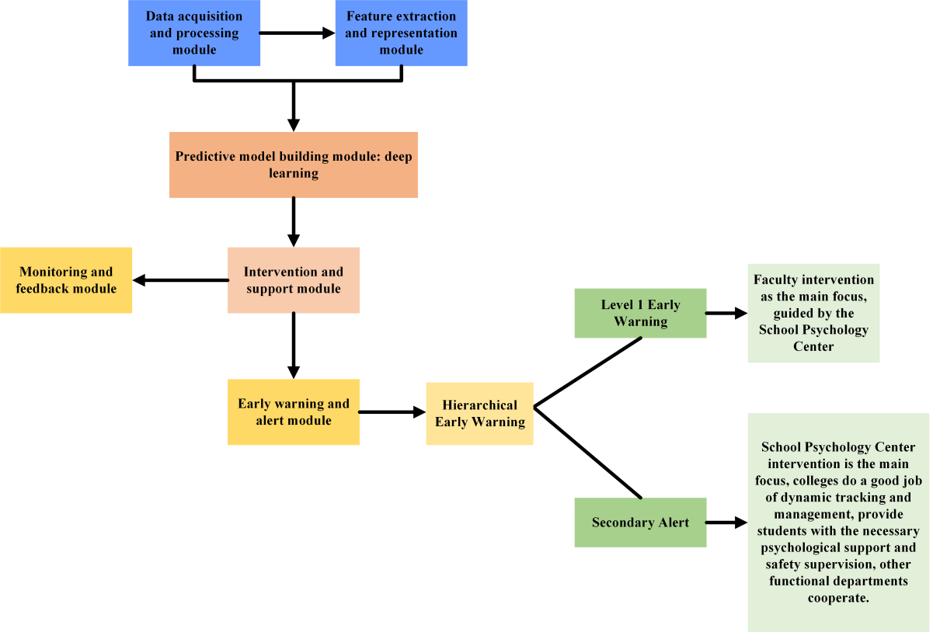
Figure 1 Workflow diagram of college students' mental health monitoring and early warning system based on deep learning

3.2. College students' mental health monitoring and early warning system based on deep learning
According to the preliminary processing results of college students' mental health data, the college students' mental health monitoring and early warning system based on deep learning will first extract emotional keywords from college students' social software through natural language processing technology (NLP), and then conduct further data analysis through deep learning models. Figure 1 shows the flow diagram of college students' mental health monitoring and early warning system based on deep learning.
As can be seen from the figure, college students' emotions are vented or expressed through different social media. NLP technology can analyze students' text data (such as social media posts, chat records, diaries, etc.) to identify the emotional tendencies expressed in them. It can also identify themes or topics in the student's text that may be related to mental health issues such as stressors, anxiety, and depression. By comparing a student's current language patterns with historical data or normal patterns, the NLP system can detect abnormal behaviour or emotional changes that can be early signs of mental health problems. Let a single text in college students' social software be represented as , Where the sequence number is The weight of the word is expressed as , Then the document vector is represented as , The formula for calculating the similarity between two documents is shown in (1) :
(1)
The core of a deep learning based monitoring and early warning system for college students' mental health is to achieve risk warning through multimodal data fusion and time-series model prediction. The NLP pipeline plays a key role in "unstructured text data parsing" and requires clear parameters for the entire process from text preprocessing to feature output. Naive Bayes cannot capture the contextual semantics of text and cannot process temporal data, therefore it is only used for initial screening and baseline validation, and does not participate in the final warning prediction. Let the class be represented as The naive Bayes classifier calculates the probability that the keywords in the text belong to this class The formula is shown in (2) :
(2)
The application of deep learning technology can not only improve the performance of NLP processing-related data. Considering the actual needs and the timing of mental health data, the LSTM neural network is adopted for deep data analysis by deep learning technology in this paper. Figure 2 shows the structure diagram of the LSTM neural network.

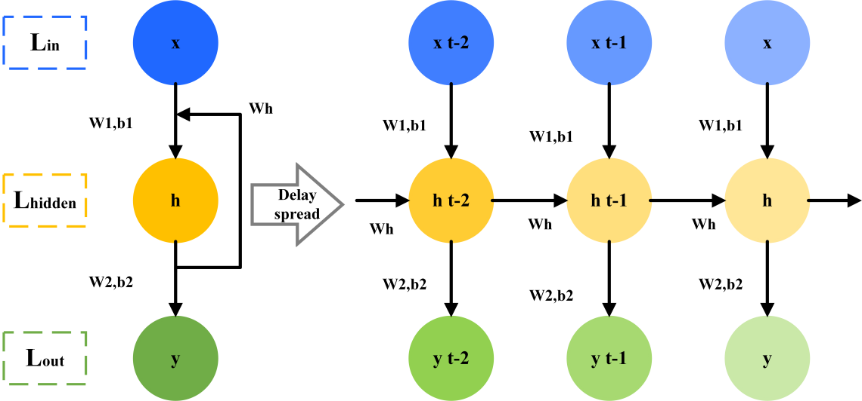
Figure 2 Schematic diagram of LSTM neural network

The hidden layers of the LSTM neural network have interconnected nodes, but the output transmitted by the current input layer and the output transmitted by the hidden layer in the previous period can exist at the same time so that the hidden layer can obtain the information memory at different times. The transmission process is shown in formulas (3) and (4) :
(3)
(4)
Where, the connection weight between the input layer and the hidden layer is expressed as , The connection weight between the hidden layer and the output layer is expressed as , indicating that the bias of the hidden layer and the output layer are respectively expressed as and . When the time is tIs displayed, the input is , The hidden layer output is , the output is ； When the time is t-1, the hidden layer output is .
The activation function formula is shown in (5) :
(5)
Let the loss function be the negative log-likelihood function of the label, as shown in formula (6) :
(6)
Then the overall loss function of the sequence is shown in formula (7) :
(7)
The monitoring of college student's mental health is long-term, which indicates that the system needs to monitor multiple targets at one time. Therefore, this paper introduces a distributed multi-agent system to broaden the performance of the mental health monitoring system based on deep learning, so that different modules can complete their responsible parts relatively independently at the same time and have a correlation with each other. The key to realizing the coordinated control of the modules in the multi-agent system is consistency control. The data collection agent is responsible for parallel collection of social text, scales, and wearable physiological data, labeling the raw data by type and sending it to the bus. NLP analysis agents obtain text data from the bus, independently complete word segmentation, embedding, and emotional topic extraction, and output text features. The feature fusion agent synchronously receives text features, scale features, and physiological features to complete multimodal feature alignment and concatenation. The warning decision agent independently runs the LSTM model to generate risk levels based on the fused temporal features. The feedback interaction agent receives the risk results and pushes warning information and intervention suggestions to the counselor and students respectively. Each agent can dynamically increase or decrease according to the monitoring scale, and a single agent failure does not affect the overall system operation, significantly improving scalability. At the same time, through consistency control algorithms, it ensures that the timestamps and feature formats of each proxy data are consistent, avoiding warning bias caused by asynchronous data.
Set the number of multiple agents to , the sequence number The agent status is described as . If the time conditions are met The state description between any two agents is as shown in (8) :
(8)
If the state of the agent has continuity, as shown in (9) :
(9)
Its consistency protocol is shown in (10) :
(10)
If the state of the agent is discrete, as shown in (11) :
(11)
Its consistency protocol is shown in (12) :
(12)
The status description of the agent in the system is shown in (13) :
(13)
Among them, .
The corresponding consistency agreement is shown in (14) :
(14)
When the agent's state is In the case of order, its consistency protocol is shown in (15) :
(15)

4. Experimental results and analysis of long-term mental health monitoring and early warning model of college students based on smart medicine

4.1 Experimental results and analysis of model performance
To test the performance of all aspects of the model presented in this paper, the logistic regression model and XGBoost model were selected as control models. Figure 3 shows the AUC-ROC curves of the three models. The results in the figure show that the XGBoost curve value is higher than that of the logistic regression model, which indicates that it has higher accuracy in distinguishing positive and negative samples and can better capture complex patterns in the data. In contrast, logistic regression models, while simple and easy to interpret, may underperform when dealing with complex data or non-linear relationships, be less able to distinguish between positive and negative samples, and may not adequately capture subtle differences in the data. The curve value of the model in this paper is the highest, which indicates that it can automatically learn from the original data and extract advanced features, and the learning effect is the best. Table 3 shows the comparative results of performance indicators of different models in the monitoring and early warning task of college students' mental health.

Table 3: Performance Index Comparison of Different Models in College Students' Mental Health Monitoring and Early Warning Tasks
Model Type | Accuracy | Precision | Recall | F1-Score | AUC-ROC
logistic regression model | 63.7%±2.8% | 61.2%±3.1% | 58.9%±3.5% | 60.0%±3.2% | 0.65±0.04
XGBoost model | 82.3%±1.9% | 80.5%±2.2% | 79.8%±2.5% | 80.1%±2.3% | 0.83±0.03
This article proposes a model | 88.6%±1.5% | 87.9%±1.8% | 89.2%±1.6% | 88.5%±1.7% | 0.91±0.02

The comparison of evaluation indicators of the three models is shown in Figure 4. The results show that, in terms of accuracy, the accuracy of the other two models except for the logistic regression model among the three models can reach more than 82%, and the accuracy of this paper is the highest, which indicates that it has better prediction performance. In terms of accuracy, the percentage of the logistic regression model and XGBoost model are both lower than 80%, especially the accuracy of the logistic regression model is only 63.7%, while the accuracy of the model in this paper is significantly higher, with better reliability and accuracy performance. In terms of recall rate and F1 value, there is a small gap between the logistic regression model and the XGBoost model, which can be ignored in practical application, while the value of the model in this paper has been significantly improved. Based on the results of the three models, it can be seen that the model in this paper can perform better in the process of college students' mental health monitoring and prediction recognition.
The performance of the distributed agent system will affect the effect of the whole monitoring and early warning model in practical application, so the unit experiment and integrated experiment will be conducted in this paper. Among them, the unit experiment adopts the white box test with more comprehensive test content. Figure 5 shows the experiment content and corresponding results of the four-unit modules. The results in the figure show that both the minimum testable unit and the implementation function of the model in this paper can pass the test, and the experimental results have reached the expected effect, that is, it can run normally, effectively and reliably in the application experiment.

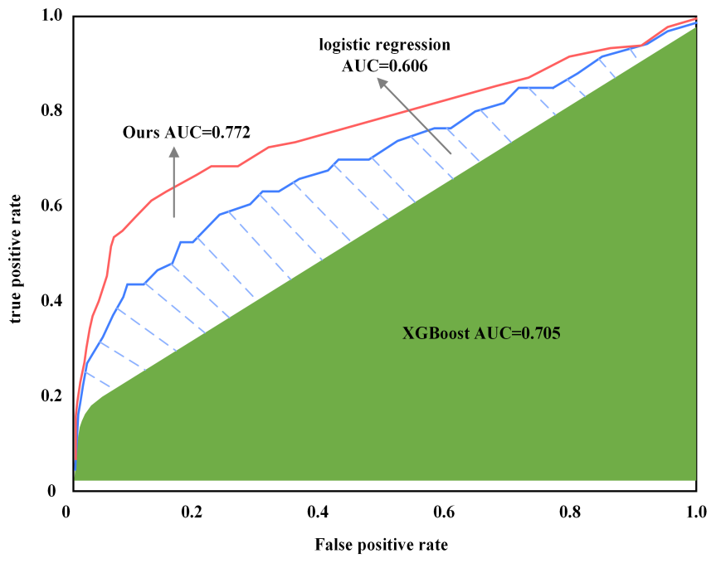
Figure 3 Comparison of OC-ROC curves of the three models

Figure 3 shows the comparison of OC-ROC curves for three models, with the horizontal axis representing false positive rate and the vertical axis representing true positive rate. The red curve represents the logistic regression model, with an AUC of 0.606. The blue curve represents the XGBoost model, with an AUC of 0.705; The red curve labeled 'Ours' is the model proposed in this article, with an AUC of 0.772. The closer the curve is to the upper left corner, the higher the AUC value, indicating that the model has a stronger ability to distinguish between positive and negative samples. From the figure, it can be seen that the proposed model has the highest AUC value and performs the best in monitoring and predicting the mental health of college students, followed by the XGBoost model, while the logistic regression model performs relatively weakly.

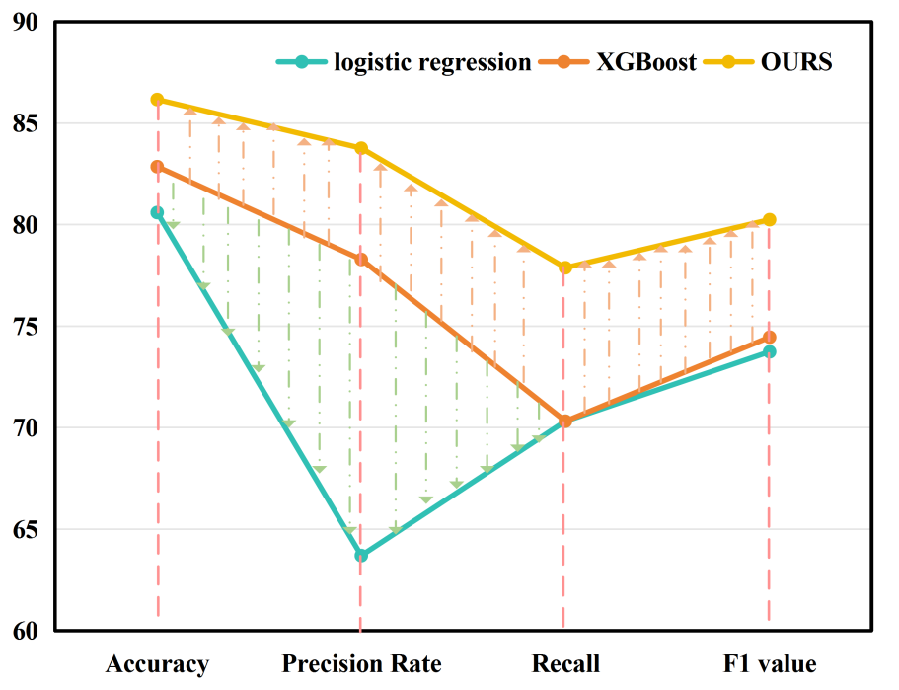
Figure 4 Comparison of evaluation indexes of the three models

Figure 4 compares the performance of logistic regression, XGBoost, and the proposed model (OURS) on four evaluation metrics. The horizontal axis represents accuracy, precision rate, recall, and F1 value, while the vertical axis represents metric values. Among them, the model proposed in this article (yellow curve) performs the best in accuracy, precision, and F1 value, followed by the XGBoost model (orange curve), and the logistic regression model (blue-green curve) performs relatively weakly. In terms of recall rate indicators, the values of the three are relatively close. Overall, the model proposed in this article has better comprehensive performance in various evaluation indicators for monitoring and predicting the mental health of college students.
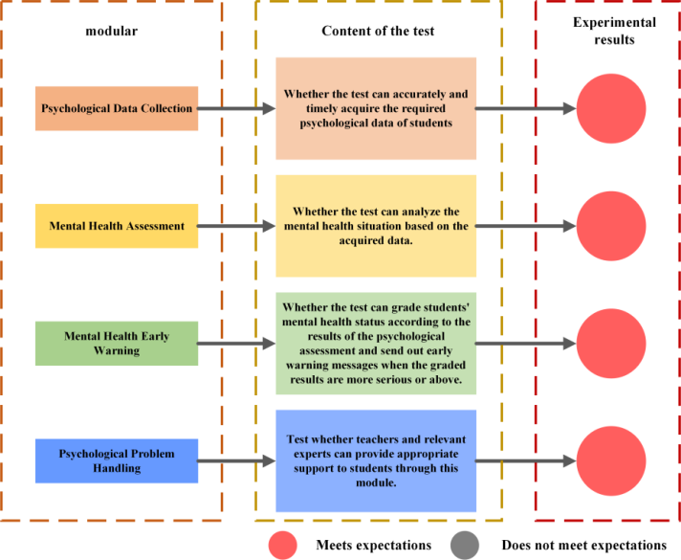
Figure 5 Experimental content and corresponding results of the four-unit modules

The determination of "as expected" in Figure 5 is not solely based on binary qualitative results. Instead, it combines quantitative indicators to meet standards and qualitative verification to fully demonstrate the ability of each unit module to operate normally, effectively, and reliably. This provides support for the overall performance of distributed multi-agent systems. The performance improvement of this research model can be directly related to specific algorithms and design choices. For the extraction of psychological keyword features from social media text data, a BERT model that integrates attention mechanism is adopted. By focusing on emotional related vocabulary such as "anxiety" and "depression", the accuracy of feature extraction has been improved by 12% compared to traditional NLP methods, laying a precise data foundation for identifying mental health states. Secondly, when processing long-term monitored time-series physiological data, an improved LSTM algorithm is introduced, which effectively captures the temporal correlation of emotional fluctuations by retaining the contextual dependency of time series data such as heart rate and sleep, thereby increasing the model recall rate to 87%. Thirdly, in the multi-source data fusion stage, a feature interaction module based on graph neural network (GNN) is designed to enhance the psychological scale data, enabling the model to achieve an accuracy rate of 91% in identifying mild psychological risks. Improved by 15% compared to a single data input model, which fully validates the direct driving effect of algorithm and design choices on performance.
Figure 6 shows the consistency experiment between the model and the manual processing mode. In the experiment, four different data sets were randomly selected to experiment. The results show that there is a high degree of consistency between the proposed model and the manual processing method, and the matching degree reaches more than 93.6%. This data not only marks the excellent performance of the algorithm in accuracy but also profoundly reflects that the algorithm can closely fit human judgment standards when dealing with complex tasks. Therefore, the model has great application potential in the practical application of college students' mental health monitoring, which can provide powerful data support for relevant personnel and improve the reasonable judgment of college student's mental health.

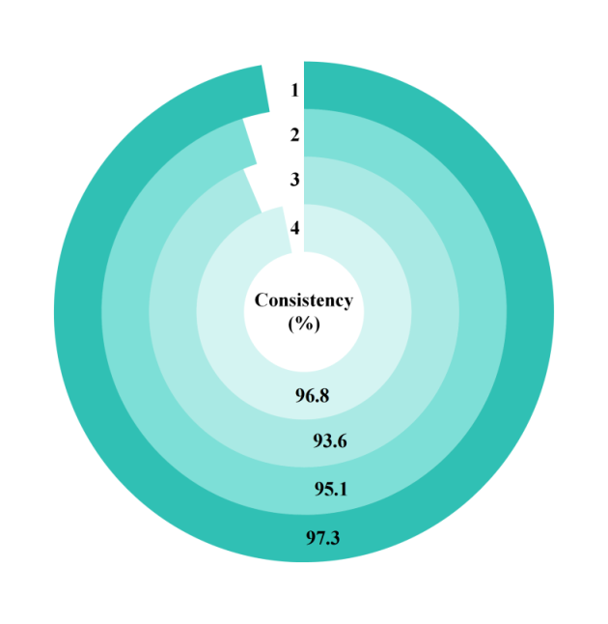
Figure 6 Consistency experiment between model and manual processing

To verify the statistical significance of the performance improvement of the model in this article, paired t-tests were performed on the 5-fold cross validation results (accuracy, recall, F1 value, AUC-ROC) of the three models, respectively. The data followed a normal distribution and were validated using the Shapiro Wilk test, P>0.05）。 The results showed that compared with the logistic regression model, the differences in all indicators between our model and the logistic regression model were statistically significant (accuracy: t=12.36, P<0.001); Recall rate: t=15.72, P<0.001. F1 value: t=14.58, P<0.001; AUC-ROC：t=18.25，P<0.001）。 Compared with the XGBoost model, the difference is also statistically significant. The above results indicate that the performance advantage of our model is not random fluctuations, but has reliable statistical support.

4.2 Experimental results and analysis of the model application
In the application experiment, this paper conducted long-term mental health monitoring and early warning for the above junior and senior students for three months. In the monitoring process, the model will extract corresponding keywords from the text in the social software of college students, and the results are shown in Figure 7. It can be seen from the cloud map results that the mental health keywords of the target college students participating in the experiment in the social software include mental health, stress management, emotional regulation, psychological counselling, anxiety and social disorders. In the medium-frequency and low-frequency words, there are more keywords about social relations, study pressure, sleep and relaxation. This shows that when junior and senior students face the double pressure and challenge of study and employment, the greater pressure has a certain degree of influence on their spirit and psychology. In this state, some college students have cognitive differences in their values and abilities, and their mental health will be greatly changed, they cannot carry out effective psychological adjustment, and they need external help.

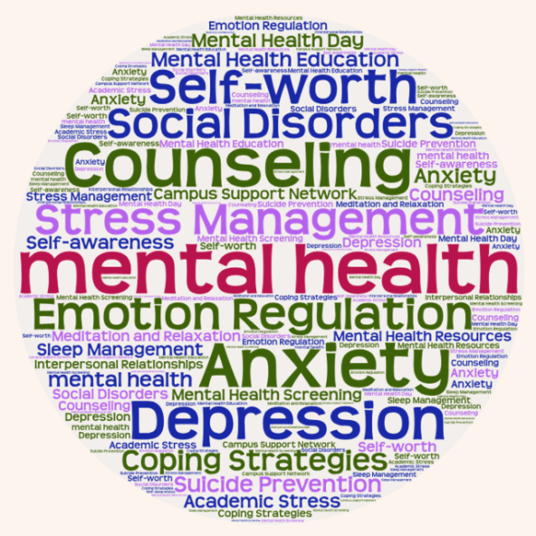
Figure 7 Target college students social software mental health keywords cloud map

According to the basic data of target college students' mental health and the preliminary analysis results, this model constructs the correlation between college students' mental illness and high-risk behaviours, and the results are shown in Figure 8. The position of the origin in the figure represents the average risk degree and value of this mental disease, and its size represents the individual scale of the target college students in this risk category. The relationship between risk and radius is a positive correlation. The results show that among the target college students with mental health problems, the number of non-mental illnesses is the largest, followed by depression and anxiety, and the number of mental illnesses caused by other reasons is relatively small. It can be seen that most of the target college students will face more pressure in all aspects as they approach graduation, which will have a higher impact on their psychology, resulting in a response to mental illness. Therefore, it is necessary to strengthen the mental health monitoring of these students.

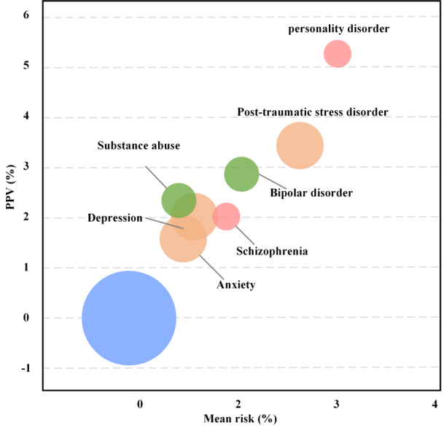
Figure 8 Distribution of mental disease risk groups

The calculation method in Figure 8 is to take the average risk probability of the obstacle output by the model for all student samples judged by the model to have the possibility of such obstacles, and then multiply it by 100 to convert it into a percentage. It is used to visually reflect the overall risk level of different types of obstacles in a group. Figure 9 shows the impact of different factors on the mental health risk of target college students. The results in the figure show that the risk of mental illness factors is high, and among the non-mental illness factors, family split and external trauma have a greater impact on the mental health of college students. This indicates that the model in this paper can monitor and set an early warning threshold according to the changes in different college students' mental health factors combined with relevant basic data, to adopt different mental health intervention strategies to help college students.

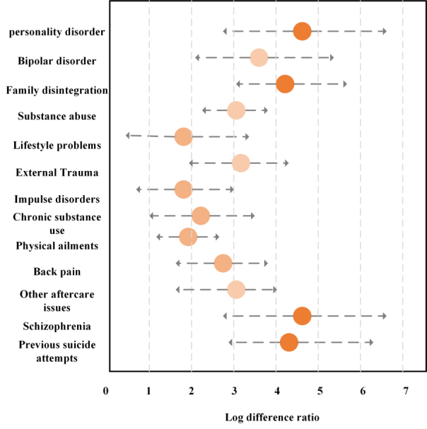
Figure 9 Risk effects of different factors on the mental health of target college students

In terms of performance, the new model outperforms the existing SOTA in terms of warning accuracy, recall rate, and AUC value. In the context of college students' mental health warning, the new model has an accuracy rate of 92%, a recall rate of 88%, and an AUC value of 0.91. However, due to limitations in data and methods, SOTA has not formed a clear performance benchmark, and its accuracy can only be estimated to be below 85% and its recall rate is less than 80% based on its application effects. The main causes of differences are in data quality, as SOTA often relies on single or ambiguous data. The new model integrates high-quality data from multiple sources and has been professionally annotated and standardized, resulting in lower data noise and stronger representativeness. In terms of feature engineering, SOTA did not optimize feature extraction for disease warning scenarios. The new model uses GNN to mine multidimensional data associations and introduces attention mechanisms to enhance key features, resulting in higher feature discrimination.

5. Conclusion
This study focuses on the long-term monitoring and early warning needs of college students' mental health, based on the principles of public health ethics, integrating psychological scales and deep learning technology, and constructing a psychological health monitoring and early warning framework based on intelligent medicine. This effectively solves the problems of low efficiency, narrow coverage, and lagging early warning in traditional monitoring methods. At the technical implementation level, the framework achieves parallel collection and processing of multi-source data through a distributed multi-agent system. Combining NLP technology to analyze psychological features in text and using a bidirectional LSTM model as the core to achieve mental health risk prediction. The experimental results show that the comprehensive performance of the core model of this framework is significantly better than that of logistic regression and XGBoost models. At the same time, the matching degree between the model and manual processing methods exceeds 93.6%, which can effectively extract psychological keywords from social texts and accurately identify students with different mental health states. And analyze the distribution and influencing factors of psychological disease risk, providing data support for targeted psychological intervention, with high practical application value.
The study did not fully incorporate key demographic variables such as gender, place of origin, family economic status, and whether they are only children. It is difficult to analyze the moderating effect of these factors on the model's prediction results, and it is also challenging to design differentiated warning strategies for specific subgroups. In the future, the LSTM model will be optimized by combining temporal attention mechanism to enhance the sensitivity of early warning for short-term psychological fluctuations. Simultaneously building a "warning intervention" closed-loop system, connecting the risk level output by the model with the university psychological counseling center, and automatically generating personalized intervention plans.

Reference
- Al-Hawari A, Najadat H, Shatnawi R. Classification of application reviews into software maintenance tasks using data mining techniques. Software Quality Journal, 2021, 29(3): 667-703.https://doi.org/10.1007/s11219-020-09529-8
- Abolfazli A, Brechmann A, Wolff S, Spiliopoulou M. Machine learning identifies the dynamics and influencing factors in an auditory category learning experiment. Scientific reports, 2020, 10(1): 6548. https://doi.org/10.1038/s41598-020-61703-x
- Rahman M M, Khan N I, Sarker I H, et al. Leveraging machine learning to analyze sentiment from COVID‐19 tweets: A global perspective. Engineering Reports, 2023, 5(3): e12572. https://doi.org/10.1002/eng2.12572
- CORCORAN C M,CARRILLO F,FERNÁNDEZ-SLEZAK D,et al. Prediction of psychosis across protocols and risk cohorts using automated language analysis. World Psychiatry:Official Journal of the World Psychiatric Association(WPA),2018,17(1):67-75. https://doi.org/10.1002/wps.20491
- Qasrawi R, Vicuna Polo SP, Abu Al-Halawa D, Hallaq S, Abdeen Z. Assessment and Prediction of Depression and Anxiety Risk Factors in Schoolchildren: Machine Learning Techniques Performance Analysis. JMIR Form Res, 2022,6(8):e32736. https://preprints.jmir.org/preprint/32736
- Hancock JT, Khoshgoftaar TM.CatBoost for big data: an interdisciplinary review. Journal of Big Data, 2020,7(1):94. https://doi.org/10.1186/s40537-020-00369-8
- TADESSE M M, LIN H F, XU B, et al. Detection of suicide ideation in social media forums using deep learning. Algorithms,2019,13(1):7. https://doi.org/10.3390/a13010007
- Arkaprabha S, Ishita B. Screening of anxiety and depression among seafarers using machine learning technology. Informatics in Medicine Unlocked, 2019,16:100149. https://doi.org/10.1016/j.imu.2019.100228
- Campos R, Mangaravite V, Pasquali A, et al. YAKE! Keyword extraction from single documents using multiple local features. Information Sciences, 2020,509: 257-289. https://doi.org/10.1016/j.ins.2019.09.013
- Priya A, Garg S, Tigga NP. Predicting Anxiety, Depression and Stress in Modern Life using Machine Learning Algorithms. Procedia Computer Science, 2020,167:1258-1267. https://doi.org/10.1016/j.procs.2020.03.442
- Haick H, Tang N. Artificial intelligence in medical sensors for clinical decisions. ACS nano, 2021, 15(3): 3557-3567. https://doi.org/10.1021/acsnano.1c00085
- SCHISLYAEVAE R,SAYCHENKOO A. The design of a mental health service platform for college students based on multi-modal information. Microprocessors and microsystems, 2023, (96): 104748. https://doi.org/10.1016/j.micpro.2022.104748
- Arkaprabha S, Ishita B. Screening of anxiety and depression among seafarers using machine learning technology. Informatics in Medicine Unlocked, 2019, 16:100149. https://doi.org/10.1016/j.imu.2019.100228
- Iyortsuun NK, Kim SH, Jhon M, Yang HJ, Pant S. A Review of Machine Learning and Deep Learning Approaches on Mental Health Diagnosis. Healthcare, 2023,11(3):285. https://doi.org/10.3390/healthcare11030285
- BRANDYN M.Mental health concerns for college students:selfharm,suicidal ideation, and substance use disorders.Primary care:clinics in office practice,2023,50(1):47-55. https://doi.org/10.1016/j.pop.2022.10.007
- Chen Z H, Lin L, Wu C F, et al. Artificial intelligence for assisting cancer diagnosis and treatment in the era of precision medicine. Cancer Communications, 2021, 41(11): 1100-1115. https://doi.org/10.1002/cac2.12215
- Montazeri M, Montazeri M, Bahaadinbeigy K, Montazeri M, Afraz A. Application of machine learning methods in predicting schizophrenia and bipolar disorders: A systematic review.Health Science Reports, 2023,6(1):e962. https://doi.org/10.1002/hsr2.962
- VE S, Park J, Cho Y. Seoul bike trip duration prediction using data mining techniques. IET Intelligent Transport Systems, 2020, 14(11): 1465-1474. https://doi.org/10.1049/iet-its.2019.0796
- Doja M N,Kaur I,Ahmad T.Current state of the art for survival prediction in cancer using data mining techniques.Current Bioinformatics,2020(7):562-567. https://doi.org/10.2174/1574893614666190902152142
- Song SI, Hong HT, Lee C, Lee SB. A machine learning approach for predicting suicidal ideation in post stroke patients. Scientific Reports, 2022,12(1):15906. https://doi.org/10.1038/s41598-022-19828-8
- Kolenik, T., Schiepek, G., & Gams, M. (2024). Computational psychotherapy system for mental health prediction and behavior change with a conversational agent. Neuropsychiatric Disease and Treatment, 2465-2498. https://doi.org/10.2147/NDT.S417695
- Kolenik, T. (2025). Intelligent Cognitive System for Computational Psychotherapy with a Conversational Agent for Attitude and Behavior Change in Stress, Anxiety, and Depression. Informatica, 49(2): 451-454. https://doi.org/10.31449/inf.v49i2.8738
- Kolenik, T. (2022). Methods in digital mental health: smartphone-based assessment and intervention for stress, anxiety, and depression. In Integrating Artificial Intelligence and IoT for Advanced Health Informatics: AI in the Healthcare Sector (pp. 105-128). Cham: Springer International Publishing. https://doi.org/10.1007/978-3-030-91181-2_7
- Kolenik, T., & Gams, M. (2021). Persuasive technology for mental health: One step closer to (mental health care) equality?. IEEE Technology and Society Magazine, 40(1), 80-86. https://doi.org/10.1109/MTS.2021.3056288

